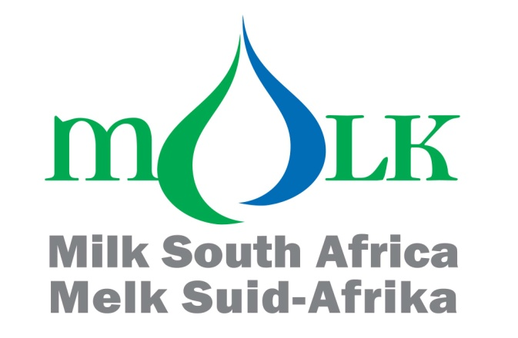

HIGHLIGHTS OF THE ATTACHED ANALYSES OF THE
IMPORTS AND EXPORTS OF DAIRY PRODUCTS UP TO SEPTEMBER 2022

Synopsis
- The mass of imports of dairy products in 2021, was 24.8 percent higher than in 2020, and 0.03 percent higher than 2019. The increase from 2020 to 2021, was due to the increase in imports of two of the six categories of dairy products.
- The estimated mass of imports of dairy products in 2022, is 27.9 percent lower than in 2021, and 10.1 percent lower than 2020. The decrease from 2021 to 2022, is due to the decrease in imports of four of the six categories of dairy products.
- The average f.o.b. import prices in (January to September) 2022, of all six different categories of dairy products, are higher than in 2021.
- The mass of exports of dairy products in 2021, was 9.2 percent higher than in 2020 and 13.2 higher than in 2019. The increase from 2020 to 2021, was due to the increase in exports of four of the six categories of dairy products.
- The estimated mass of exports of dairy products in 2022, is 0.9 percent lower than in 2021 and 8.2 higher than in 2020. The decrease from 2021 to 2022, is due to the decrease in exports of four of the six categories of dairy products.
- The average f.o.b. export prices in (January to September) 2022, of five of the six different categories of dairy products, were higher than in 2021.
- The estimated mass of imports and exports in 2022, shows that South Africa is a nett importer of concentrated milk (04.02), whey (04.04), butter (04.05), and cheese (04.06) and a nett exporter of milk and cream (04.01), buttermilk and yoghurt (04.03).
- Graphs reflecting the mass of imports and exports per month of each of the six categories of dairy products, are shown in Annexure B.
- The mass of sales by South Africa to the other members of the Southern African Customs Union (Botswana, eSwatini, Namibia and Lesotho) in January to September 2022, of all six categories of dairy products, is higher than the mass of South African exports of the dairy products in the same period.
- The exposure in 2021, to foreign competition (that is imports plus exports) was the third highest in the 10 years from 2012 to 2021. The estimated exposure in 2022, is the lowest in the 11 years from 2012 to 2022.
Note:

- The estimated total import and export quantities in 2022, were calculated on the assumption that the levels of import in the first nine months of 2022, will be maintained during the rest of 2022.

- Estimates regarding future imports and exports based on historic import figures should be viewed with caution as the pattern of imports (distribution per month of total import and export during a year) in different years differ meaningfully.

Imports and exports of dairy products up to September 2022

This report was compiled by the Office of SAMPRO and forms part of the Industry Information Project of Milk SA. The purpose of the project is to make market signals available to members and other interested parties, which is a pre-requisite for effective competition, as envisaged by the Competition Act.

All reports compiled by the Office of SAMPRO and all activities of the Industry Information Project of Milk SA, are designed and implemented in accordance with the Competition Act.

INTRODUCTION

- The imports and exports figures of dairy products for January to September 2022, were recently released by SARS.

- In this document, a brief analysis of imports and exports is provided per tariff heading. The estimated imports and exports in 2022, are calculated based on the assumption that the levels of the imports and exports recorded in the first 6 months of 2022, will be maintained during the rest of 2022. Estimates regarding future imports based on historic import figures should be viewed with caution as the pattern of imports (distribution per month of total import and export during a year) in different years differ meaningfully.

- The patterns of imports and exports within each year (the distribution per month of the total imports and exports of the year) are indicated in Annexure B.

IMPORTS

- The indices of the mass of imports in the years 2015 to 2022 are indicated in Table 1. The mass of imports is indicated in Annexure A.

Table 1: Indices of the mass of imports per tariff heading (2002=100)

Heading | Description | 2015 | 2016 | 2017 | 2018 | 2019 | 2020 | 2021 | 2022  (EST)
04.01 | Milk and cream, unsweetened | 12 877.1 | 9 213.0 | 18 779.0 | 8 457.2 | 8 828.7 | 2 693.5 | 10 985.8 | 1 485.4
04.02 | Milk, concentrated | 114.1 | 95.3 | 143.8 | 135.1 | 162.7 | 179.3 | 176.0 | 135.1
04.03 | Buttermilk powder, yoghurt | 300.8 | 288.0 | 356.2 | 403.7 | 394.3 | 459.1 | 381.2 | 363.0
04.04 | Whey, whey powder, etc | 118.5 | 89.7 | 97.1 | 152.4 | 275.2 | 216.2 | 215.7 | 263.8
04.05 | Butter, butter spreads and butter oil | 346.9 | 362.1 | 361.2 | 612.7 | 290.9 | 485.8 | 298.7 | 314.0
04.06 | Cheese and curd | 408.9 | 425.5 | 394.8 | 366.6 | 311.1 | 220.1 | 271.3 | 250.0
TOTAL |  | 281.7 | 235.6 | 339.2 | 278.9 | 307.1 | 246.1 | 307.2 | 221.4

- Table 1, indicates that:

- The mass of imports in 2020, was 19.9 percent lower than in 2019. The decrease from 2019 to 2020, was due to the decrease in imports of three of the six categories of dairy products;

- The mass of imports in 2021, was 24.8 percent higher than in 2020, and 0.03 percent higher than in 2019. The increase from 2020 to 2021, was due to the increase in imports of two of the six categories of dairy products; and

- The estimated mass of imports in 2022, is 27.9 percent lower than in 2021. The decrease from 2021 to 2022, is due to the decrease in imports of four of the six categories of dairy products.

- In Table 2, the mass of imports in January to September 2022, is compared with the mass of imports in January to September 2021.

Table 2: Imports from January to September 2022 and January to September 2021

Heading | Description | A  2022  Kg | B  2021  Kg | A as  %  of B
04.01 | Milk and cream, unsweetened | 2 324 061 | 19 043 114 | 12.2
04.02 | Milk, concentrated | 11 161 554 | 15 366 036 | 72.6
04.03 | Buttermilk powder, yogurt | 2 401 281 | 2 826 085 | 85.0
04.04 | Whey, whey powder, etc | 15 644 211 | 12 742 219 | 122.8
04.05 | Butter, butter spreads and butter oil | 3 483 562 | 3 104 846 | 112.2
04.06 | Cheese and curd | 5 853 152 | 6 114 804 | 95.7
Total |  | 40 867 821 | 59 197 105 | 69.0

- The mass of imports of whey (04.04) and butter (04.05) is higher in January to September 2022, than in January to September 2021, while the mass of the other four products is lower.

- Table 3, indicates the indices of the average free on board (f.o.b.) import prices in the years 2015 to 2021 and in January to September 2022.

Table 3: Indices of the average f.o.b. import prices per tariff heading (2002=100)

Heading | Description | 2015 | 2016 | 2017 | 2018 | 2019 | 2020 | 2021 | 2022  (Jan-Sep)
04.01 | Milk and cream, unsweetened | 60.8 | 59.2 | 60.8 | 63.6 | 71.2 | 82.1 | 71.9 | 103.0
04.02 | Milk, concentrated | 236.7 | 252.3 | 247.4 | 236.2 | 279.4 | 353.9 | 357.4 | 446.9
04.03 | Buttermilk powder, yoghurt | 194.7 | 177.4 | 197.0 | 163.2 | 224.0 | 279.8 | 278.5 | 387.0
04.04 | Whey, whey powder, etc | 410.5 | 371.0 | 401.0 | 376.5 | 330.8 | 509.3 | 430.5 | 444.3
04.05 | Butter, butter spreads and  butter oil | 304.3 | 360.6 | 530.0 | 560.3 | 539.7 | 532.7 | 515.5 | 661.1
04.06 | Cheese and curd | 183.3 | 190.9 | 207.5 | 209.9 | 233.1 | 264.2 | 233.8 | 281.5

- Table 3, indicates that:

- The average import prices of five of the six categories of dairy products in 2020, were higher than in 2019;

- The average import prices of five of the six categories of dairy products in 2021, were lower than in 2020; and

- The average import prices (January to September) of all six categories of dairy products in 2022, are higher than in 2021;

- Table 4, indicates the average f.o.b. prices of the imported dairy products in the years 2015 to 2021 and January to September 2022.

Table 4: Average f.o.b. import prices per tariff heading

Heading | Description | 2015  R/kg | 2016  R/kg | 2017  R/kg | 2018  R/kg | 2019  R/kg | 2020 R/kg | 2021  R/kg | 2022  (Jan-Sep)  R/kg
04.01 | Milk and cream, unsweetened | 7.65 | 7.44 | 7.65 | 8.00 | 8.95 | 10.32 | 9.04 | 12.94
04.02 | Milk, concentrated | 30.92 | 32.94 | 32.31 | 30.84 | 36.49 | 46.22 | 46.68 | 58.36
04.03 | Buttermilk powder, yoghurt | 28.06 | 25.56 | 28.39 | 23.51 | 32.27 | 40.32 | 40.13 | 55.76
04.04 | Whey, whey powder, etc | 31.98 | 28.90 | 31.24 | 29.33 | 25.77 | 39.68 | 33.53 | 34.61
04.05 | Butter, butter spreads and  butter oil | 39.56 | 46.88 | 68.89 | 72.84 | 70.17 | 69.25 | 67.01 | 85.94
04.06 | Cheese and curd | 54.94 | 57.22 | 62.19 | 62.92 | 69.85 | 79.19 | 70.06 | 84.36

- The average import prices of all the six different categories of dairy products increased from 2021 to 2022 (January to September), as follows:

- 04.01 43.2 percent;
- 04.02 25.0 percent;
- 04.03 39.0 percent;
- 04.04 3.2 percent;
- 04.05 28.3 percent; and
- 04.06 20.4 percent.

EXPORTS

- The indices of the mass of exports in the years 2015 to 2022, are indicated in Table 5. The mass of exports is indicated in Annexure A.

Table 5: Indices of the mass of exports per tariff heading (2002=100)

Heading | Description | 2015 | 2016 | 2017 | 2018 | 2019 | 2020 | 2021 | 2022  (Est)
04.01 | Milk and cream, unsweetened | 226.9 | 178.1 | 141.0 | 132.9 | 159.5 | 166.3 | 188.0 | 165.5
04.02 | Milk, concentrated | 45.3 | 38.1 | 77.1 | 66.5 | 56.0 | 55.7 | 53.6 | 73.3
04.03 | Buttermilk powder, yoghurt | 1 659.9 | 1 330.5 | 1 139.7 | 1 318.3 | 1 131.2 | 1 036.3 | 1 064.6 | 1 028.1
04.04 | Whey, whey powder, etc | 1 025.5 | 924.7 | 963.8 | 167.6 | 180.6 | 329.3 | 465.2 | 499.4
04.05 | Butter, butter spreads and  butter oil | 97.7 | 88.5 | 71.3 | 80.8 | 79.3 | 87.1 | 85.1 | 80.4
04.06 | Cheese and curd | 88.7 | 87.9 | 79.5 | 91.7 | 84.0 | 105.9 | 127.9 | 126.7
TOTAL |  | 178.6 | 146.4 | 141.7 | 131.8 | 131.2 | 136.0 | 148.5 | 147.2

- Table 5, indicates that:

- The mass of exports in 2020, was 3.7 percent higher than in 2019. The increase was due to the increases in exports of four of the six categories of dairy products;

- The mass of exports in 2021, was 9.2 percent higher than in 2020 and 13.2 percent higher than in 2019. This increase was due to the increase in exports of four of the six categories of dairy products; and

- The estimated mass of exports in 2022, is 0.9 percent lower than in 2021 and 8.2 percent higher than in 2020. This decrease is due to the decrease in exports of four of the six categories of dairy products.

- In Table 6, the mass of exports in January to September 2022, is compared with the mass of exports in January to September 2021.

Table 6: Exports from January to September 2022 and January to September 2021

Heading | Description | A  2022  Kg | B  2021  Kg | A  as %  van B
04.01 | Milk and cream, unsweetened | 15 889 729 | 16 591 029 | 95.8
04.02 | Milk, concentrated | 7 718 601 | 5 742 101 | 134.4
04.03 | Buttermilk powder, yoghurt | 7 478 138 | 7 551 162 | 99.0
04.04 | Whey, whey powder. etc | 1 545 803 | 1 621 507 | 95.3
04.05 | Butter, butter spreads and butter oil | 920 503 | 960 733 | 95.8
04.06 | Cheese and curd | 4 350 566 | 4 241 512 | 102.6
Total |  | 37 903 341 | 36 708 045 | 103.3

- Table 6, indicates that the mass of exports of four of the six categories of dairy products is lower in January to September 2022, than in the same months of 2021. The mass exports that was higher is concentrated milk (04.02) and cheese (04.06).

- Table 7, indicates the indices of the average f.o.b. prices in the years 2015 to 2021 and in January to September 2022, of the exports of the six categories of dairy products.

Table 7: Indices of average f.o.b. export prices per tariff heading (2000 =100)

Heading | Description | 2015 | 2016 | 2017 | 2018 | 2019 | 2020 | 2021 | 2022  (Jan-Sep)
04.01 | Milk and cream, unsweetened | 247.1 | 243.7 | 262.2 | 268.6 | 270.9 | 293.3 | 315.1 | 357.2
04.02 | Milk, concentrated | 184.0 | 219.9 | 246.7 | 217.2 | 219.6 | 279.2 | 294.5 | 355.7
04.03 | Buttermilk powder, yoghurt | 157.1 | 178.1 | 310.9 | 154.5 | 176.1 | 169.9 | 203.1 | 183.5
04.04 | Whey, whey powder, etc | 132.6 | 321.5 | 167.6 | 236.2 | 227.7 | 246.2 | 274.1 | 463.1
04.05 | Butter, butter spreads and butter oil | 267.7 | 325.2 | 394.6 | 442.8 | 374.5 | 484.3 | 454.5 | 495.8
04.06 | Cheese and curd | 190.4 | 217.6 | 254.6 | 222.4 | 235.4 | 243.4 | 262.3 | 289.1

- Table 7, indicates that:

- The average prices of exports of five of the six categories of dairy products in 2020, were higher than in 2019; and

- The average prices of exports of five of the six categories of dairy products in 2021, were higher than in 2020.

- The average prices (January to September) of exports of five of the six categories of dairy products in 2022, are higher than in 2021.

- The average f.o.b. export prices in the years 2015 to 2021 and January to September 2022, are indicated in Table 8.

Table 8: Average f.o.b. export prices per tariff heading

Heading | Description | 2015  R/kg | 2016  R/kg | 2017  R/kg | 2018  R/kg | 2019  R/kg | 2020  R/kg | 2021  R/kg | 2022  (Jan-Sep)  R/kg
04.01 | Milk and cream, unsweetened | 10.30 | 10.16 | 10.93 | 11.20 | 11.30 | 12.23 | 13.14 | 14.89
04.02 | Milk, concentrated | 30.97 | 37.00 | 41.51 | 36.56 | 36.97 | 46.98 | 49.56 | 59.86
04.03 | Buttermilk powder, yoghurt | 18.76 | 21.27 | 37.12 | 18.45 | 21.02 | 20.28 | 24.25 | 21.90
04.04 | Whey, whey powder, etc | 10.51 | 25.46 | 13.27 | 18.71 | 18.03 | 19.50 | 21.71 | 36.67
04.05 | Butter, butter spreads and butter oil | 40.66 | 49.40 | 59.94 | 67.27 | 56.89 | 73.57 | 69.04 | 75.31
04.06 | Cheese and curd | 45.50 | 52.00 | 60.86 | 53.15 | 56.25 | 58.17 | 62.68 | 69.10

- The average export prices of five of the six different categories of dairy products increased from 2021 to January to September 2022, as follows:

- 04.01 13.4 percent;
- 04.02 20.8 percent;
- 04.04 69.0 percent;
- 04.05 9.1 percent; and
- 04.06 10.2 percent.

- The average export price of one of the six different categories of dairy products decreased from 2021 to January to September 2022, as follows:

- 04.03 9.7 percent.

RATIO BETWEEN IMPORTS AND EXPORTS

- The mass of imports as a percentage of the mass of exports of dairy products by South Africa, is a highly aggregated indication of the industry’s international competitiveness. The ratios between the mass of imports and exports of the six categories of dairy products from 2015 to 2021, and estimated figures in respect of 2022, are indicated in Table 9.

Table 9: Mass of imports as a percentage of the mass of exports

Heading | Description | 2015 | 2016 | 2017 | 2018 | 2019 | 2020 | 2021 | 2022  EST
04.01 | Milk and cream, unsweetened | 92.5 | 84.3 | 217.1 | 103.7 | 90.2 | 26.4 | 95.2 | 14.6
04.02 | Milk, concentrated | 197.7 | 196.3 | 146.4 | 159.5 | 227.9 | 252.8 | 257.6 | 144.6
04.03 | Buttermilk powder, yoghurt | 16.5 | 19.7 | 28.4 | 27.9 | 31.7 | 40.3 | 32.6 | 32.1
04.04 | Whey, whey powder, etc | 221.3 | 185.9 | 192.9 | 1 741.3 | 2 917.9 | 1 257.6 | 888.3 | 1 012.0
04.05 | Butter, butter spreads and  butter oil | 344.1 | 396.7 | 491.2 | 735.1 | 355.5 | 540.6 | 340.4 | 378.4
04.06 | Cheese and curd | 314.2 | 330.3 | 338.7 | 272.5 | 252.7 | 141.7 | 144.6 | 134.5
TOTAL |  | 113.1 | 115.4 | 171.7 | 151.7 | 167.8 | 129.7 | 148.3 | 107.8

- As indicated in Table 9:

- The ratio between the imports and exports in 2020, in respect of three of the six categories of dairy products, namely milk and cream (04.01), whey (04.04) and cheese (04.06) was lower than in 2019;

- The ratio between the imports and exports in 2021, in respect of three of the six categories of dairy products, namely buttermilk powder and yoghurt (04.03), whey (04.04) and butter (04.05) was lower than in 2020;

- The ratio between the imports and exports in 2022, in respect of four of the six categories of dairy products, namely (04.01), concentrated milk (04.02), buttermilk powder and yoghurt (04.03) and cheese (04.06) is lower than in 2021, and

- In 2022, the mass of exports of two of the six categories of dairy products, namely (04.01) milk and cream and (04.03) buttermilk and yoghurt exceed the mass of imports.

EXPOSURE OF THE SOUTH AFRICAN DAIRY INDUSTRY TO FOREIGN COMPETITION

- The sum of the mass of the imports and exports of dairy products by South Africa, is a highly aggregated indication of the exposure of the South African dairy industry to foreign competition, and this is indicated in Table 10.

Table 10: Mass of imports and exports (2002=100)

YEAR | IMPORTS |  | EXPORTS |  | IMPORTS PLUS EXPORTS
 | TON | INDEX | TON | INDEX | TON | INDEX
2002 | 24 617.40 | 100.0 | 34 328.20 | 100.0 | 58 945.60 | 100.0
2003 | 24 458.80 | 99.4 | 22 905.20 | 66.7 | 47 364.00 | 80.4
2004 | 18 289.50 | 74.3 | 23 508.10 | 68.5 | 41 797.60 | 70.9
2005 | 30 771.40 | 125.0 | 17 216.00 | 50.2 | 47 987.40 | 81.4
2006 | 30 878.60 | 125.4 | 26 543.30 | 77.3 | 57 421.90 | 97.4
2007 | 44 313.00 | 180.0 | 18 516.50 | 53.9 | 62 829.50 | 106.6
2008 | 34 009.40 | 138.2 | 42 781.00 | 124.6 | 76 790.40 | 130.3
2009 | 32 373.40 | 131.5 | 41 770.70 | 121.7 | 74 144.10 | 125.8
2010 | 35 061.20 | 142.4 | 33 950.60 | 98.9 | 69 011.80 | 117.1
2011 | 37 714.40 | 153.2 | 41 817.10 | 121.8 | 79 531.50 | 134.9
2012 | 59 102.53 | 240.1 | 52 500.96 | 152.9 | 111 603.49 | 189.3
2013 | 35 673.76 | 144.9 | 70 481.90 | 205.3 | 106 155.66 | 180.1
2014 | 40 199.03 | 163.3 | 71 098.95 | 207.1 | 111 297.99 | 188.8
2015 | 69 353.98 | 281.7 | 61 296.87 | 178.6 | 130 650.85 | 221.6
2016 | 58 000.35 | 235.6 | 50 247.54 | 146.4 | 108 247.89 | 183.6
2017 | 83 504.44 | 339.2 | 48 626.69 | 141.7 | 132 131.14 | 224.2
2018 | 68 652.58 | 278.9 | 45 257.49 | 131.8 | 113 910.08 | 193.2
2019 | 75 596.08 | 307.1 | 45 051.75 | 131.2 | 120 647.83 | 204.7
2020 | 60 579.33 | 246.1 | 46 695.39 | 136.0 | 107 274.72 | 182.0
2021 | 75 618.94 | 307.2 | 50 990.95 | 148.5 | 126 609.89 | 214.8
2022 (Est) | 54 490.43 | 221.3 | 50 537.79 | 147.2 | 105 028.22 | 178.2

- From Table 10, it is clear that the exposure to foreign competition of the South African dairy industry:

- Was in 2020, the second lowest in the 9 years from 2012 to 2020;

- Was in 2021, the third highest in the 10 years from 2012 to 2021; and

- Is in 2022, the lowest in the 11 years from 2012 to 2022.

- In Table 11, the mass of total sales of the different dairy products to the Southern African Customs Union (SACU) member states, namely Botswana, eSwatini, Lesotho and Namibia (BeLN countries) in the period January to September 2022, is compared to the mass of the exports in January to September 2022 by South Africa to other countries. Sales by South Africa to the other members of SACU, are not classified by SARS as exports.

Table 11: Mass of sales to the BeLN countries compared to exports outside of SACU from January to September 2022

Heading | Description | (A)  Sales  To  BeLN | (B)  Exports to  Countries  Outside  SACU | (A+B)=(C)  Sales to BeLN plus exports outside  SACU | A  as  %  of  C
 |  | Kilogram |  |  | %
04.01 | Milk and cream, unsweetened | 46 676 295 | 15 889 729 | 62 566 024 | 74.6
04.02 | Milk, concentrated | 27 802 767 | 7 718 601 | 35 521 368 | 78.3
04.03 | Buttermilk powder, yogurt | 17 559 385 | 7 478 138 | 25 037 523 | 70.1
04.04 | Whey, whey powder, etc | 2 310 861 | 1 545 803 | 3 856 664 | 59.9
04.05 | Butter, butter spreads and  butter oil | 1 296 630 | 920 503 | 2 217 133 | 58.5
04.06 | Cheese and curd | 4 860 309 | 4 350 566 | 9 210 875 | 52.8
Total |  | 100 506 247 | 37 903 340 | 138 409 587 | 72.6

- Table 11, indicates that:

- The mass of the total sales of dairy products by South Africa to the BeLN countries from January to September 2022, exceeds the mass of exports. (Exports are sales to destinations outside SACU); and

- The mass of the sales by South Africa to members of SACU, of all six categories of dairy products from January to September 2022, exceeds the mass of exports by South Africa.

MARIETJIE LE ROUX

DE WET JONKER

ALWYN P KRAAMWINKEL
31 January 2023

Annexure A

Table 1: Imports and Exports by heading in kg

 |  | Imports | Exports | Imports | Exports | Imports | Exports
 |  | 2002 | 2002 | 2003 | 2003 | 2004 | 2004
Heading | Description | Kg | Kg | Kg | Kg | Kg | Kg
04.01 | Milk and cream, unsweetened | 208 613 | 12 801 289 | 684 821 | 9 640 776 | 1 526 416 | 9 190 414
04.02 | Milk, concentrated | 11 018 625 | 14 039 210 | 6 703 019 | 7 452 953 | 3 067 368 | 5 972 199
04.03 | Buttermilk powder, yoghurt | 882 034 | 969 846 | 1 077 191 | 2 161 584 | 850 505 | 2 076 324
04.04 | Whey, whey powder etc | 7 906 468 | 412 723 | 6 271 924 | 268 045 | 6 777 606 | 2 628 212
04.05 | Butter, butter spreads and butter oil | 1 479 363 | 1 526 319 | 4 629 804 | 996 146 | 1 800 706 | 788 997
04.06 | Cheese and curd | 3 122 250 | 4 578 773 | 5 092 997 | 2 385 733 | 4 266 915 | 2 851 990
 | Total | 24 617 353 | 34 328 160 | 24 459 756 | 22 905 237 | 18 289 516 | 23 508 136
 |  | Imports | Exports | Imports | Exports | Imports | Exports
 |  | 2005 | 2005 | 2006 | 2006 | 2007 | 2007
Heading | Description | Kg | Kg | Kg | Kg | Kg | Kg
04.01 | Milk and cream, unsweetened | 2 105 485 | 8 666 131 | 4 943 877 | 12 559 045 | 13 858 507 | 7 277 746
04.02 | Milk, concentrated | 12 337 153 | 3 517 660 | 9 032 137 | 4 366 952 | 14 386 700 | 4 235 315
04.03 | Buttermilk powder, yoghurt | 1 689 886 | 2 969 313 | 1 561 696 | 4 980 518 | 1 611 115 | 3 904 306
04.04 | Whey, whey powder, etc | 8 091 601 | 137 326 | 7 514 344 | 2 339 330 | 5 711 984 | 1 239 684
04.05 | Butter, butter spreads and butter oil | 2 722 816 | 846 786 | 3 141 909 | 770 915 | 3 331 164 | 880 002
04.06 | Cheese and curd | 3 824 459 | 1 078 744 | 4 684 645 | 1 526 513 | 5 413 513 | 979 477
 | Total | 30 771 400 | 17 215 960 | 30 878 608 | 26 543 273 | 44 312 983 | 18 516 530

 |  |  |  | Imports | Exports |  | Imports |  | Exports | Imports |  | Exports
 |  |  |  | 2008 | 2008 |  | 2009 |  | 2009 | 2010 |  | 2010
Heading |  | Description |  | Kg | Kg |  | Kg |  | Kg | Kg |  | Kg
04.01 |  | Milk and cream, unsweetened |  | 12 799 205 | 19 293 810 |  | 10 902 048 |  | 21 292 977 | 11 118 947 |  | 17 451 437
04.02 |  | Milk, concentrated |  | 5 852 035 | 11 446 267 |  | 5 385 534 |  | 7 864 904 | 6 771 519 |  | 4 612 872
04.03 |  | Buttermilk powder, yoghurt |  | 669 432 | 5 743 800 |  | 1 380 614 |  | 5 709 480 | 1 378 705 |  | 4 527 147
04.04 |  | Whey, whey powder, etc |  | 7 539 920 | 3 298 052 |  | 6 259 760 |  | 3 852 586 | 7 267 982 |  | 3 805 172
04.05 |  | Butter, butter spreads and butter oil |  | 2 812 100 | 1 564 877 |  | 3 200 689 |  | 1 309 556 | 2 192 835 |  | 1 470 776
04.06 |  | Cheese and curd |  | 4 336 703 | 1 434 165 |  | 5 244 744 |  | 1 741 226 | 6 331 199 |  | 2 083 150
 |  | Total |  | 34 009 395 | 42 780 971 |  | 32 373 389 |  | 41 770 729 | 35 061 187 |  | 33 950 554
 |  |  |  | Imports |  | Exports | Imports |  | Exports | Imports |  | Exports
 |  |  |  | 2011 |  | 2011 | 2012 |  | 2012 | 2013 |  | 2013
Heading |  | Description |  | Kg |  | Kg | Kg |  | Kg | Kg |  | Kg
04.01 |  | Milk and cream, unsweetened |  | 8 324 364 |  | 20 801 621 | 15 240 656 |  | 28 077 665 | 4 267 449 |  | 29 074 468
04.02 |  | Milk, concentrated |  | 7 895 127 |  | 7 244 566 | 13 257 357 |  | 6 653 309 | 7 115 030 |  | 15 316 274
04.03 |  | Buttermilk powder, yoghurt |  | 2 131 189 |  | 9 215 883 | 2 146 004 |  | 12 913 857 | 1 590 917 |  | 19 517 880
04.04 |  | Whey, whey powder, etc |  | 9 445 819 |  | 1 255 978 | 9 266 509 |  | 1 384 114 | 11 165 088 |  | 2 466 431
04.05 |  | Butter, butter spreads and butter oil |  | 3 153 315 |  | 992 242 | 6 107 761 |  | 1 033 349 | 3 132 054 |  | 1 174 557
04.06 |  | Cheese and curd |  | 6 764 628 |  | 2 306 790 | 13 084 240 |  | 2 438 666 | 8 403 219 |  | 2 932 285
 |  | Total |  | 37 714 442 |  | 41 817 080 | 59 102 527 |  | 52 500 960 | 35 673 757 |  | 70 481 895

 |  | Imports | Exports | Imports | Exports | Imports | Exports
 |  | 2014 | 2014 | 2015 | 2015 | 2016 | 2016
Heading | DESCRIPTION | Kg | Kg | Kg | Kg | Kg | Kg
04.01 | Milk and cream, unsweetened | 6 992 447 | 32 751 503 | 26 863 360 | 29 051 149 | 19 219 616 | 22 804 187
04.02 | Milk, concentrated | 9 836 418 | 8 383 267 | 12 574 543 | 6 361 606 | 10 502 625 | 5 350 645
04.03 | Buttermilk, yoghurt, etc | 2 086 328 | 22 774 653 | 2 653 250 | 16 098 030 | 2 540 075 | 12 903 458
04.04 | Whey, whey powder, etc | 9 480 080 | 1 868 337 | 9 365 343 | 4 232 308 | 7 095 931 | 3 816 533
04.05 | Butter, butter spreads and butter oil | 2 071 983 | 1 860 197 | 5 131 861 | 1 491 368 | 5 356 852 | 1 350 229
04.06 | Cheese and curd | 9 731 777 | 3 460 994 | 12 765 628 | 4 062 404 | 13 285 247 | 4 022 491
 | Total | 40 199 034 | 71 098 952 | 69 353 984 | 61 296 865 | 58 000 347 | 50 247 544
 |  | Imports | Exports | Imports | Exports | Imports | Exports
 |  | 2017 | 2017 | 2018 | 2018 | 2019 | 2019
Heading | DESCRIPTION | Kg | Kg | Kg | Kg | Kg | Kg
04.01 | Milk and cream, unsweetened | 39 175 443 | 18 044 769 | 17 642 842 | 17 009 995 | 18 417 754 | 20 412 096
04.02 | Milk, concentrated | 15 842 375 | 10 822 898 | 14 889 772 | 9 336 954 | 17 929 714 | 7 868 718
04.03 | Buttermilk, yoghurt, etc | 3 141 948 | 11 053 751 | 3 561 120 | 12 785 725 | 3 477 423 | 10 970 946
04.04 | Whey, whey powder, etc | 7 673 604 | 3 977 971 | 12 048 155 | 691 890 | 21 755 229 | 745 578
04.05 | Butter, butter spreads and butter oil | 5 343 309 | 1 087 716 | 9 064 150 | 1 232 997 | 4 302 967 | 1 210 490
04.06 | Cheese and curd | 12 327 764 | 3 639 588 | 11 446 544 | 4 199 938 | 9 712 995 | 3 843 918
 | Total | 83 504 443 | 48 626 693 | 68 652 583 | 45 257 499 | 75 596 081 | 45 051 747

 |  |  |  |  |  | 2022 Estimate
 |  | Import | Export | Import | Export | Import | Export
 |  | 2020 | 2020 | 2021 | 2021 | 2022 | 2022
Code | Description | Kg | Kg | Kg | Kg | Kg | Kg
04.01 | Milk and cream, unsweetened | 5 618 926 | 21 290 150 | 22 917 767 | 24 062 085 | 3 098 748 | 21 186 306
04.02 | Milk, concentrated | 19 758 063 | 7 815 738 | 19 393 125 | 7 528 119 | 14 882 072 | 10 291 469
04.03 | Buttermilk powder, yoghurt | 4 049 836 | 10 050 795 | 3 362 363 | 10 325 074 | 3 201 708 | 9 970 850
04.04 | Whey, whey powder etc | 17 093 913 | 1 359 203 | 17 055 546 | 1 920 121 | 20 858 948 | 2 061 070
04.05 | Butter, butter spreads and butter oil | 7 187 133 | 1 329 523 | 4 419 336 | 1 298 177 | 4 644 749 | 1 227 338
04.06 | Cheese and curd | 6 871 457 | 4 849 976 | 8 470 800 | 5 857 371 | 7 804 203 | 5 800 755
 | Total | 60 579 329 | 46 695 385 | 75 618 936 | 50 990 949 | 54 490 428 | 50 537 788

 |  | 2022 (Jan to Sep 2022)
 |  | Import | Export
 |  | 2022 | 2022
Code | Description | Kg | Kg
04.01 | Milk and cream, unsweetened | 2 324 061 | 15 889 729
04.02 | Milk, concentrated | 11 161 554 | 7 718 601
04.03 | Buttermilk powder, yoghurt | 2 401 281 | 7 478 138
04.04 | Whey, whey powder etc | 15 644 211 | 1 545 803
04.05 | Butter, butter spreads and butter oil | 3 483 562 | 920 503
04.06 | Cheese and curd | 5 853 152 | 4 350 566
 | Total | 40 867 821 | 37 903 341

Annexure B
MASS OF IMPORTS AND EXPORTS PER MONTH OF SELECTED DAIRY PRODUCTS BY SOUTH AFRICA¹⁾

Graph 1
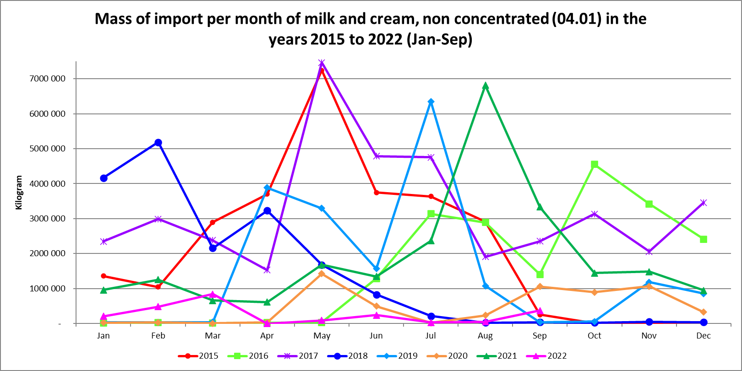
Table 1
Highest and lowest imports per month of milk and cream, non-concentrated (04.01) in the years 2015 to 2022 (Jan – Sep)
 | Highest | Lowest
2015 | May | October
2016 | October | January
2017 | May | April
2018 | February | August
2019 | July | January
2020 | May | March
2021 | August | April
2022 (Jan-Sep) | March | April
- Graphs prepared by the Office of SAMPRO based on information obtained from SARS.

Graph 2
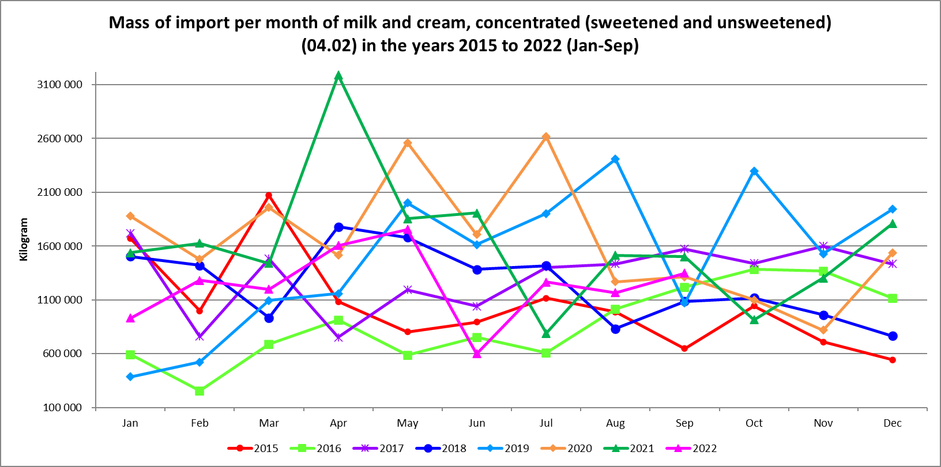

Table 2
Highest and lowest imports per month of milk and cream, concentrated (sweetened and unsweetened) (04.02) in the years 2015 to 2022 (Jan – Sep)

 | Highest | Lowest
2015 | March | December
2016 | October | February
2017 | January | April
2018 | April | December
2019 | August | January
2020 | July | November
2021 | April | July
2022 (Jan-Sep) | May | June
Graph 3
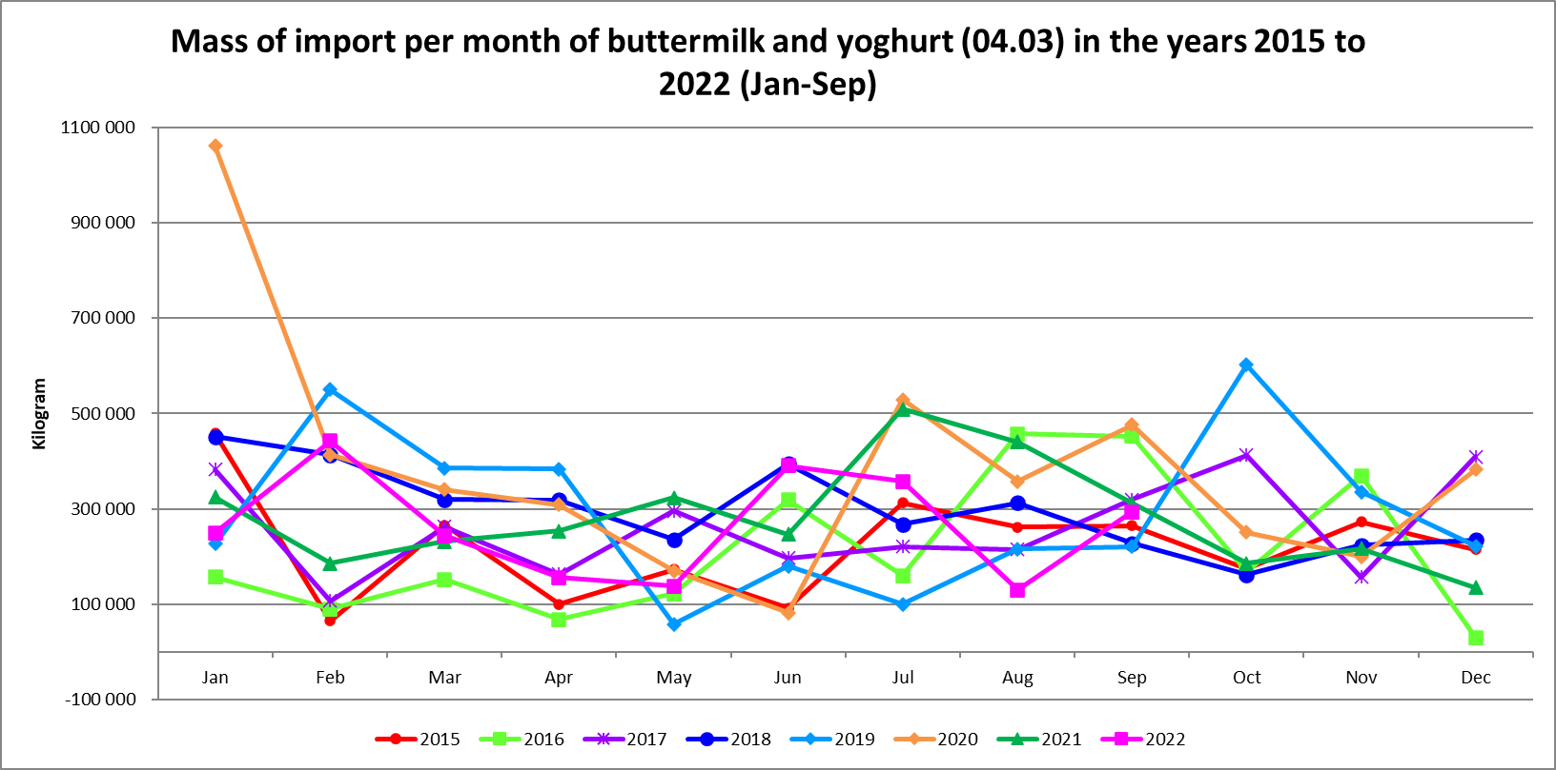

Table 3
Highest and lowest imports per month of buttermilk and yogurt (04.03) in the years 2015 to 2022 (Jan – Sep)

 | Highest | Lowest
2015 | January | February
2016 | August | December
2017 | October | February
2018 | January | October
2019 | October | May
2020 | January | June
2021 | July | December
2022 (Jan-Sep) | February | August
Graph 4
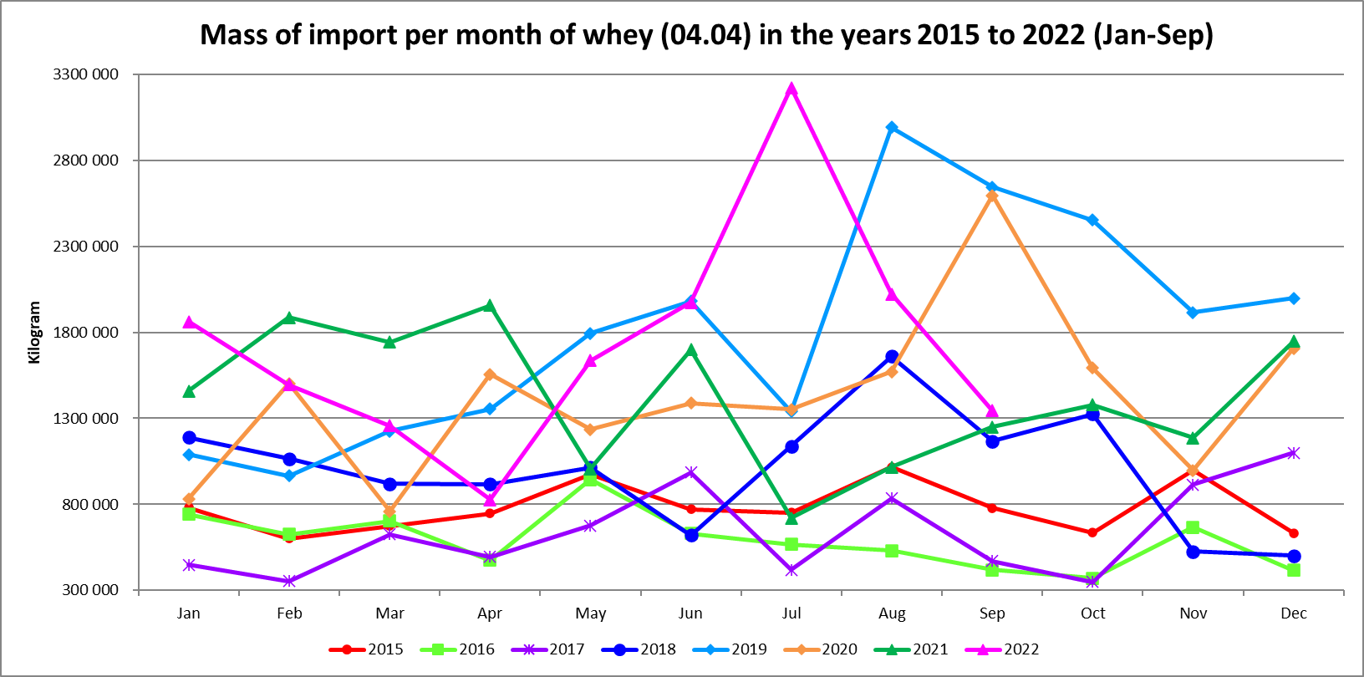

Table 4
Highest and lowest imports per month of whey (04.04) in the years 2015 to 2022 (Jan – Sep)

 | Highest | Lowest
2015 | August | February
2016 | May | October
2017 | December | October
2018 | August | December
2019 | August | February
2020 | September | March
2021 | December | July
2022 (Jan-Sep) | July | April
Graph 5
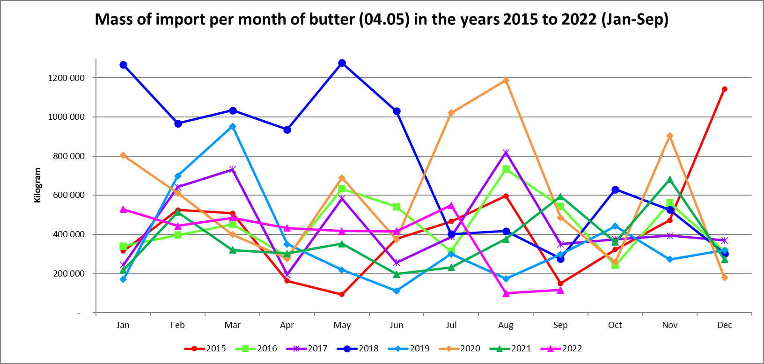

Table 5
Highest and lowest imports per month of butter (04.05) in the years 2015 to 2022 (Jan – Sep)

 | Highest | Lowest
2015 | December | May
2016 | August | October
2017 | August | April
2018 | May | September
2019 | March | June
2020 | August | December
2021 | November | June
2022 (Jan-Sep) | July | August
Graph 6
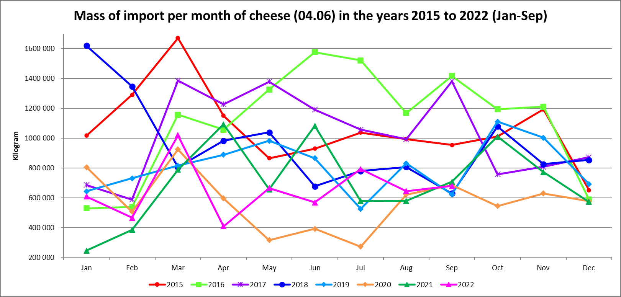

Table 6
Highest and lowest imports per month of cheese (04.06) in the years 2015 to 2022 (Jan – Sep)

 | Highest | Lowest
2015 | March | December
2016 | June | January
2017 | March | February
2018 | January | September
2019 | October | July
2020 | March | July
2021 | April | January
2022 (Jan-Sep) | March | April
Graph 7
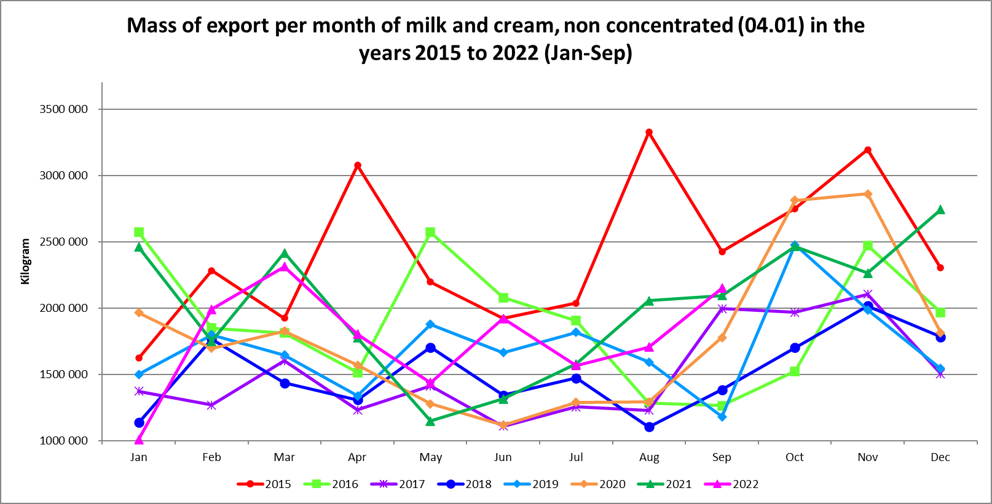

Table 7
Highest and lowest exports per month in terms of mass of milk and cream, non-concentrated (04.01) in the years 2015 to 2022 (Jan – Sep)

 | Highest | Lowest
2015 | August | January
2016 | January | September
2017 | November | June
2018 | November | August
2019 | October | September
2020 | November | June
2021 | December | May
2022 (Jan-Sep) | March | January
Graph 8
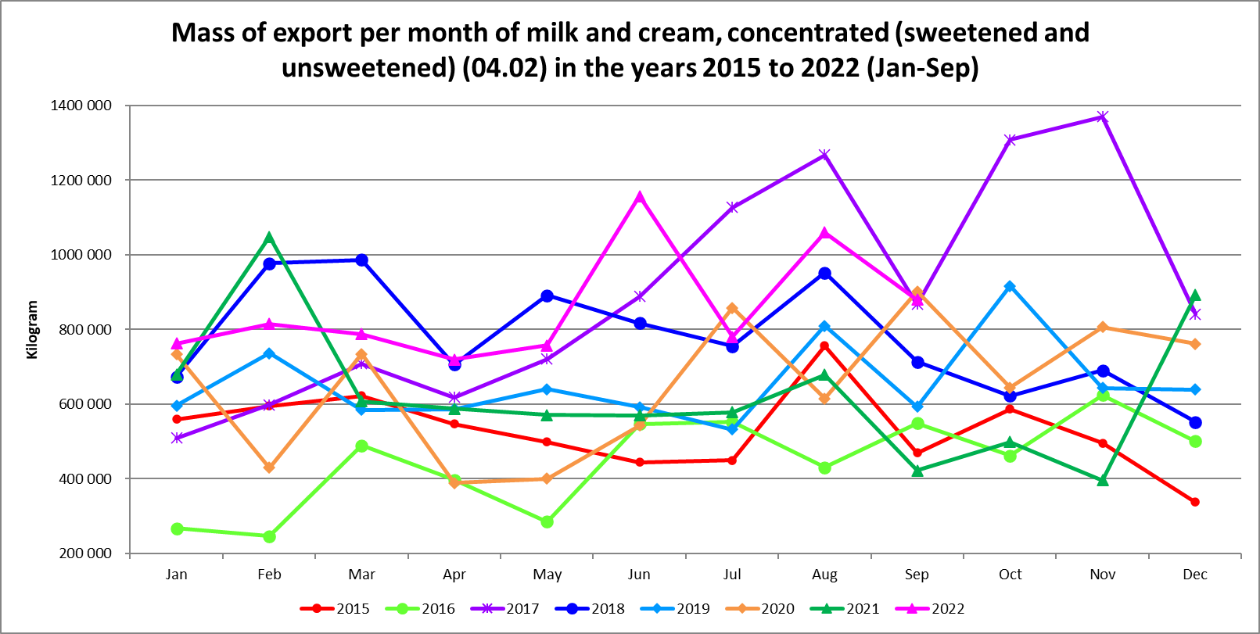

Table 8
Highest and lowest exports per month in terms of mass of milk and cream, concentrated (sweetened and unsweetened) (04.02) in the years 2015 to 2022 (Jan – Sep)

 | Highest | Lowest
2015 | August | December
2016 | November | February
2017 | November | January
2018 | March | December
2019 | October | July
2020 | September | April
2021 | February | November
2022 (Jan-Sep) | June | April
Graph 9
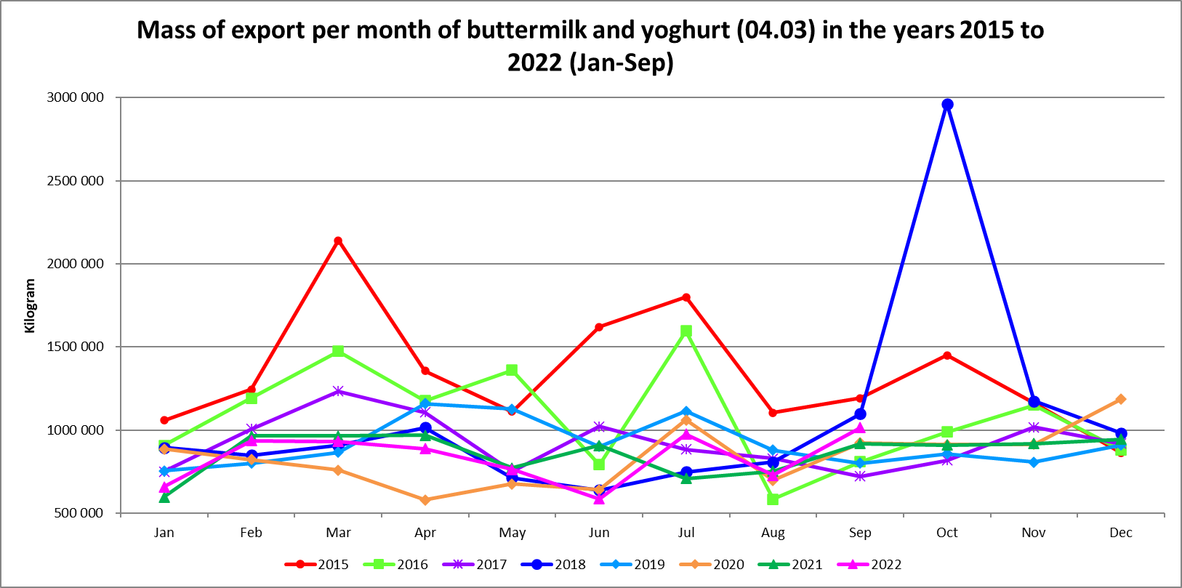

Table 9
Highest and lowest exports per month in terms of mass of buttermilk (04.03) in the years 2015 to 2022 (Jan – Sep)

 | Highest | Lowest
2015 | March | December
2016 | July | August
2017 | March | September
2018 | October | June
2019 | April | January
2020 | December | April
2021 | April | January
2022 (Jan-Sep) | September | June
Graph 10
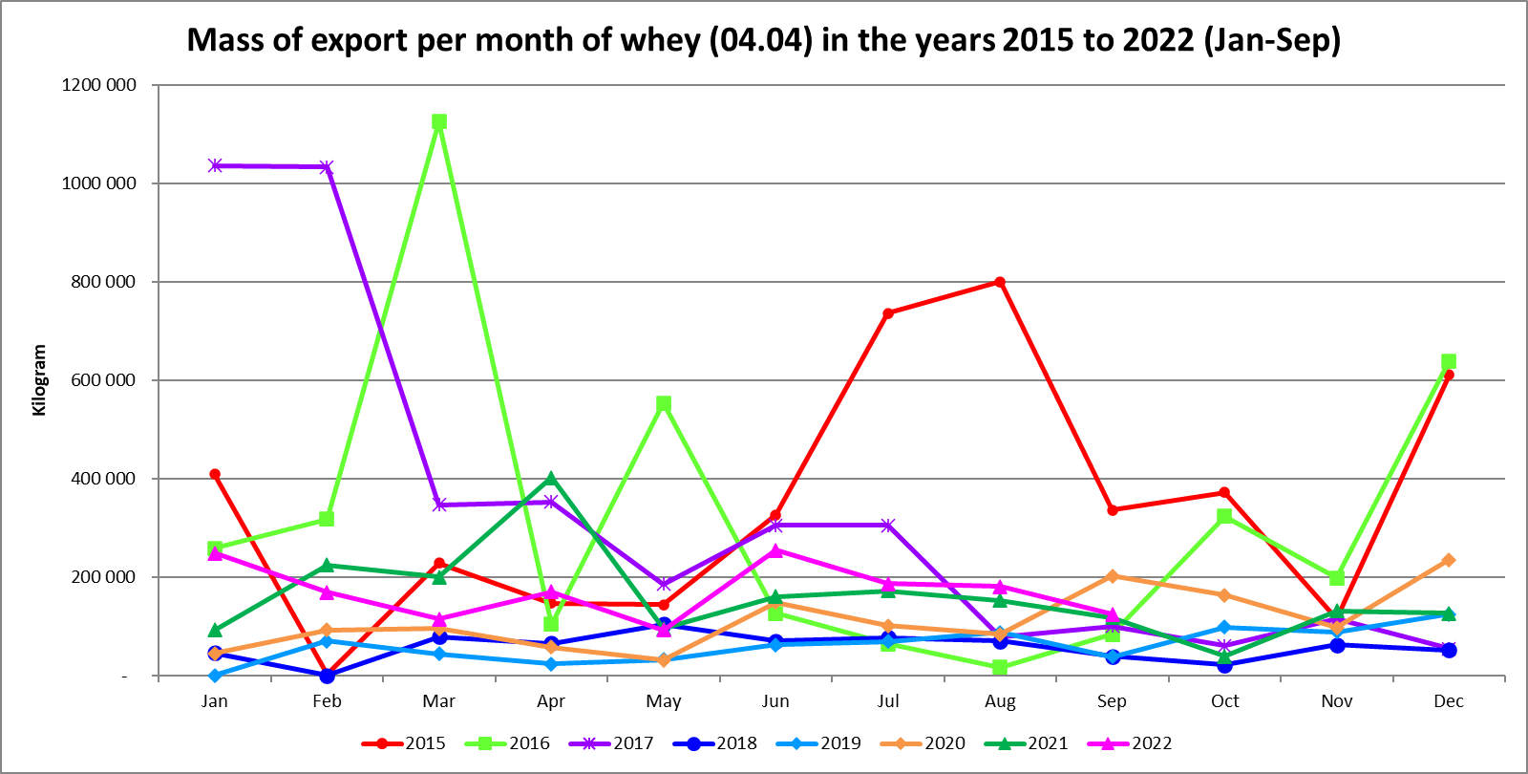

Table 10
Highest and lowest exports per month in terms of mass of whey (04.04) in the years 2015 to 2022 (Jan – Sep)

 | Highest | Lowest
2015 | August | February
2016 | March | August
2017 | January | December
2018 | May | February
2019 | December | January
2020 | December | May
2021 | April | October
2022 (Jan-Sep) | June | May
Graph 11
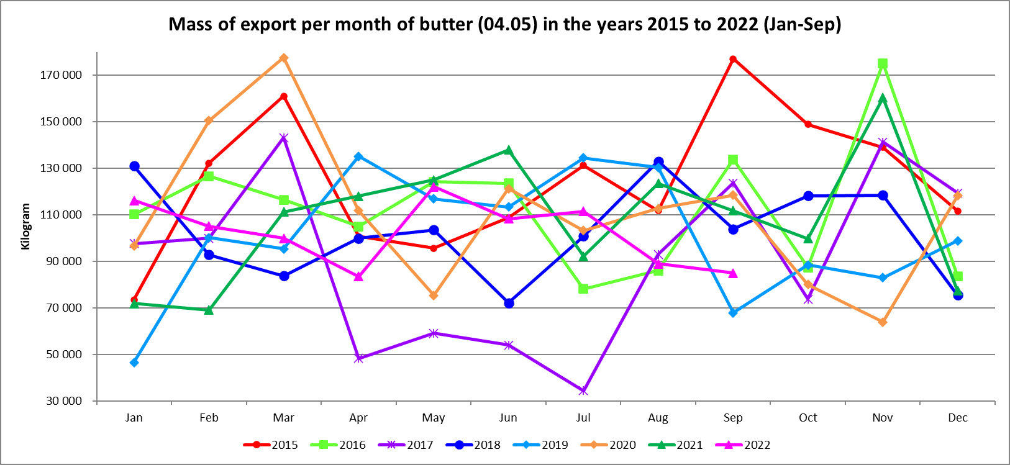

Table 11
Highest and lowest exports per month in terms of mass of butter (04.05) in the years 2015 to 2022 (Jan – Sep)

 | Highest | Lowest
2015 | September | January
2016 | November | July
2017 | March | July
2018 | August | June
2019 | April | January
2020 | March | November
2021 | November | February
2022 (Jan-Sep) | May | April
Graph 12
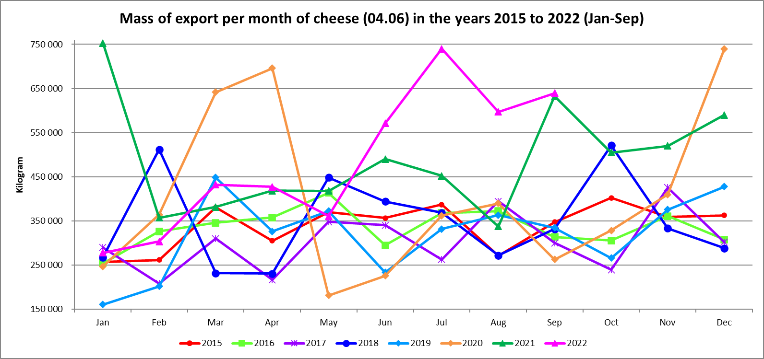

Table 12
Highest and lowest exports per month in terms of mass of cheese (04.06) in the years 2015 to 2022 (Jan – Sep)

 | Highest | Lowest
2015 | October | January
2016 | May | January
2017 | November | February
2018 | October | April
2019 | March | January
2020 | December | May
2021 | January | August
2022 (Jan-Sep) | July | January

