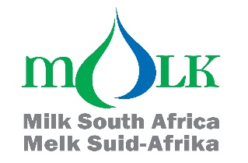

Attention: Milk processors, milk producers and other interested persons

TRENDS OF MONTHLY UNPROCESSED (RAW) MILK PURCHASES IN THE RSA: JAN 2020 TO AUG 2023

The preliminary figure for Aug 2023 shows a 0,57% increase in unprocessed milk purchases versus the amount bought in Aug 2022. The amount of 302 233 058t is the preliminary milk purchase figure for Aug 2023.

The year-to-date figure for Jan-Aug 2023 is 2 046 171 988t, which is 1,40% less than the same period in 2022 and 1.76% less than the same period in 2021.

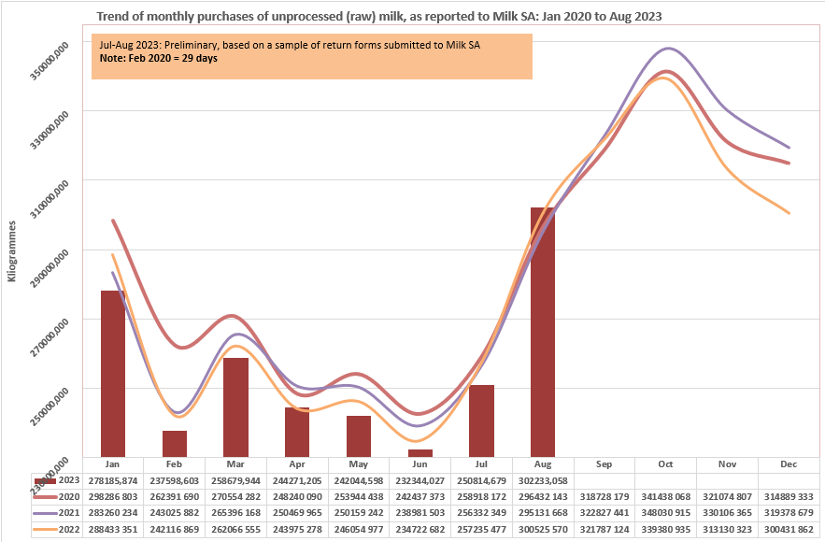

Milk SA takes no responsibility for the accuracy of this information which is intended to provide market signals only, and Milk SA indemnifies itself against any actions based on this information.

- Source: Milk SA Statistics (from monthly return forms submitted to Milk SA by ± 305 role-players).
- Each year's total figures are reviewed in March of the following year.

Yours sincerely
Nico Fouché
CEO: Milk SA
2023.09.19
TT100

