Attention: Milk processors, milk producers and other interested persons

TRENDS OF MONTHLY UNPROCESSED (RAW) MILK PURCHASES IN THE RSA: JAN 2021 TO FEB 2024

The preliminary unprocessed milk purchase figure for Feb 2024 (248 483 t) is 4,24% more than the amount bought in Feb 2023.

The year-to-date figure for Jan-Feb 2024 is 534 072 t, which is 3,18% more than the same period in 2023 and 0,66% more than the same period in 2022.

The FINAL year-to-date figure for Jan-Dec 2023 is 3 339 272 t, which is 0,32% less than the same period in 2022 and 1,88% less than the same period in 2021.

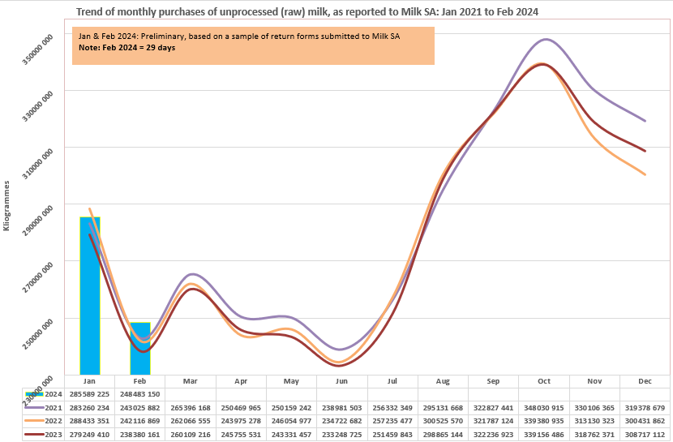

Milk SA takes no responsibility for the accuracy of this information which is intended to provide market signals only, and Milk SA indemnifies itself against any actions based on this information.

- Source: Milk SA Statistics (from monthly return forms submitted to Milk SA by ± 305 role-players).
- Each year's total figures are reviewed in March of the following year.

Yours sincerely
Nico Fouché
CEO: Milk SA
2024.02.19
TT114

