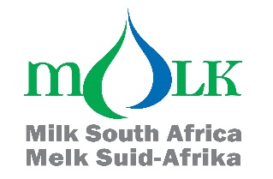

Attention: Milk processors, milk producers and other interested persons

TRENDS OF MONTHLY UNPROCESSED (RAW) MILK PURCHASES IN THE RSA: JAN 2021 TO MAY 2024

The preliminary unprocessed milk purchase figure for May 2024 (264 919 t) is 8,87 % more than the amount bought in May 2023.

The year-to-date figure for Jan-May 2024 is 1 317 220t, which is 3,98% more than the same period in 2023 and 2,90% more than the same period in 2022.

The FINAL year-to-date figure for Jan-Dec 2023 is 3 339 272 t, which is 0,32% less than the same period in 2022 and 1,88% less than the same period in 2021.

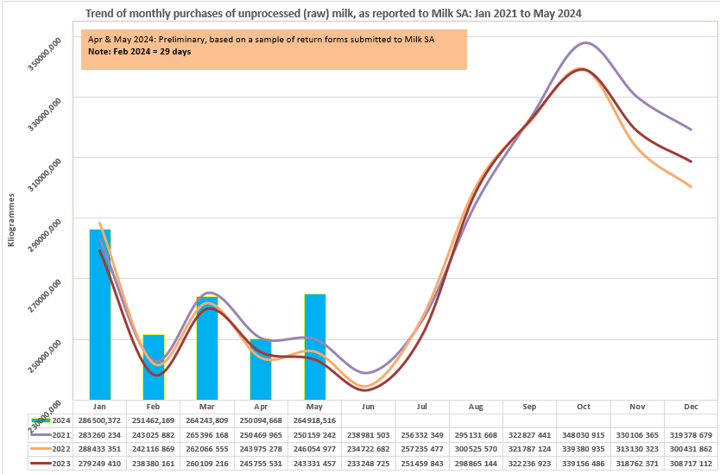

Milk SA takes no responsibility for the accuracy of this information which is intended to provide market signals only, and Milk SA indemnifies itself against any actions based on this information.

- Source: Milk SA Statistics (from monthly return forms submitted to Milk SA by ± 305 role-players).
- Each year's total figures are reviewed in March of the following year.

Yours sincerely
Nico Fouché
CEO: Milk SA
2024.06.21
TT124

