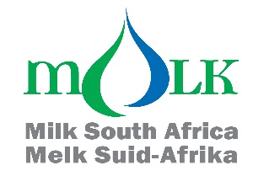

Attention: Milk processors, milk producers and other interested persons

TRENDS OF MONTHLY UNPROCESSED (RAW) MILK PURCHASES IN THE RSA: JAN 2022 TO OCT 2025

The preliminary unprocessed milk purchase figure for Oct 2025 (357 701 t) is 1.55% more than the amount bought in Oct 2024.

The year-to-date figure for Jan-Oct 2025 is 2 831 380 t, which is 1,10% more than the same period in 2024 and 4,41% more than the same period in 2023.

The FINAL year-to-date figure for Jan-Dec 2024 is 3 458 060 t, which is 3,56% more than the same period in 2023 and 3.23% more than the same period in 2022.

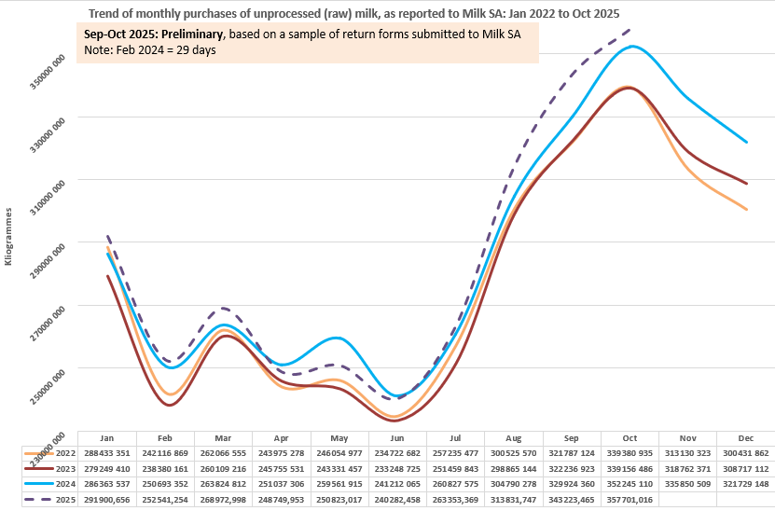

Milk SA takes no responsibility for the accuracy of this information which is intended to provide market signals only, and Milk SA indemnifies itself against any actions based on this information.

- Source: Milk SA Statistics (from monthly return forms submitted to Milk SA).
- Each year's total figures are reviewed in March of the following year.

Yours sincerely
Nico Fouché
CEO: Milk SA
2025.11.20
TT179

