CHIEF EXECUTIVE OFFICER’S REPORT FOR THE FINANCIAL YEAR 2015
TO THE MEMBERS OF MILK SOUTH AFRICA
AT THEIR ANNUAL GENERAL MEETING OF 2 JUNE 2016

1. Introduction

The CEO's role includes being ultimately responsible for the day-to-day management decisions and for implementing the Company's long and short term plans.

The Office of Milk SA remained efficient and focused on its main duty, namely the administration of the statutory measures and general administration of the Company's business.

Milk SA continued to provide an excellent platform for its members, the MPO and SAMPRO, as well as other stakeholders to collaborate on issues that drives the South African dairy industry.

I can confidently report that the Company's two members, SAMPRO and the MPO, as well as everyone else related to Milk SA's business, played a significant role in promoting the strategic direction of the Company namely to broaden the market for dairy products, to promote the competitiveness of the South African dairy industry and to empower the previously disadvantaged community.

2. Statutory Measures

In terms of the Marketing of Agricultural Products Act, 1996, (Act No. 47 of 1996) the Minister of Agriculture, Forestry and Fisheries entrusted the implementation, administration and enforcement of the following statutory measures to Milk SA, as published on 20 December 2013:

i. | Notice 1218 | Registration of persons involved in the secondary dairy industry.
ii. | Notice 1219 | Records and returns in respect of milk and other dairy products.
iii. | Notice 1220 | Levies on milk and other dairy products.

These statutory measures will lapse on 31 December 2017.

The Office and the Board of Directors of Milk SA did everything in their power and employed all statutory and other measures at their disposal - within the budgetary, resource and other constraints - to ensure optimal compliance with regard to levy payments and other statutory obligations.

3. Annual movement in the number of registered persons in the three registration categories

In December 2015, the number of milk buyers / processors comprised 40,4% of the total number of persons / institutions that are registered with Milk SA, followed by importers of dairy products (29,9%) and producer-distributors (29,7%).

Contributions to the levies by category were as follows in 2015: Milk buyers / processors (88,4%), importers of dairy products (10,5%) and producer-distributors (1,1%).

Milk buyers / processors contributed 98,75% and producer-distributors 1,25% to the total milk declared to Milk SA.

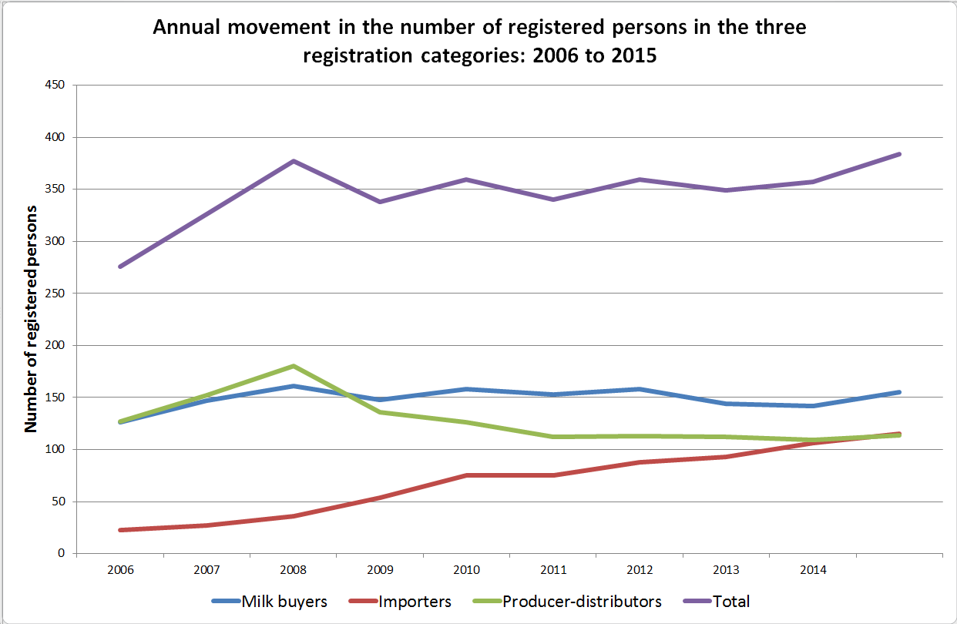

Number of registered persons: 2006 to 2015
 |  | Buyers | Importers | Producer-Distributors | Total
December | 2006 | 126 | 23 | 127 | 276
 | 2007 | 147 | 27 | 152 | 326
 | 2008 | 161 | 36 | 180 | 377
 | 2009 | 148 | 54 | 136 | 338
 | 2010 | 158 | 75 | 126 | 359
 | 2011 | 153 | 75 | 112 | 340
 | 2012 | 158 | 88 | 113 | 359
 | 2013 | 144 | 93 | 112 | 349
 | 2014 | 142 | 106 | 109 | 357
 | 2015 | 155 | 115 | 114 | 384

4. Levy budget and income, 2006 to 2015

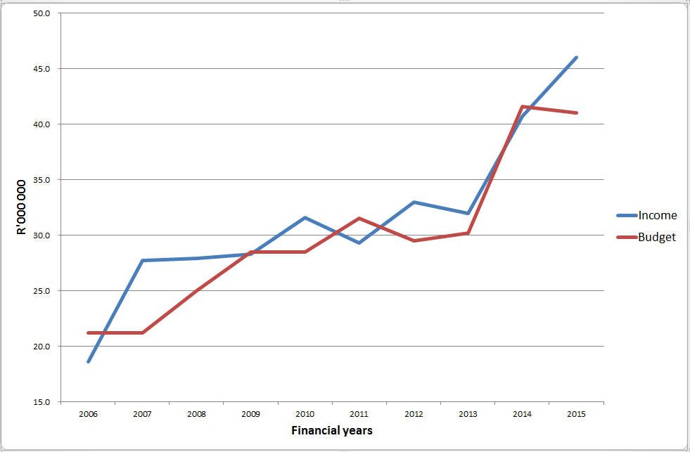

2006 to 2013: Levy rate = 1,0 cent / kg of milk
2014 to 2015: Levy rate = 1,3 cent / kg of milk

5. Percentage contribution of the categories of levy payers to the income in 2008, 2010, 2012, 2014 and 2015

 | 2008 | 2010 | 2012 | 2014 | 2015
Milk buyers | 92 | 91 | 87 | 91 | 88
Importers | 6 | 7 | 12 | 8 | 11
Producer-distributors | 2 | 2 | 1 | 1 | 1

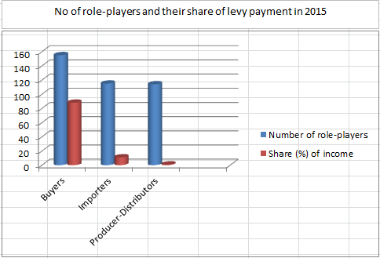

6. The web-based information system

The web-based system continued to contribute to successful administration in terms of:

- Capturing and processing of data relating to registrations, returns and levy payments.
- Management reports in respect of the above for the office, attorneys and accountants.
- Submission of project proposals and reports by applicants / project leaders.
- Hosting of project reports, financial and other information relating to Milk SA and its activities for access by different role-players and the public.
- Access by the levy payers, of statutory information submitted to Milk SA and of their invoices.
- A contact system of all industry and other role-players.

7. Inspections in terms of Section 21 of the Marketing of Agricultural Products Act, 1996
(Act No. 47 of 1996)

On request of Milk SA, the Minister of Agriculture appointed two inspectors for the current period of the statutory measures, namely Mr Wicus van der Merwe and Mr Jones Ditsela.

Objectives of the Inspections

i. The main objective of the inspections is to establish and report on compliance of role-players with the statutory requirements, which have significant implications for the income and accuracy of industry information.

ii. Secondary objectives are to advise and guide role-players regarding their statutory responsibilities as well as to fulfil a public relations role for Milk SA.

Procedures

- Inspections were based on normal audit principles in terms of testing on a sample basis and obtaining appropriate supporting documentation where applicable.

Scope of physical inspections during 2015

Eleven role-players were visited during 2015 in the following provinces:

- North-west province 1 milk processor.
- KwaZulu-Natal 8 milk processors.
- Western Cape 2 milk processors.

Communication of the inspection findings

i. Problems identified during the inspections were pointed out to the Board of Directors in a summary report, and letters with detailed findings and suggested corrective measures were sent to each individual role player.

ii. Matters with a potential impact on statistical data and levy income of Milk South Africa were highlighted in a report to the Board of Directors.

Observations

i. In general the majority of the role-players comply with the requirements of the Act, in that they keep adequate records of imports of dairy products, milk purchases as well as records to differentiate between milk used for concentrated products and milk used for other purposes.

ii. Role-players did not in all cases take heed of the changes in the statutory measures that came into effect on 1 January 2014.

Follow-up procedures

i. Letters were written to each role-player under the signatures of the Inspector and the CEO of Milk South Africa, wherein detailed findings were communicated and required follow-up action explained.

ii. In certain cases, agreements were reached with the role-players in terms of which they would revisit their records to find the relevant data for completion of revised returns.

iii. A control schedule was drawn up in order for Milk SA to be able to follow up and keep track of outstanding matters with the relevant role-players.

iv. Where significant problems were identified, role-players were scheduled for second audits in order to ensure that appropriate corrections were implemented.

v. Inspection procedures were carried out electronically in respect of eight milk processors in the Western Cape province.

Conclusion

i. In general, role-players complied with the requirements of the statutory measures, as amended from the previous (2010 to 2013) regulations - by keeping adequate records of milk purchases and production as well as processing thereof.

ii. However, the inspector found that most of the role-players visited, did not implement the changes required by the statutory measures that were enforced since January 2014.

iii. As a result of the findings mentioned under ii above, many revised monthly returns had to be submitted, which placed an additional burden on the resources of the Office of Milk SA.

iv. Although monetary adjustments needed to be made - to the benefit and expense of both Milk SA and the role-players - the net effect of the adjustments was to the advantage of Milk SA.

v. The guideline document on the interpretation of the new statutory measures that was drafted by the Office of Milk SA in conjunction with the Inspector, was disseminated to all role-players again.

8. Processing of unprocessed (raw) milk into concentrated and other products: 2006 to 2015

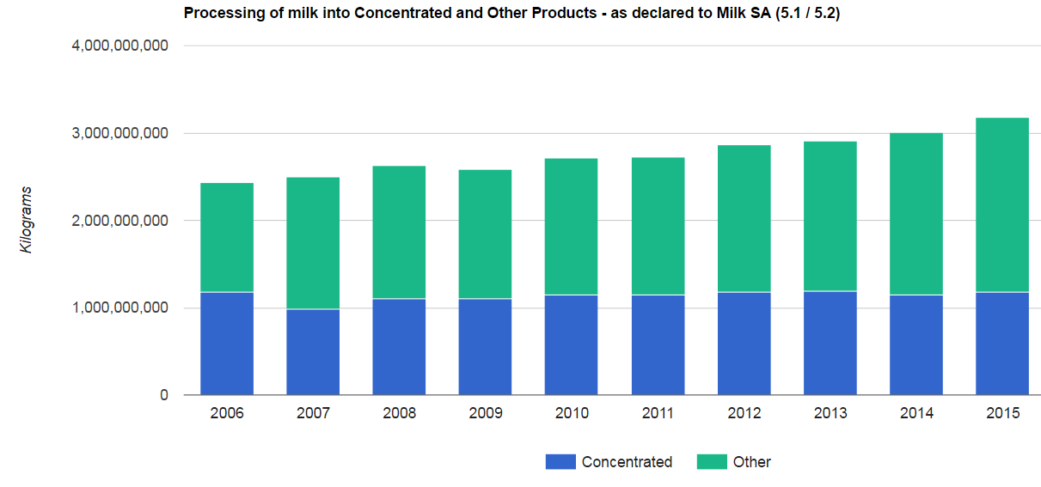

 | 2006 | 2007 | 2008 | 2009 | 2010 | 2011 | 2012 | 2013 | 2014 | 2015
Concentrated % | 48.4 | 39.4 | 41.9 | 42.6 | 42.3 | 41.9 | 41.6 | 41.9 | 40.0 | 37.0
Other % | 51.6 | 60.6 | 58.1 | 57.4 | 57.7 | 58.1 | 58.4 | 58.1 | 60.0 | 63.0

9. Imports of product categories, 2006 to 2015 as reported to Milk SA
(Milk equivalent: kilogrammes)

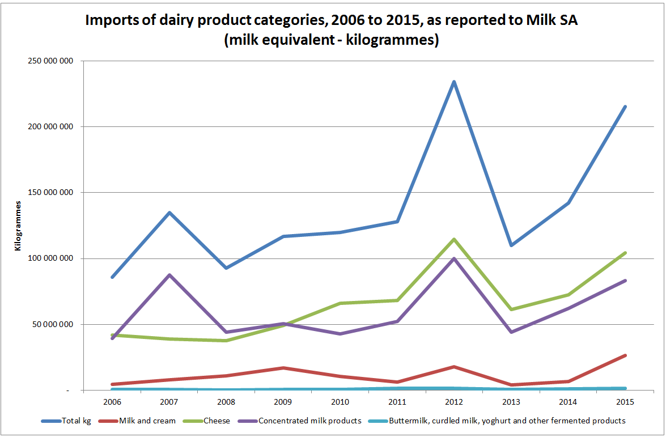

10. Milk equivalent of imported products, 2006 to 2015 ('000 kg)

2006 | 2007 | 2008 | 2009 | 2010 | 2011 | 2012 | 2013 | 2014 | 2015
85 924 | 135 073 | 92 821 | 116 601 | 119 922 | 127 896 | 234 108 | 109 758 | 142 143 | 215 274

11. Imports per category in 2015 (Kilogrammes: not milk equivalent)

 | Kilogrammes reported to Milk SA in 2015
0401 Milk & Cream, not concentrated … | 26 498 694
0402 Milk & Cream, concentrated … | 9 233 304
0403 Buttermilk, curdled milk, yoghurt … | 1 295 961
0404 Whey | 7 773 551
0405 Butter | 7 782 117
0406 Cheese | 10 437 979

12. Administration of the projects of Milk South Africa

The content of the projects of Milk South Africa are subject to the requirements of the objectives of the statutory measures and the strategic direction as decided by the Members of Milk SA, and they are also aligned with the relevant government legislation and initiatives of government institutions and other external institutions.

The strategic direction of Milk SA was defined to promote the broadening of the market for milk and other dairy products, to improve the competitiveness of the South African dairy industry and to promote transformation in the South African dairy industry.

Milk SA signed contracts with the project managers in accordance with Milk SA's policy on the funding of statutory projects. Quarterly and annual reports for each project were submitted by the project managers.

The relevant structures including the Work Groups, Advisory Committees, Audit & Risk Committee, Executive Committee and Board of Directors fulfilled their roles to ensure that the projects were well structured and monitored and that their goals are optimally achieved.

The Board continued to employ an internal auditor to provide independent and objective advice in order to improve Milk South Africa's performance in respect of its administrative and project outputs. During 2015, internal audit reports were issued to the Board of Directors on the following:

i. Procurement by the Office of Milk SA.

ii. Follow-up on the previous audit findings regarding Administration of the Statutory Measures.

iii. Dairy Quality and Safety projects, as performed by the Dairy Standard Agency.

Actual expenditure of the statutory levies on the six disciplines vs the guideline percentages, during 2014 to 2015

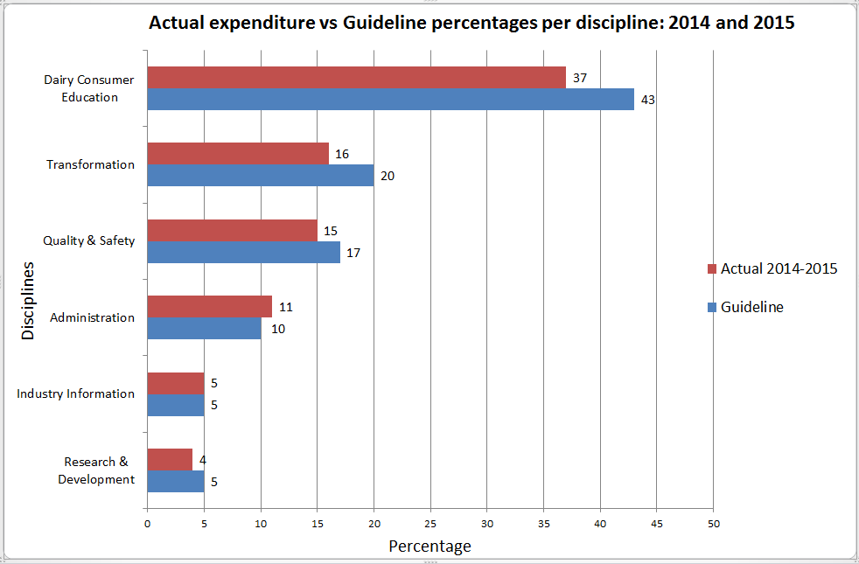

i. The aim is that each discipline should meet the guidelines within the four-year period of 2014 to 2017. A management tool to this effect is monitored by the CEO and the Board.

ii. Variations of especially milk purchases, as declared to Milk SA, influence the achieved percentages. The extraordinary high milk volumes in the 2015 financial year had a significant effect on the levy income and percentage expenditure per discipline.

iii. The Board policy to use the levies on an inflationary basis during the four years, should also be taken into account.

iv. Up to 31 December 2015, 88% of the levy income for the two years (2014 and 2015) had been utilized.

v. The guideline percentages are not equal to or linked with budget amounts: Guideline percentages (for the disciplines) in monetary terms depend on the levy income, while the budgets are fixed amounts.

13. Office structure of Milk South Africa and external support structure

Board of Directors

External Support Structure
- Attorneys: Gildenhuys Malatji & MacRobert
- Web-based systems support: Octoplus
- Accountants: PricewaterhouseCoopers
- Internal Auditor: Medupe
- External Auditors: Fourie & Botha
Solid lines: Line authority
Dash lines: Administrative authority
Secretary to the Transformation Manager
June Mngadi
Office Support Assistant
Matilda Wistebaar
Jnr Administration Assistant
Vincent Mafate
Snr Administration Officer
Lucua du Preez
Personal Assistant
Nicolette Teichmann
Chief Executive Officer
Nico Fouché
Transformation Manager
Godfrey Rathogwa

14. Functional structure of Milk South Africa

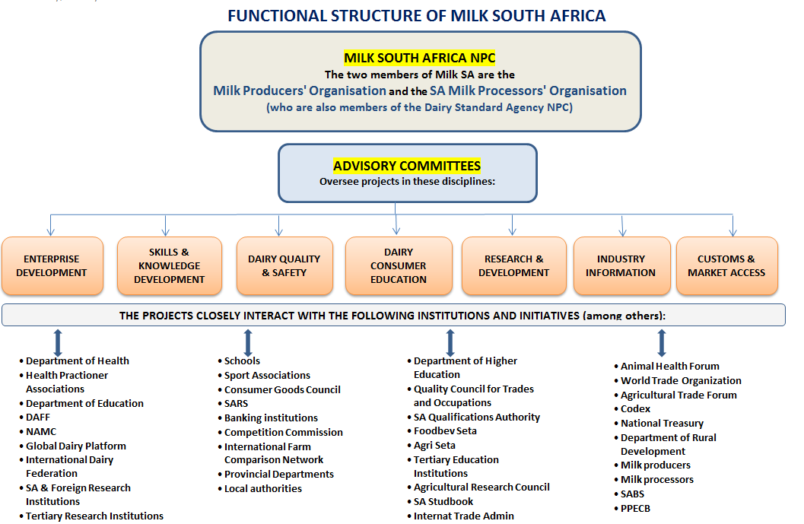

The above structure clearly shows that:

i. The primary and secondary industry sectors (represented by the MPO and SAMPRO respectively) are united in Milk South Africa as well as in the Dairy Standard Agency, in terms of the objectives that they commonly pursue in the interests of the entire South African dairy industry and community.

ii. The strategic direction of Milk SA requires a multi-disciplined approach.

iii. The multi-disciplined approach enabled Milk SA to unlock a wealth of support and co-operation from governmental, semi-governmental and private business sources.

iv. In respect of the South African dairy industry, collective issues of strategic importance exists which -

a. cannot be addressed through competition in the market;

b. should be addressed in the interests of the South African dairy industry, the consumer, and economic development, and

c. can, in terms of the Competition Act, be addressed by collective action by the members of the dairy industry.

15. Contractors in 2015

i | PricewaterhouseCoopers Inc | Accountants.
ii | Octoplus (Pty) Ltd | Web-based system support and enhancement.
iii | Internet Solutions (Dimension Data) | Web-based systems hosting & security.
iv | Fourie & Botha Inc | External Accountants (i.t.o. Companies Act).
v | Gildenhuys Malatji Inc | Attorneys.
vi | MacRobert Inc | Attorneys.
vii | Medupe (Pty) Ltd | Internal Auditor.
viii | Milk Producers’ Organization (NPC) | Projects:  - Industry Information.  - Empowerment of previously disadvantaged individuals in the primary dairy sector, through training and skills development.  - Mentoring emerging dairy farmers (Elim).  - Dairy Occupational Qualification.
ix | SA Milk Processors’ Organization | Projects:  - Dairy Consumer Education.  - Skills development (training).
x | Dairy Standard Agency NPC | Project: Improvement of dairy quality & safety.
xi | University of Pretoria (Onderstepoort) | Projects:  - Fasciola hepatica: Impact on dairy production and sustainable management on selected farms in South Africa.  - Resistance to available antibiotics in lactating cows with mastitis.
xii | University of KwaZulu-Natal | Investigating alternative methods such as bacteriophages and bacteriocins to control mastitis organisms.
xiii | Veterinary Network (Pty) Ltd | Project: National disease monitoring and extension system for the South African dairy industry.
xiv | Dr HH Meissner (Programme Manager: Research & Development: Milk SA) | Project: Co-ordination, support and promotion of needs-driven R&D in the South African Dairy Industry.
xv | SA National Committee of the IDF | Participation in the projects and activities of the International Dairy Federation (IDF) through the SA National Committee of the IDF.

16. Communication & Liaison

16.1 Milk Essay was launched in 2010 as a quarterly publication, while the website continued to be updated with project reports, minutes, industry statistics, news and other information.

16.2 The Office of Milk SA and its Project Managers liaised with the ARC, Department of Agriculture, Provincial Departments, Department of Health, Department of Trade and Industry, NAMC and other government and non-governmental institutions on a variety of issues which are in the interests of the dairy industry as a whole. Detailed information in this regard appears in the annual and quarterly project reports.

16.3 The communication policy of Milk SA was reviewed during the financial year, ensuring that the persons who pay the statutory levies and the other target groups have access to the relevant information that should be of value to them.

16.4 The website of Milk SA was regularly updated with the relevant reports and other information, also in the form of "podcast" videos, covering the various disciplines of Milk SA.

17. Corporate Governance

Good Corporate Governance is central to the success of Milk South Africa. The increased administrative responsibilities and the scope and depth of the projects, urged the need for new and refined policies, procedures and systems. The corporate governance instruments are listed below.

i. | Corporate Governance & Directors' Duties
ii. | Directors' Disclosure of Interest Policy and Policy for handling of conflicts of interests
iii. | House rules for the Board of Directors
iv. | Duties of Directors (to be signed by directors)
v. | Role and Responsibilities of the Vice-Chairperson
vi. | Board meeting procedures
vii. | Charter for the Board of Directors
viii. | Charter for the Members of Milk South Africa
ix. | Chart of Authority - CEO
x. | Financial Policy of Milk South Africa
xi. | Depreciation & Maintenance of Assets Policy
xii. | Policy for the financing of statutory projects of Milk South Africa
xiii. | Policy for the monitoring of statutory projects to ensure effective use of statutory funds
xiv. | Dispute resolution procedure in respect of contractual agreements between Milk SA and Service providers i.t.o. the statutory measures
xv. | Standard Agreement between Milk SA and Contractor (for projects)
xvi. | Policy for Advisory Committees of Milk SA
xvii. | Human Resources Policy
xviii. | Human Resources Committee: Terms of Reference
xix. | Audit & Risk Committee: Terms of Reference
xx. | Terms of Reference for each Advisory Committee of Milk SA
xxi. | Executive Committee: Terms of Reference
xxii. | Policy and Procedures for the Administration of the statutory measures administrated by Milk South Africa
xxiii. | Memorandum of Incorporation of Milk South Africa NPC

