CHIEF EXECUTIVE OFFICER’S REPORT FOR THE FINANCIAL YEAR 2016
TO THE MEMBERS OF MILK SOUTH AFRICA
AT THEIR ANNUAL GENERAL MEETING OF 31 MAY 2016

1. Introduction

As generally expected, Milk SA recorded 0,45% less unprocessed milk during 2016 than the prior year, as 2015 saw an unusual increase of 6,37 against 2014. The average increase for the twelve years (2005 to 2016) is 3,0%. Coupled with a continued positive demand for the majority of dairy product categories relative to non-dairy food products (as measured by the Nielsen company), it reflects a healthy dairy industry.

In order to allow the Office of Milk SA more efficient focus on the administration of the statutory measures, the Board has implemented a number of structural changes in Milk SA:

- The Customs and Market Access function was established as a project of Milk SA under a Management Committee and a Project Manager.
- The administration of the Research & Development Programme has been transferred from the Office of Milk SA to the Milk Producers' Organisation, and a Management Committee was formed.
- A Statutory Measures Committee was established to support the Office with the implementation, administration and enforcement of statutory measures.

2. Statutory Measures

In terms of the Marketing of Agricultural Products Act, 1996, (Act No. 47 of 1996) the Minister of Agriculture, Forestry and Fisheries entrusted the implementation, administration and enforcement of the following statutory measures to Milk SA, as published on 20 December 2013 for a period of four years:

Notice 1218 | Registration of persons involved in the secondary dairy industry.
Notice 1219 | Records and returns in respect of milk and other dairy products.
Notice 1220 | Levies on milk and other dairy products.

The Office and the Board of Directors of Milk SA employed all statutory powers and other means at their disposal - within the budgetary, resource and other constraints - to ensure optimal compliance with regard to levy payments and other statutory obligations.

The persons who are subject to these statutory measures are:

a. Persons who buy unprocessed milk for the purpose of processing it or to use it to manufacture other products, or to sell it to persons outside the jurisdiction of the Republic of South Africa, or to move it outside the jurisdiction of the Republic of South Africa;

b. Persons who import milk and other dairy products classifiable under customs tariff headings 04.01, 04.02, 04.03, 04.04, 04.05 and 04.06.

c. Persons who are milk producers and who process the raw milk produced by them, or to use it to manufacture other products, or who sell it to persons located outside the jurisdiction of the Republic of South Africa, or who move it outside the jurisdiction of the Republic of South Africa; and

d. Persons who sell unprocessed milk to retailers.

The above persons are compelled to register with Milk SA, submit information per monthly return form and pay levies to Milk SA which were determined at the following rates:

Customs Tariff  Classification | Product description | Levy per kilogramme  (VAT exclusive)
04.01 | Milk and cream, not concentrated nor containing added sugar or other sweetening matter. | 1,3
04.02 | Milk and cream, concentrated or containing added sugar or other sweetening matter. | 12,5
04.03 | Buttermilk, curdled milk and cream, yogurt, kephir and other fermented or acidified milk and cream, whether or not concentrated or containing added sugar or other sweetening or flavouring matter or containing added fruits, nuts or cocoa. | 4,7
04.04 | Whey, whether or not concentrated or containing added sugar or other sweetening matter; Products consisting of natural milk constituents, whether or not containing added sugar or other sweetening matter, not elsewhere specified or included. | 3,8
04.05 | Butter or other fats and oils derived from milk; dairy spreads. | 13,4
04.06 | Cheese and curd. | 18,7

The contributions of the Ministerially appointed inspector continued to contribute immensely to the integrity of industry information and the optimal collection of levy funds.

Interest on late payments, legal action and support from especially the newly formed Statutory Measures Committee also played meaningful roles in this regard.

An annual report on the administration of the statutory measures was tabled to the National Agricultural Market Council.

The MPO joined SAMPRO in the application for the continuation and amendment of the above regulations for the period 2018 to 2021, and the Office has submitted relevant input for their consideration.

3. Annual movement in the number of registered persons in the three registration categories

In December 2016, the number of processors comprised 39,0% of the total number of persons / institutions that are registered with Milk SA, followed by importers of dairy products (32,4%) and milk producers (28,6%).

Contributions to the levies by category were as follows in 2016: Milk processors (87,72%), importers of dairy products (10,19%) and milk producers (2,10%).

Milk processors contributed 97,67% and milk producers 2,33% to the total unprocessed milk declared to Milk SA.

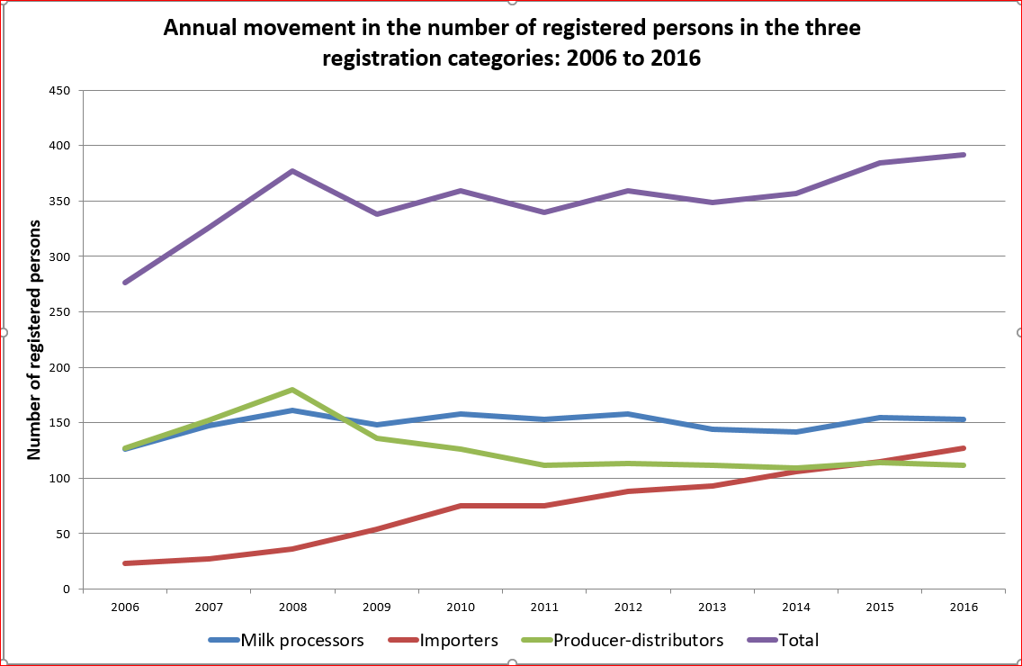

Number of registered persons: 2006 to 2016
 | Processors | Importers | Milk producers | Total
2006 | 126 | 23 | 127 | 276
2007 | 147 | 27 | 152 | 326
2008 | 161 | 36 | 180 | 377
2009 | 148 | 54 | 136 | 338
2010 | 158 | 75 | 126 | 359
2011 | 153 | 75 | 112 | 340
2012 | 158 | 88 | 113 | 359
2013 | 144 | 93 | 112 | 349
2014 | 142 | 106 | 109 | 357
2015 | 155 | 115 | 114 | 384
2016 | 153 | 127 | 112 | 392

4. Levy budget and income, 2006 to 2016

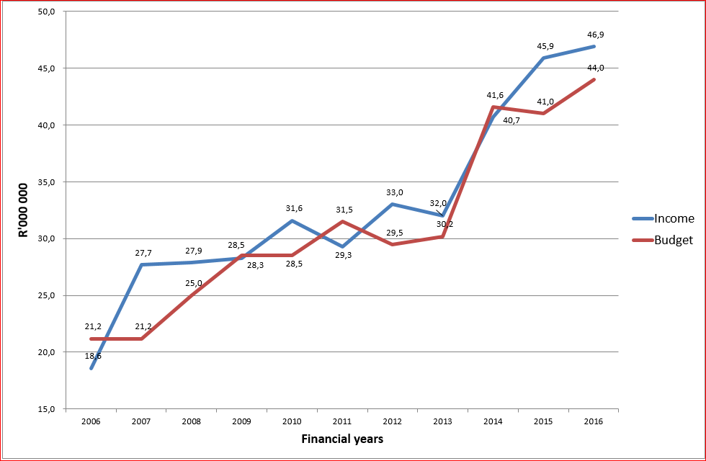

2006 to 2013: Levy rate = 1,0 cent / kg of milk
2014 to 2016: Levy rate = 1,3 cent / kg of milk

5. Percentage contribution of the numbers of levy payers to the income in 2008, 2010, 2012, 2014 and 2016, per category

 | 2008 | 2010 | 2012 | 2014 | 2016
Milk buyers | 92 | 91 | 87 | 91 | 88
Importers | 6 | 7 | 12 | 8 | 10
Milk producers | 2 | 2 | 1 | 1 | 2

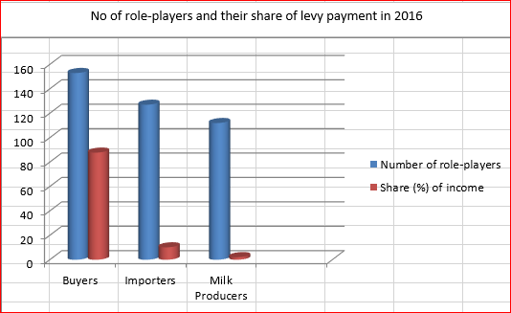

6. The web-based information system

The web-based system continued to contribute to successful administration in terms of:

- Capturing and processing of data relating to registrations, returns and levy payments.
- Management reports in respect of the above for the office, attorneys and accountants.
- Submission of project proposals and reports by applicants / project leaders.
- Hosting of project reports, financial and other information relating to Milk SA and its activities for access by different role-players and the public.
- Access by the levy payers, of statutory information submitted to Milk SA and of their invoices.
- A contact system of all industry and other role-players.

7. Inspections in terms of Section 21 of the Marketing of Agricultural Products Act, 1996
(Act No. 47 of 1996)

Inspectors

On request of Milk SA, the Minister of Agriculture appointed two inspectors for the current period of the statutory measures (2014 to 2017), namely Mr Wicus van der Merwe and Mr Jones Ditsela.

Purpose

On-site inspections among registered role-players aims to eliminate discrepancies regarding actual and obliged declarations to Milk SA, in terms of due levy amounts and information as required by the statutory measures.

Procedures

Inspections are based on normal audit principles in terms of testing on a sample basis and obtaining appropriate supporting documentation where applicable.

Scope of physical inspections during 2016

Eighteen role-players were visited in the following provinces:

- North-west province 3 milk producers
- Mpumalanga 2 milk producers and 1 milk processor
- KwaZulu-Natal 1 milk producer
- Western Cape 1 milk producer and 4 milk processors
- Free State 1 milk producer and 3 milk processors
- Limpopo 2 milk processors

Communication of the inspection findings

i. Problems identified during the inspections were pointed out to the Board of Directors in a summary report, and letters with detailed findings and suggested corrective measures were sent to each individual role player.

ii. Matters with a potential impact on statistical data and levy income of Milk South Africa were highlighted in a report to the Board of Directors.

Observations

The majority of role-players comply with the requirements of the statutory measures, while administrative negligence was the main reason for non-compliance in most of the relevant cases.

Follow-up procedures

i. Letters were written to each role-player under the signatures of the Inspector and the CEO of Milk South Africa, wherein detailed findings were communicated and required follow-up action explained.

ii. In certain cases, agreements were reached with the role-players in terms of which they would revisit their records to find the relevant data for completion of revised returns.

iii. A control schedule was drawn up in order for Milk SA to be able to follow up and keep track of outstanding matters with the relevant role-players.

iv. Where significant problems were identified, role-players were scheduled for second audits in order to ensure that appropriate corrections were implemented.

Conclusions

i. In general, role-players complied with the requirements of the statutory measures (2014 to 2017), as amended from the previous (2010 to 2013) regulations - by keeping adequate records of milk purchases and production as well as processing thereof.

ii. Although monetary adjustments needed to be made as result of the inspections - to the benefit and expense of both Milk SA and the role-players - the net effect of the adjustments was to the advantage of Milk SA.

8. Processing of unprocessed (raw) milk into concentrated and other products: 2006 to 2016 as reported to Milk SA

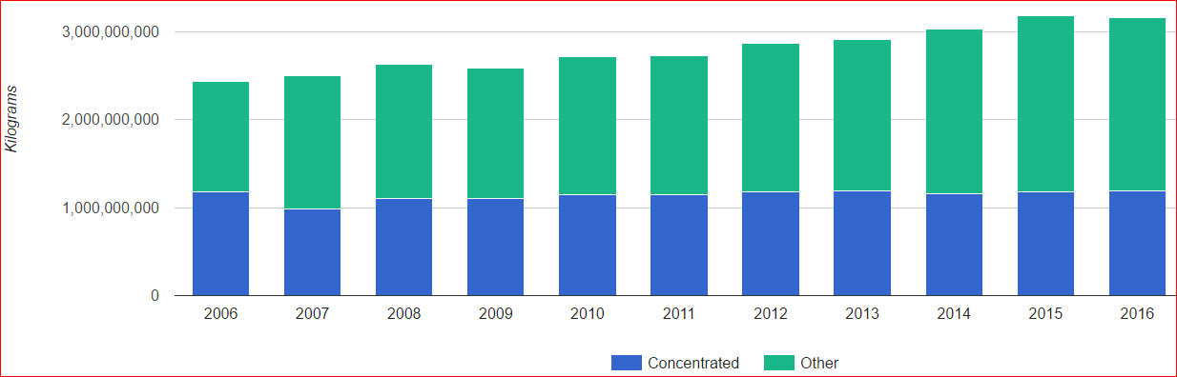

 | 2006 | 2007 | 2008 | 2009 | 2010 | 2011 | 2012 | 2013 | 2014 | 2015 | 2016
Concentrated % | 48.4 | 39.4 | 41.9 | 42.6 | 42.3 | 41.9 | 41.6 | 41.9 | 40.0 | 37.0 | 37.6
Other % | 51.6 | 60.6 | 58.1 | 57.4 | 57.7 | 58.1 | 58.4 | 58.1 | 60.0 | 63.0 | 62.4

9. Imports of product categories, 2006 to 2016 as reported to Milk SA
(Milk equivalent: kilogrammes)

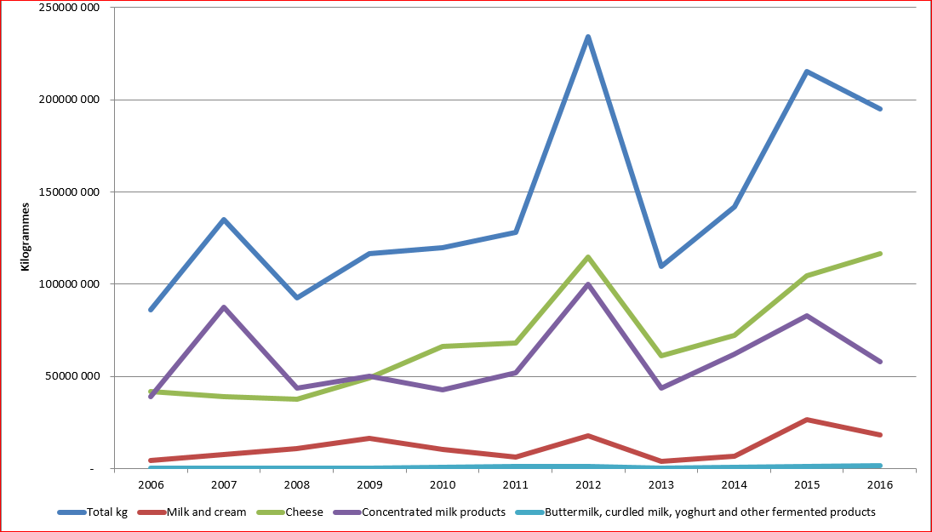

10. Milk equivalent of imported products, 2006 to 2016 ('000 kg) as reported to Milk SA

2006 | 2007 | 2008 | 2009 | 2010 | 2011 | 2012 | 2013 | 2014 | 2015 | 2016
85 924 | 135 073 | 92 821 | 116 601 | 119 922 | 127 896 | 234 108 | 109 758 | 142 143 | 215 274 | 194 870

11. Imports per category in 2016 (kilogrammes and milk equivalent) as reported to Milk SA

 | Kilogrammes of imported products | Milk equivalent (litres)
0401 Milk & Cream, not concentrated … | 18 553 960 | 18 553 960
0402 Milk & Cream, concentrated … | 6 459 617 | 58 136 553
0403 Buttermilk, curdled milk, yoghurt … | 1 678 995 | 1 678 995
0404 Whey | 6 313 031 | 0
0405 Butter | 8 306 203 | 0
0406 Cheese | 11 650 069 | 116 500 686
TOTAL | 52 961 875 | 194 870 194

12. Administration of the projects of Milk South Africa

The Policy for Funding of Statutory Projects and the standard contractual terms had been reviewed by Exco and the Board.

The content of the projects of Milk South Africa are subject to the requirements of the objectives of the statutory measures, the strategic direction as decided by the Members of Milk SA, review by the Board of Directors, while they are also aligned with the relevant government legislation and initiatives of government institutions and other external institutions.

The strategic direction of Milk SA was defined to promote the broadening of the market for milk and other dairy products, to improve the competitiveness of the South African dairy industry and to promote transformation in the South African dairy industry.

Milk SA signed contracts with the project managers in accordance with Milk SA's policy on the funding of statutory projects. Quarterly and annual reports for each project were submitted by the project managers and published on the Milk SA website.

The relevant structures including the Work Groups, Advisory Committees, Audit & Risk Committee, Executive Committee and Board of Directors fulfilled their roles to ensure that the projects are well structured and monitored and that their goals are optimally achieved.

The Board continued to employ an internal auditor to provide independent and objective advice in order to improve Milk South Africa's performance in respect of its administrative and project outputs. During 2016, internal audit reports were issued to the Board of Directors on the following:

i. Promoting sustainable commercialization of existing milk producers: A project that is managed by Milk SA.

ii. Dairy quality and safety: Projects that are managed by the Dairy Standard Agency.

iii. Participation of the SA dairy industry and its projects in the activities of the IDF, via the SA National Committee of the IDF (SANCIDF): A project that is managed by SANCIDF.

iv. Collecting, processing and dissemination of national and international information for the dairy industry of South Africa: A project that is managed by the MPO.

iv. Administration of statutory measures: As administrated by Milk SA.

Expenditure of the statutory levies during 2014 to 2016

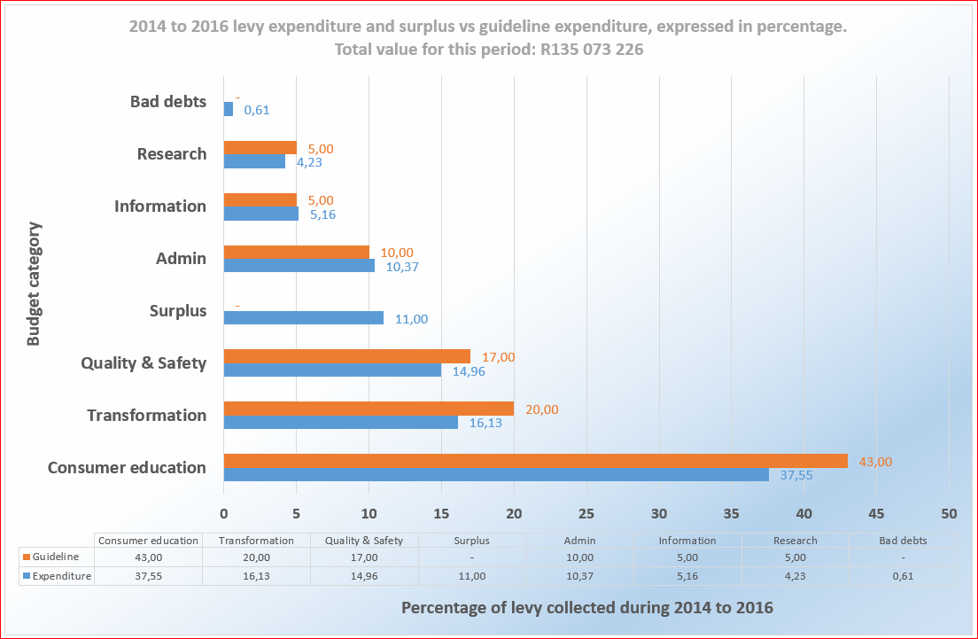

i. The aim is that each discipline should meet its guideline percentage within the four-year period of 2014 to 2017. A management tool to this effect is monitored by the CEO and the Board, while actions are taken to keep administrative expenditure within the 10% legal limit and transformation at the legal 20% or more.

ii. Variations of especially milk purchases, as declared to Milk SA, influence the achieved percentages versus the guideline percentages. The extraordinary high milk volumes in the 2015 financial year had a significant effect on the levy income and percentage expenditure per discipline.

iii. The Board policy to budget for and use the levies on an inflationary basis during the four years, means that expenditure per discipline would ideally meet the guidelines only by the end of 2017. (As the levy rate for unprocessed milk is fixed at 1.3 cents / kg for the four years, the four-yearly budget made provision for increased expenditure over this period).

iv. Up to 31 December 2016, 89% of the levy income for the three years (2014 to 2016) had been utilized.

v. Eleven percent of the levy income remained unitilized on 31 December 2016 and the Board of Directors would invite project proposals from the existing project managers for the utilization thereof in 2017.

13. Staff structure of Milk South Africa and external support structure

Board of Directors

Snr Administration Officer
Lucua du Preez
MBA
Bachelor of Social Science: Honours in Psychology
Bachelor of Social Science

Solid lines: Line authority
Dash lines: Administrative authority
External Support Structure
- Attorneys: Gildenhuys Malatji & MacRobert
- Web-based systems support: Octoplus
- Accountants: PricewaterhouseCoopers
- Internal Auditor: Medupe
- External Auditors: Fourie & Botha & Faure Bosman
Transformation Manager*
Godfrey Rathogwa
MBA (Strategic Marketing Management)
M.Sc (Business Management in Agriculture and food industries)
B.Com Hons (Business Economy)
B.Sc Agriculture (Extension focus)
Chief Executive Officer
Nico Fouché
B.Com Hons (Business Economy)
B.Com (Human and industrial psychology)
ND: Agriculture (Plant products)
Secretary to the Transformation Manager
June Mngadi
Personal Assistant
Nicolette Teichmann
BA Languages and Philosophy
Jnr Administration Assistant
Vincent Mafate
Office Cleaner
Priscilla Sinclair
* Mr Rathogwa is also a director of Milk SA
Office Support Assistant
Matilda Wistebaar

14. Functional structure of Milk South Africa

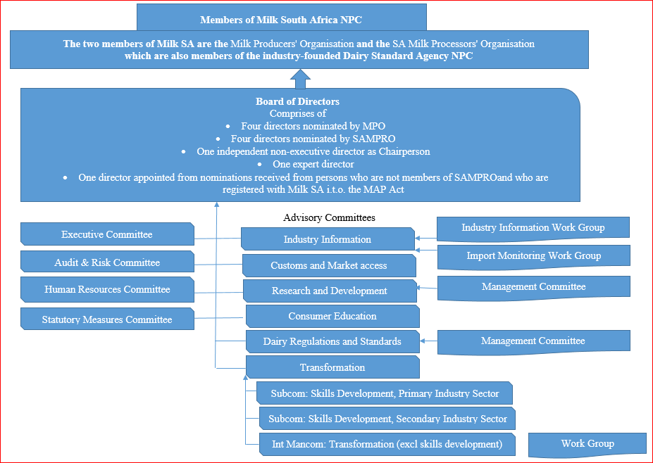

The above structure clearly shows that:

i. The primary and secondary industry sectors (represented by the MPO and SAMPRO respectively) are united in Milk South Africa as well as in the Dairy Standard Agency, in terms of the objectives that they commonly pursue in the interests of the entire South African dairy industry and community.

ii. The strategic direction of Milk SA requires a multi-disciplined approach, which enables Milk SA to unlock a wealth of support and co-operation from governmental, semi-governmental and private business sources.

iii. In respect of the South African dairy industry, collective issues of strategic importance exists which -

a. cannot be addressed through competition in the market;

b. should be addressed in the interests of the South African dairy industry, the consumer, and economic development, and

c. can, in terms of the Competition Act, be addressed by collective action by the members of the dairy industry.

15. Contractors in 2016

 | Contractors | Services
i | PricewaterhouseCoopers Inc | Accountants.
ii | Octoplus (Pty) Ltd | Web-based system support and enhancement.
iii | Internet Solutions (Dimension Data) | Web-based systems hosting & security.
iv | Fourie & Botha Inc | External Auditors (i.t.o. Companies Act).
v | Faure Bosman | External Auditors for the project "Promotion of sustainable commercialization of existing black dairy producers" (joint project of Milk SA and National Treasury).
vi | Gildenhuys Malatji Inc | Attorneys.
vii | MacRobert Inc | Attorneys.
viii | Medupe (Pty) Ltd | Internal Auditor.
ix | Milk Producers’ Organization NPC | Projects:  - Industry Information.  - Empowerment of previously disadvantaged individuals in the primary dairy sector, through training and skills development.  - Mentoring emerging dairy farmers (Elim).  - Dairy Occupational Qualification.
x | SA Milk Processors’ Organization | Projects:  - Dairy Consumer Education.  - Skills development (training).
xi | Dairy Standard Agency NPC | Project: Improvement of dairy quality & safety.
xii | University of Pretoria (Onderstepoort) | Projects:  - Fasciola hepatica: Impact on dairy production and sustainable management on selected farms in South Africa.  - Resistance to available antibiotics in lactating cows with mastitis.
xiii | University of KwaZulu-Natal | Investigating alternative methods such as bacteriophages and bacteriocins to control mastitis organisms.
xiv | Veterinary Network (Pty) Ltd | Project: National disease monitoring and extension system for the South African dairy industry.
xv | Dr HH Meissner (Programme Manager: Research & Development: Milk SA) | Project: Co-ordination, support and promotion of needs-driven R&D in the South African Dairy Industry.
xvi | SA National Committee of the IDF | Participation in the projects and activities of the International Dairy Federation through the SA National Committee of the IDF.

16. Communication & Liaison

16.1 While the website was updated with project reports, minutes, industry statistics, news and other information, the Milk Essay brochure continued to be a popular medium to inform the industry players quarterly about the performance of projects.

16.2 The website of Milk SA was regularly updated with the relevant reports and other information, also in the form of "podcast" videos, covering the various disciplines of Milk SA.

16.3 Detailed information with regard to communication of the Company and its projects with government and other institutions appears in the annual and quarterly project reports and include:

The following South African institutions:

- Department of Trade and Industry
- International Trade Administration Commission of SA
- Department of Agriculture, Forestry and Fisheries
- Provincial Departments of Agriculture
- Local municipal authorities
- SA Bureau of Standards
- Regulator of compulsory standards
- Department of Health
- National Agricultural Marketing Council
- Agricultural Research Council
- Tertiary academic institutions
- Professional Health Practitioner Associations
- Department of Education
- SA research institutions
- Schools
- Sport associations
- Banks
- Consumer Goods Council
- International Trade Administration
- SA Large Herds Conference
- SA Society for Dairy Technology
- Animal Health Forum

The following international institutions:

- Global Dairy Platform
- International Dairy Federation
- SA Research Institutions
- Foreign Research Institutions
- International Farm Comparison Network
- Codex Alimentarius ("Food code")

16.4 Appointments from the South African dairy industry have been made in 2016 on the following bodies of the International Dairy Federation (IDF):

- Dr Koos Coetzee, as member of the Science and Programme Co-ordination Committee of the IDF;
- Ms Christine Leighton, as chairperson of the International Promotion Group (functioning under the auspices of the IDF Standing Committee on Marketing); and
- Mr Alwyn Kraamwinkel, as director of the International Dairy Federation.

16.5 It is important that Milk SA's activities and its successes are also communicated by the MPO and SAMPRO, to their members.

17. Corporate Governance

Good Corporate Governance stands central to the success of Milk South Africa. Increased administrative responsibilities and the increased magnitude of the projects, necessitated new and refined policies, procedures and systems. Numerous corporate governance instruments are observed and annually reviewed.

A milk producer is defined in the Government Notices (Statutory Measures) as follows: "A person who produces milk by the milking of cows, goats or sheep". These persons, as referred to under item 2 c above, shall - in terms of the statutory measures, register with, submit returns and pay levies to Milk SA.

