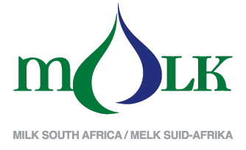

Attention: Milk processors, milk producers and other interested parties,

TRENDS OF MONTHLY UNPROCESSED (RAW) MILK PURCHASES IN THE RSA: 2013 TO SEP 2016

The preliminary figure for September 2016 shows a 5,10% higher milk purchase volume than the amount bought in September 2015. An amount of 299 987 584 kg is the preliminary milk purchase figure for September 2016.

The cumulative raw milk purchases (Jan - Sep 2016) is 2 246 372 450 kg, which is 2,23 % lower than the corresponding period in 2015 and 6,96 % higher than the corresponding period in 2014.

Milk SA takes no responsibility for the accuracy of this information which is intended to provide market signals only, and Milk SA indemnifies itself against any actions based on this information.

- Source: Milk SA Statistics (from monthly return forms submitted to Milk SA by ± 380 role-players).
- Note: 2013 - 2015 Reviewed, based on total figures declared to Milk SA.

Yours sincerely

Nico Fouché
CEO: Milk SA
2016.10.30

TT024

