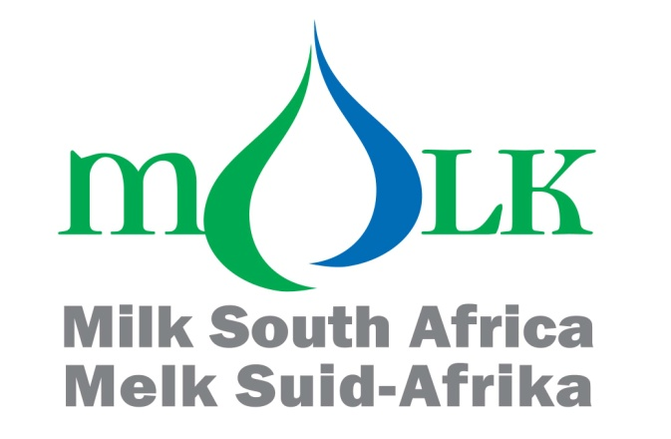

***HIGHLIGHTS OF THE ATTACHED ANALYSES OF THE***

***IMPORTS AND EXPORTS OF DAIRY PRODUCTS UP TO DECEMBER 2019***

* ***The mass of imports of dairy products in 2018, was 17.7 percent lower than in 2017. The decrease from 2017 to 2018, was due to the decrease in imports of three of the six categories of dairy products.***
* ***The mass of imports of dairy products in 2019, is 10.0 percent higher than in 2018. The increase from 2018 to 2019, is due to the increase in imports of three of the six categories of dairy products.***
* ***The average f.o.b. import prices in 2019, of four of the six different categories of dairy products, are higher than in 2018.***
* ***The mass of exports of dairy products in 2018, was 7.0 percent lower than in 2017. The decrease from 2017 to 2018, was due to the decrease in exports of three of the six categories of dairy products.***
* ***The mass of exports of dairy products in 2019, is 0.8 percent lower than in 2018. The decrease from 2018 to 2019, is due to the decrease in exports of four of the six categories of dairy products.***
* ***The average f.o.b. export prices in 2019, of four of the six different categories of dairy products, are higher than in 2018.***
* ***The mass of imports and exports in 2019, shows that South Africa is a nett importer of concentrated milk (04.02), whey (04.04), butter (04.05) and cheese (04.06) and a nett exporter of milk and cream (04.01) and buttermilk and yoghurt (04.03).***
* ***Graphs reflecting the mass of imports and exports per month of each of the six categories of dairy products, are shown in Annexure B.***
* ***The mass of sales by South Africa to the other members of the Southern African Customs Union (Botswana, Namibia, Lesotho and Swaziland), in period 2019, of each of the six categories of dairy products, was higher than the mass of South African exports of the dairy products in the same period.***
* ***The exposure to foreign competition (that is imports plus exports) in 2017 was higher than all the previous years and the exposure in 2018, was lower than in 2017. The exposure in 2019, is higher than 2018, but lower than 2017, which was the highest.***



**Imports and exports of dairy products up to December 2019**

*This report was compiled by the Office of SAMPRO and forms part of the Industry Information Project of SAMPRO. The purpose of the project is to make market signals available to members and other interested parties, which is a pre-requisite for effective competition, as envisaged by the Competition Act.*

*All reports compiled by the Office of SAMPRO and all activities of the Industry Information Project of SAMPRO, are designed and implemented in accordance with the Competition Act and independently from a commercial interest of any and all the members of SAMPRO.*

**INTRODUCTION**

1. The imports and exports figures of dairy products from January to December 2019, were recently released by SARS.
2. In this document, a brief analysis of imports and exports is provided per tariff heading.
3. The pattern of imports and exports within each year (the distribution per month of the total imports and exports of the year) differs significantly from year to year as described in Annexure B. As a result, estimates of future imports and exports, based on historical figures as referred to in the previous paragraph, should be viewed with caution.

## IMPORTS

1. The indices of the mass of imports in the years 2012 to 2019, are indicated in Table 1. (The mass of imports is indicated in Annexure A).

***Table 1: Indices of the mass of imports per tariff heading (2002=100)***

|  |  |  |  |  |  |  |  |  |  |
| --- | --- | --- | --- | --- | --- | --- | --- | --- | --- |
| **Heading** | Description | **2012** | **2013** | **2014** | **2015** | **2016** | **2017** | **2018** | **2019** |
| 04.01 | Milk and cream, unsweetened | 7 306 | 2 046 | 3 352 | 12 877 | 9 213 | 18 779 | 8 457 | **8 829** |
| 04.02 | Milk, concentrated | 120 | 65 | 89 | 114 | 95 | 144 | 135 | **163** |
| 04.03 | Buttermilk powder, yoghurt | 243 | 180 | 237 | 301 | 288 | 356 | 404 | **394** |
| 04.04 | Whey, whey powder, etc | 117 | 141 | 120 | 118 | 90 | 97 | 152 | **275** |
| 04.05 | Butter, butter spreads and butter oil | 413 | 212 | 140 | 347 | 362 | 361 | 613 | **291** |
| 04.06 | Cheese and curd | 419 | 269 | 312 | 409 | 426 | 395 | 367 | **311** |
| **TOTAL** | | **240** | **145** | **163** | **282** | **236** | **339** | **279** | **307** |

1. The mass of imports in 2018, was 17.7 percent lower than in 2017. The decrease from 2017 to 2018, was due to the decrease in imports of three of the six categories of dairy products.
2. The mass of imports in 2019, is 10.0 percent higher than in 2018. The increase from 2018 to 2019, is due to the increase in imports of three of the six categories of dairy products.
3. In Table 2, the mass of imports from January to December 2019, is compared with the mass of imports from January to December 2018.

***Table 2: Imports from January to December 2019 and January to December 2018***

|  |  |  |  |  |
| --- | --- | --- | --- | --- |
| **Heading** | Description | **A**  **2019**  **Kg** | **B**  **2018**  **Kg** | **A as**  **%**  **of B** |
| 04.01 | Milk and cream, unsweetened | 18 417 754 | 17 642 842 | 104.4 |
| 04.02 | Milk, concentrated | 17 929 714 | 14 889 772 | 120.4 |
| 04.03 | Buttermilk powder, yogurt | 3 477 423 | 3 561 120 | 97.6 |
| 04.04 | Whey, whey powder, etc | 21 755 229 | 12 048 155 | 180.6 |
| 04.05 | Butter, butter spreads and butter oil | 4 302 967 | 9 064 150 | 47.5 |
| 04.06 | Cheese and curd | 9 712 995 | 11 446 544 | 84.9 |
| Total | | 75 596 082 | 68 652 583 | 110.1 |

1. The mass of imports of milk and cream (04.01), concentrated milk (04.02) and whey (04.03) are higher in the period January to December 2019, than in the same period of the previous year.
2. Table 3 indicates the indices of the average f.o.b. import prices in the years 2012 to 2019.

***Table 3: Indices of the average f.o.b. import prices per tariff heading (2002=100)***

|  |  |  |  |  |  |  |  |  |  |
| --- | --- | --- | --- | --- | --- | --- | --- | --- | --- |
| **Heading** | Description | **2012** | **2013** | **2014** | **2015** | **2016** | **2017** | **2018** | **2019** |
| 04.01 | Milk and cream, unsweetened | 44 | 47 | 68 | 61 | 59 | 61 | 64 | 71 |
| 04.02 | Milk, concentrated | 206 | 291 | 326 | 237 | 252 | 247 | 236 | 279 |
| 04.03 | Buttermilk powder, yoghurt | 160 | 247 | 292 | 195 | 177 | 197 | 163 | 224 |
| 04.04 | Whey, whey powder, etc | 299 | 367 | 447 | 411 | 371 | 401 | 376 | 331 |
| 04.05 | Butter, butter spreads and  butter oil | 231 | 270 | 370 | 304 | 361 | 530 | 560 | 540 |
| 04.06 | Cheese and curd | 134 | 173 | 206 | 183 | 191 | 208 | 210 | 233 |

1. The average import prices of three of the six categories of dairy products in 2018, were lower than in 2017.
2. The average import prices of two of the six categories of dairy products in 2019, are lower than in 2018.
3. Table 4 indicates the average f.o.b. prices of the imported dairy products in the years 2012 to 2019.

***Table 4: Average f.o.b. import prices per tariff heading***

|  |  |  |  |  |  |  |  |  |  |
| --- | --- | --- | --- | --- | --- | --- | --- | --- | --- |
| **Heading** | Description | **2012**  **R/kg** | **2013**  **R/kg** | **2014**  **R/kg** | **2015**  **R/kg** | **2016**  **R/kg** | **2017**  **R/kg** | **2018**  **R/kg** | **2019**  **R/kg** |
| 04.01 | Milk and cream, unsweetened | 5.55 | 5.95 | 8.50 | 7.65 | 7.44 | 7.65 | 8.00 | 8.95 |
| 04.02 | Milk, concentrated | 26.85 | 37.95 | 42.63 | 30.92 | 32.94 | 32.31 | 30.84 | 36.49 |
| 04.03 | Buttermilk powder, yoghurt | 23.03 | 35.55 | 42.09 | 28.06 | 25.56 | 28.39 | 23.51 | 32.27 |
| 04.04 | Whey, whey powder, etc | 23.33 | 28.62 | 34.82 | 31.98 | 28.90 | 31.24 | 29.33 | 25.77 |
| 04.05 | Butter, butter spreads and  butter oil | 29.99 | 35.05 | 48.14 | 39.56 | 46.88 | 68.89 | 72.84 | 70.17 |
| 04.06 | Cheese and curd | 40.02 | 51.90 | 61.70 | 54.94 | 57.22 | 62.19 | 62.92 | 69.85 |

1. The average import prices of two of the six different categories of dairy products decreased from 2018 to 2019 as follows:

* 04.04 12.1 percent, and
* 04.05 3.7 percent.

1. The average import prices of four of the six different categories of dairy products increased from 2018 to 2019 as follows:

* 04.01 11.9 percent,
* 04.02 18.3 percent,
* 04.03 37.3 percent, and
* 04.06 11.0 percent.

**EXPORTS**

1. The indices of the mass of exports in the years 2012 to 2019, are indicated in Table 5. (The mass of exports is indicated in Annexure A).

***Table 5: Indices of the mass of exports per tariff heading (2002=100)***

|  |  |  |  |  |  |  |  |  |  |
| --- | --- | --- | --- | --- | --- | --- | --- | --- | --- |
| **Heading** | Description | **2012** | **2013** | **2014** | **2015** | **2016** | **2017** | **2018** | **2019** |
| 04.01 | Milk and cream, unsweetened | 219 | 227 | 256 | 227 | 178 | 141 | 133 | **159** |
| 04.02 | Milk, concentrated | 47 | 109 | 60 | 45 | 38 | 77 | 67 | **56** |
| 04.03 | Buttermilk powder, yoghurt | 1 332 | 2 012 | 2 348 | 1 660 | 1 330 | 1 140 | 1 318 | **1 131** |
| 04.04 | Whey, whey powder, etc | 335 | 598 | 453 | 1 025 | 925 | 964 | 168 | **181** |
| 04.05 | Butter, butter spreads and  butter oil | 68 | 77 | 122 | 98 | 88 | 71 | 81 | **79** |
| 04.06 | Cheese and curd | 53 | 64 | 76 | 89 | 88 | 79 | 92 | **84** |
| **TOTAL** | | **153** | **205** | **207** | **179** | **146** | **142** | **132** | **131** |

1. Table 5 indicates that:

* The mass of exports in 2018, was 7.0 percent lower than in 2017. The decrease was due to the decrease in exports of three of the six categories of dairy products; and
* The mass of exports in 2019, is 0.8 percent lower than in 2018. The decrease is due to the decrease in exports of four of the six categories of dairy products.

1. In Table 6, the mass of exports from January to December 2019, is compared with the mass of exports from January to December 2018.

***Table 6: Exports from January to December 2019 and January to December 2019***

|  |  |  |  |  |
| --- | --- | --- | --- | --- |
| **Heading** | Description | **A**  **2019 Kg** | **B**  **2018 Kg** | **A**  **as %**  **van B** |
| 04.01 | Milk and cream, unsweetened | 20 412 096 | 17 009 995 | 120.0 |
| 04.02 | Milk, concentrated | 7 868 718 | 9 336 954 | 84.3 |
| 04.03 | Buttermilk powder, yoghurt | 10 970 946 | 12 785 725 | 85.8 |
| 04.04 | Whey, whey powder, etc | 745 578 | 691 890 | 107.8 |
| 04.05 | Butter, butter spreads and  butter oil | 1 210 490 | 1 232 997 | 98.2 |
| 04.06 | Cheese and curd | 3 843 918 | 4 199 938 | 91.5 |
| **Total** | | 45 051 747 | 45 257 499 | 99.5 |

1. Table 6 indicates that the mass of exports of four of the six categories of dairy products were lower in the period January to December 2019, than in the same period in 2018.
2. Table 7 indicates the indices of the average f.o.b. prices from 2012 to 2019, of the exports of the six categories of dairy products.

***Table 7: Indices of average f.o.b. export prices per tariff heading (2000 =100)***

|  |  |  |  |  |  |  |  |  |  |
| --- | --- | --- | --- | --- | --- | --- | --- | --- | --- |
| **Heading** | Description | **2012** | **2013** | **2014** | **2015** | **2016** | **2017** | **2018** | **2019** |
| 04.01 | Milk and cream, unsweetened | 201 | 205 | 227 | 247 | 244 | 262 | 269 | **271** |
| 04.02 | Milk, concentrated | 145 | 116 | 179 | 184 | 220 | 247 | 217 | **220** |
| 04.03 | Buttermilk powder, yoghurt | 142 | 149 | 167 | 157 | 178 | 311 | 155 | **176** |
| 04.04 | Whey, whey powder, etc | 119 | 196 | 188 | 133 | 322 | 168 | 236 | **228** |
| 04.05 | Butter, butter spreads and  butter oil | 244 | 242 | 266 | 268 | 325 | 395 | 443 | **375** |
| 04.06 | Cheese and curd | 169 | 178 | 193 | 190 | 218 | 255 | 222 | **235** |

1. Table 7 indicates that:

* The average prices of exports of three of the six categories of dairy products in 2018, were higher than in 2017; and
* The average prices of exports of four of the six categories of dairy products in 2019, were higher than in 2018.

1. The average free-on-board f.o.b. export prices from 2012 to 2019, are indicated in

Table 8.

***Table 8: Average f.o.b. export prices per tariff heading***

|  |  |  |  |  |  |  |  |  |  |
| --- | --- | --- | --- | --- | --- | --- | --- | --- | --- |
| **Heading** | Description | **2012**  **R/kg** | **2013**  **R/kg** | **2014**  **R/kg** | **2015**  **R/kg** | **2016**  **R/kg** | **2017**  **R/kg** | **2018**  **R/kg** | **2019**  **R/kg** |
| 04.01 | Milk and cream, unsweetened | 8.39 | 8.55 | 9.45 | 10.30 | 10.16 | 10.93 | 11.20 | 11.30 |
| 04.02 | Milk, concentrated | 24.37 | 19.49 | 30.05 | 30.97 | 37.00 | 41.51 | 36.56 | 36.97 |
| 04.03 | Buttermilk powder, yoghurt | 16.97 | 17.76 | 19.97 | 18.76 | 21.27 | 37.12 | 18.45 | 21.02 |
| 04.04 | Whey, whey powder, etc | 9.43 | 15.55 | 14.85 | 10.51 | 25.46 | 13.27 | 18.71 | 18.03 |
| 04.05 | Butter, butter spreads and  butter oil | 37.06 | 36.75 | 40.37 | 40.66 | 49.40 | 59.94 | 67.27 | 56.89 |
| 04.06 | Cheese and curd | 40.44 | 42.47 | 46.11 | 45.50 | 52.00 | 60.86 | 53.15 | 56.25 |

1. The average export prices of four of the six different categories of dairy products increased from 2018 to 2019 as follows:

* 04.01 0.9 percent;
* 04.02 1.1 percent;
* 04.03 13.9 percent; and
* 04.06 5.8 percent.

1. The average export prices of 04.04 and 04.05 decreased with 3.6 percent and 15.4 percent from 2018 to 2019.

**RATIO BETWEEN IMPORTS AND EXPORTS**

1. The mass of imports as a percentage of the mass of exports of dairy products by South Africa, is a highly aggregated indication of the industry’s international competitiveness. The ratios between the mass of imports and exports of the six categories of dairy products from 2011 to 2018, and figures in respect of 2019, are indicated in Table 9.

***Table 9: Mass of imports as a percentage of the mass of exports***

|  |  |  |  |  |  |  |  |  |  |
| --- | --- | --- | --- | --- | --- | --- | --- | --- | --- |
| **Heading** | Description | **2012** | **2013** | **2014** | **2015** | **2016** | **2017** | **2018** | **2019** |
| 04.01 | Milk and cream, unsweetened | 54.3 | 14.7 | 21.4 | 92.5 | 84.3 | 217.1 | 103.7 | 90.2 |
| 04.02 | Milk, concentrated | 199.3 | 46.5 | 117.3 | 197.7 | 196.3 | 146.4 | 159.5 | 227.9 |
| 04.03 | Buttermilk powder, yoghurt | 16.6 | 8.2 | 9.2 | 16.5 | 19.7 | 28.4 | 27.9 | 31.7 |
| 04.04 | Whey, whey powder, etc | 669.5 | 452.7 | 507.4 | 221.3 | 185.9 | 192.9 | 1 741.3 | 2 917.9 |
| 04.05 | Butter, butter spreads and  butter oil | 591.1 | 266.7 | 111.4 | 344.1 | 396.7 | 491.2 | 735.1 | 355.5 |
| 04.06 | Cheese and curd | 536.5 | 286.6 | 281.2 | 314.2 | 330.3 | 338.7 | 272.5 | 252.7 |
| **TOTAL** | | **90.2** | **112.6** | **50.6** | **56.5** | **115.4** | **171.7** | **151.7** | **167.8** |

1. As indicated in Table 9:

* The ratio between the total mass of imports and exports in 2018, in respect of three of the six categories of dairy products, namely milk and cream (04.01), buttermilk and yogurt (04.03) and cheese and curd (04.06) was lower than in 2017; and
* The ratio between the total mass of imports and exports in 2019, in respect of three of the six categories of dairy products, namely milk and cream (04.01), butter (04.05) and cheese (04.06) is lower than in 2018.

**EXPOSURE OF THE SOUTH AFRICAN DAIRY INDUSTRY TO FOREIGN COMPETITION**

1. The sum of the mass of the imports and exports of dairy products by South Africa, is a highly aggregated indication of the exposure of the South African dairy industry to foreign competition, and this is indicated in Table 10.

***Table 10: Mass of imports and exports (2002=100)***

|  |  |  |  |  |  |  |
| --- | --- | --- | --- | --- | --- | --- |
| **YEAR** | **IMPORTS** | | **EXPORTS** | | **IMPORTS PLUS EXPORTS** | |
| **TON** | **INDEX** | **TON** | **INDEX** | **TON** | **INDEX** |
| 2002 | 24 617.40 | 100.0 | 34 328.20 | 100.0 | 58 945.60 | 100.0 |
| 2003 | 24 458.80 | 99.4 | 22 905.20 | 66.7 | 47 364.00 | 80.4 |
| 2004 | 18 289.50 | 74.3 | 23 508.10 | 68.5 | 41 797.60 | 70.9 |
| 2005 | 30 771.40 | 125.0 | 17 216.00 | 50.2 | 47 987.40 | 81.4 |
| 2006 | 30 878.60 | 125.4 | 26 543.30 | 77.3 | 57 421.90 | 97.4 |
| 2007 | 44 313.00 | 180.0 | 18 516.50 | 53.9 | 62 829.50 | 106.6 |
| 2008 | 34 009.40 | 138.2 | 42 781.00 | 124.6 | 76 790.40 | 130.3 |
| 2009 | 32 373.40 | 131.5 | 41 770.70 | 121.7 | 74 144.10 | 125.8 |
| 2010 | 35 061.20 | 142.4 | 33 950.60 | 98.9 | 69 011.80 | 117.1 |
| 2011 | 37 714.40 | 153.2 | 41 817.10 | 121.8 | 79 531.50 | 134.9 |
| 2012 | 59 012.55 | 239.7 | 52 500.96 | 152.9 | 111 513.49 | 189.2 |
| 2013 | 35 673.76 | 144.9 | 70 481.90 | 205.3 | 106 155.66 | 180.1 |
| 2014 | 40 199.03 | 163.3 | 71 098.95 | 207.1 | 111 297.99 | 188.8 |
| 2015 | 69 353.98 | 281.7 | 61 296.87 | 178.6 | 130 650.85 | 221.6 |
| 2016 | 58 000.35 | 235.6 | 50 247.54 | 146.4 | 108 247.89 | 183.6 |
| 2017 | 83 504.44 | 339.2 | 48 626.69 | 141.7 | 132 131.14 | 224.2 |
| 2018 | 68 652.58 | 278.9 | 45 257.49 | 131.8 | 113 910.08 | 193.2 |
| **2019** | **75 596.08** | **307.1** | **45 051.75** | **131.2** | **120 647.83** | **204.7** |

1. From Table 10 it is clear that the exposure to foreign competition of the South African dairy industry:

* Was in 2017, the highest in the years 2002 to 2018; and that

* The exposure in 2019, is higher than in 2018, but lower than 2017, when it was the highest.

1. Table 11 indicates the mass of total sales to the Southern African Customs Union (SACU) member states, namely Botswana, Lesotho, Namibia and Swaziland (BLNS countries) in the period January to September 2019. Sales by South Africa to the other members of SACU, is not classified by SARS as exports.

***Table 11: Mass of sales to the BLNS countries compared to exports outside of SACU in the period January to December 2019***

|  |  |  |  |  |  |
| --- | --- | --- | --- | --- | --- |
| **Heading** | Description | **(A)**  **Sales**  **To**  **BLNS** | **(B)**  **Exports to**  **Countries**  **Outside**  **SACU** | **(A+B)=(C)**  **Sales to BLNS plus exports outside**  **SACU** | **A**  **as**  **%**  **of**  **C** |
| Kilogram | | | **%** |
| 04.01 | Milk and cream, unsweetened | 56 225 676 | 20 412 096 | 76 637 772 | 73.4 |
| 04.02 | Milk, concentrated | 46 266 943 | 7 868 718 | 54 135 661 | 85.5 |
| 04.03 | Buttermilk powder, yogurt | 26 864 136 | 10 970 946 | 37 835 082 | 71.0 |
| 04.04 | Whey, whey powder, etc | 3 263 448 | 745 578 | 4 009 026 | 81.4 |
| 04.05 | Butter, butter spreads and  butter oil | 1 350 027 | 1 210 490 | 2 560 517 | 52.7 |
| 04.06 | Cheese and curd | 6 162 925 | 3 843 918 | 10 006 843 | 61.6 |
| **Total** | | **140 133 155** | **45 051 747** | **185 184 902** | **75.7** |

1. Table 11 indicates that:

* The mass of the total sales of dairy products by South Africa to the BLNS countries, exceeded the mass of exports. (Exports are sales to destinations outside SACU); and
* The mass of the sales by South Africa to members of SACU, of each of the six categories of dairy products, exceeded the mass of exports by South Africa.

## MARIETJIE LE ROUX

## DE WET JONKER

## ALWYN P KRAAMWINKEL

**1 April 2020**

***Z:\Databasis\Invoer&Uitvoere\Analise 2019\Highlights of Import Export Dec 2019.docx***

## Annexure A

|  |  |  |  |  |  |  |  |
| --- | --- | --- | --- | --- | --- | --- | --- |
| **Table 1: Imports and Exports by heading in kg** | | |  |  |  |  |  |
|  |  | **Imports** | **Exports** | **Imports** | **Exports** | **Imports** | **Exports** |
|  |  | **2002** | **2002** | **2003** | **2003** | **2004** | **2004** |
| **Heading** | Description | **Kg** | **Kg** | **Kg** | **Kg** | **Kg** | **Kg** |
| **04.01** | **Milk and cream, unsweetened** | **208 613** | **12 801 289** | **684 821** | **9 640 776** | **1 526 416** | **9 190 414** |
| **04.02** | **Milk, concentrated** | **11 018 625** | **14 039 210** | **6 703 019** | **7 452 953** | **3 067 368** | **5 972 199** |
| **04.03** | **Buttermilk powder, yoghurt** | **882 034** | **969 846** | **1 077 191** | **2 161 584** | **850 505** | **2 076 324** |
| **04.04** | **Whey, whey powder, etc** | **7 906 468** | **412 723** | **6 271 924** | **268 045** | **6 777 606** | **2 628 212** |
| **04.05** | **Butter, butter spreads and butter oil** | **1 479 363** | **1 526 319** | **4 629 804** | **996 146** | **1 800 706** | **788 997** |
| **04.06** | **Cheese and curd** | **3 122 250** | **4 578 773** | **5 092 997** | **2 385 733** | **4 266 915** | **2 851 990** |
|  | **Total** | **24 617 353** | **34 328 160** | **24 459 756** | **22 905 237** | **18 289 516** | **23 508 136** |
|  |  |  |  |  |  |  |  |
|  |  |  |  |  |  |  |  |
|  |  | **Imports** | **Exports** | **Imports** | **Exports** | **Imports** | **Exports** |
|  |  | **2005** | **2005** | **2006** | **2006** | **2007** | **2007** |
| **Heading** | Description | **Kg** | **Kg** | **Kg** | **Kg** | **Kg** | **Kg** |
| **04.01** | **Milk and cream, unsweetened** | **2 105 485** | **8 666 131** | **4 943 877** | **12 559 045** | **13 858 507** | **7 277 746** |
| **04.02** | **Milk, concentrated** | **12 337 153** | **3 517 660** | **9 032 137** | **4 366 952** | **14 386 700** | **4 235 315** |
| **04.03** | **Buttermilk powder, yoghurt** | **1 689 886** | **2 969 313** | **1 561 696** | **4 980 518** | **1 611 115** | **3 904 306** |
| **04.04** | **Whey, whey powder, etc** | **8 091 601** | **137 326** | **7 514 344** | **2 339 330** | **5 711 984** | **1 239 684** |
| **04.05** | **Butter, butter spreads and butter oil** | **2 722 816** | **846 786** | **3 141 909** | **770 915** | **3 331 164** | **880 002** |
| **04.06** | **Cheese and curd** | **3 824 459** | **1 078 744** | **4 684 645** | **1 526 513** | **5 413 513** | **979 477** |
|  | **Total** | **30 771 400** | **17 215 960** | **30 878 608** | **26 543 273** | **44 312 983** | **18 516 530** |

|  |  |  |  |
| --- | --- | --- | --- |
|  | |  | |
|  | |  | | **Imports** | **Exports** | | **Imports** | | **Exports** | **Imports** | | **Exports** |
|  | |  | | **2008** | **2008** | | **2009** | | **2009** | **2010** | | **2010** |
| **Heading** | | Description | | **Kg** | **Kg** | | **Kg** | | **Kg** | **Kg** | | **Kg** |
| **04.01** | | **Milk and cream, unsweetened** | | **12 799 205** | **19 293 810** | | **10 902 048** | | **21 292 977** | **11 118 947** | | **17 451 437** |
| **04.02** | | **Milk, concentrated** | | **5 852 035** | **11 446 267** | | **5 385 534** | | **7 864 904** | **6 771 519** | | **4 612 872** |
| **04.03** | | **Buttermilk powder, yoghurt** | | **669 432** | **5 743 800** | | **1 380 614** | | **5 709 480** | **1 378 705** | | **4 527 147** |
| **04.04** | | **Whey, whey powder, etc** | | **7 539 920** | **3 298 052** | | **6 259 760** | | **3 852 586** | **7 267 982** | | **3 805 172** |
| **04.05** | | **Butter, butter spreads and butter oil** | | **2 812 100** | **1 564 877** | | **3 200 689** | | **1 309 556** | **2 192 835** | | **1 470 776** |
| **04.06** | | **Cheese and curd** | | **4 336 703** | **1 434 165** | | **5 244 744** | | **1 741 226** | **6 331 199** | | **2 083 150** |
|  | | **Total** | | **34 009 395** | **42 780 971** | | **32 373 389** | | **41 770 729** | **35 061 187** | | **33 950 554** |
|  |  | |  | | | | |  | | |  | |
|  | |  | | **Imports** | | **Exports** | **Imports** | | **Exports** | **Imports** | | **Exports** |
|  | |  | | **2011** | | **2011** | **2012** | | **2012** | **2013** | | **2013** |
| **Heading** | | Description | | **Kg** | | **Kg** | **Kg** | | **Kg** | **Kg** | | **Kg** |
| **04.01** | | **Milk and cream, unsweetened** | | **8 324 364** | | **20 801 621** | **15 240 656** | | **28 077 665** | **4 267 449** | | **29 074 468** |
| **04.02** | | **Milk, concentrated** | | **7 895 127** | | **7 244 566** | **13 257 357** | | **6 653 309** | **7 115 030** | | **15 316 274** |
| **04.03** | | **Buttermilk powder, yoghurt** | | **2 131 189** | | **9 215 883** | **2 146 004** | | **12 913 857** | **1 590 917** | | **19 517 880** |
| **04.04** | | **Whey, whey powder, etc** | | **9 445 819** | | **1 255 978** | **9 266 509** | | **1 384 114** | **11 165 088** | | **2 466 431** |
| **04.05** | | **Butter, butter spreads and butter oil** | | **3 153 315** | | **992 242** | **6 107 761** | | **1 033 349** | **3 132 054** | | **1 174 557** |
| **04.06** | | **Cheese and curd** | | **6 764 628** | | **2 306 790** | **13 084 240** | | **2 438 666** | **8 403 219** | | **2 932 285** |
|  | | **Total** | | **37 714 442** | | **41 817 080** | **59 102 527** | | **52 500 960** | **35 673 757** | | **70 481 895** |

|  |  |  |  |  |  |  |  |
| --- | --- | --- | --- | --- | --- | --- | --- |
|  |  | **Imports** | **Exports** | **Imports** | **Exports** | **Imports** | **Exports** |
|  |  | **2014** | **2014** | **2015** | **2015** | **2016** | **2016** |
| **Heading** | **DESCRIPTION** | **Kg** | **Kg** | **Kg** | **Kg** | **Kg** | **Kg** |
| **04.01** | **Milk and cream, unsweetened** | **6 992 447** | **32 751 503** | **26 863 360** | **29 051 149** | **19 219 616** | **22 804 187** |
| **04.02** | **Milk, concentrated** | **9 836 418** | **8 383 267** | **12 574 543** | **6 361 606** | **10 502 625** | **5 350 645** |
| **04.03** | **Buttermilk, yoghurt, etc** | **2 086 328** | **22 774 653** | **2 653 250** | **16 098 030** | **2 540 075** | **12 903 458** |
| **04.04** | **Whey, whey powder, etc** | **9 480 080** | **1 868 337** | **9 365 343** | **4 232 308** | **7 095 931** | **3 816 533** |
| **04.05** | **Butter, butter spreads and butter oil** | **2 071 983** | **1 860 197** | **5 131 861** | **1 491 368** | **5 356 852** | **1 350 229** |
| **04.06** | **Cheese and curd:** | **9 731 777** | **3 460 994** | **12 765 628** | **4 062 404** | **13 285 247** | **4 022 491** |
|  | **Total** | **40 199 034** | **71 098 952** | **69 353 984** | **61 296 865** | **58 000 347** | **50 247 544** |
|  |  |  |  |  |  |  |  |
|  |  |  |  |  |  |  |  |
|  |  |  | |  | |  | |
|  |  | **Imports** | **Exports** | **Imports** | **Exports** | **Imports** | **Exports** |
|  |  | **2017** | **2017** | **2018** | **2018** | **2019** | **2019** |
| **Heading** | **DESCRIPTION** | **Kg** | **Kg** | **Kg** | **Kg** | **Kg** | **Kg** |
| **04.01** | **Milk and cream, unsweetened** | **39 175 443** | **18 044 769** | **17 642 842** | **17 009 995** | **18 417 754** | **20 412 096** |
| **04.02** | **Milk, concentrated** | **15 842 375** | **10 822 898** | **14 889 772** | **9 336 954** | **17 929 714** | **7 868 718** |
| **04.03** | **Buttermilk, yoghurt, etc** | **3 141 948** | **11 053 751** | **3 561 120** | **12 785 725** | **3 477 423** | **10 970 946** |
| **04.04** | **Whey, whey powder, etc** | **7 673 604** | **3 977 971** | **12 048 155** | **691 890** | **21 755 229** | **745 578** |
| **04.05** | **Butter, butter spreads and butter oil** | **5 343 309** | **1 087 716** | **9 064 150** | **1 232 997** | **4 302 967** | **1 210 490** |
| **04.06** | **Cheese and curd:** | **12 327 764** | **3 639 588** | **11 446 544** | **4 199 938** | **9 712 995** | **3 843 918** |
|  | **Total** | **83 504 443** | **48 626 693** | **68 652 583** | **45 257 499** | **75 596 081** | **45 051 747** |

**Annexure B**

***MASS OF IMPORTS AND EXPORTS PER MONTH OF SELECTED DAIRY PRODUCTS BY SOUTH AFRICA1)***

**Graph 1**



**Table 1**

**Highest and lowest imports per month of milk and cream, not concentrated (04.01) in the years 2014 to 2019**

|  |  |  |
| --- | --- | --- |
|  | **Highest** | **Lowest** |
| **2014** | February | July |
| **2015** | May | October |
| **2016** | June | January |
| **2017** | May | April |
| **2018** | February | August |
| **2019** | July | January |

1. ***Graphs prepared by the Office of SAMPRO on the basis of information obtained from SARS.***

**Graph 2**

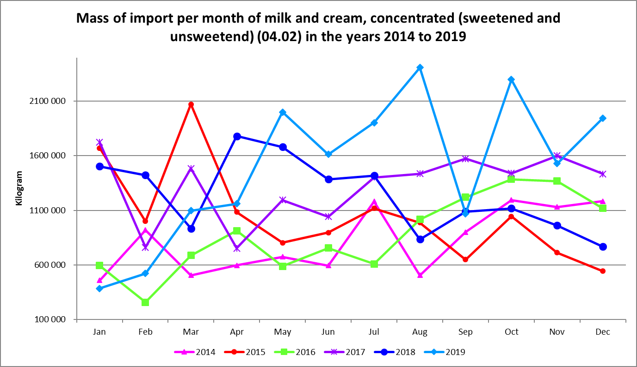

**Table 2**

**Highest and lowest imports per month of milk and cream, concentrated (sweetened and sweetened) (04.02) in the years 2014 to 2019**

|  |  |  |
| --- | --- | --- |
|  | **Highest** | **Lowest** |
| **2014** | October | January |
| **2015** | March | December |
| **2016** | October | February |
| **2017** | January | April |
| **2018** | April | December |
| **2019** | August | January |

**Graph 3**

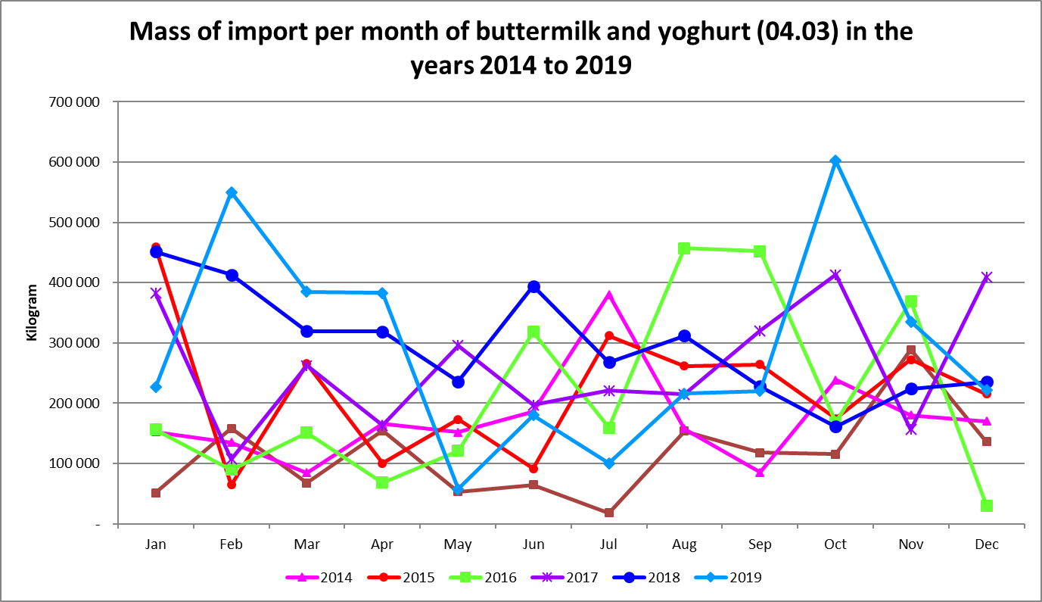

**Table 3**

**Highest and lowest imports per month of buttermilk and yogurt (04.03) in the years 2014 to 2019**

|  |  |  |
| --- | --- | --- |
|  | **Highest** | **Lowest** |
| **2014** | July | March |
| **2015** | January | February |
| **2016** | August | December |
| **2017** | October | February |
| **2018** | January | October |
| **2019** | October | May |

**Graph 4**

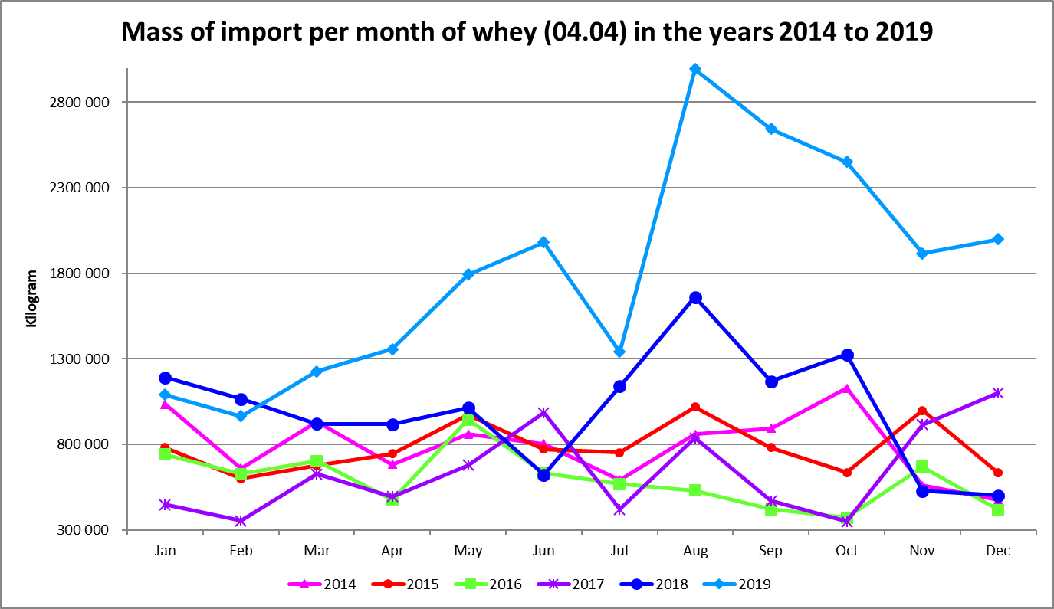

**Table 4**

**Highest and lowest imports per month of whey (04.04) in the years 2014 to 2019**

|  |  |  |
| --- | --- | --- |
|  | **Highest** | **Lowest** |
| **2014** | October | December |
| **2015** | August | February |
| **2016** | May | April |
| **2017** | December | October |
| **2018** | August | December |
| **2019** | August | February |

**Graph 5**

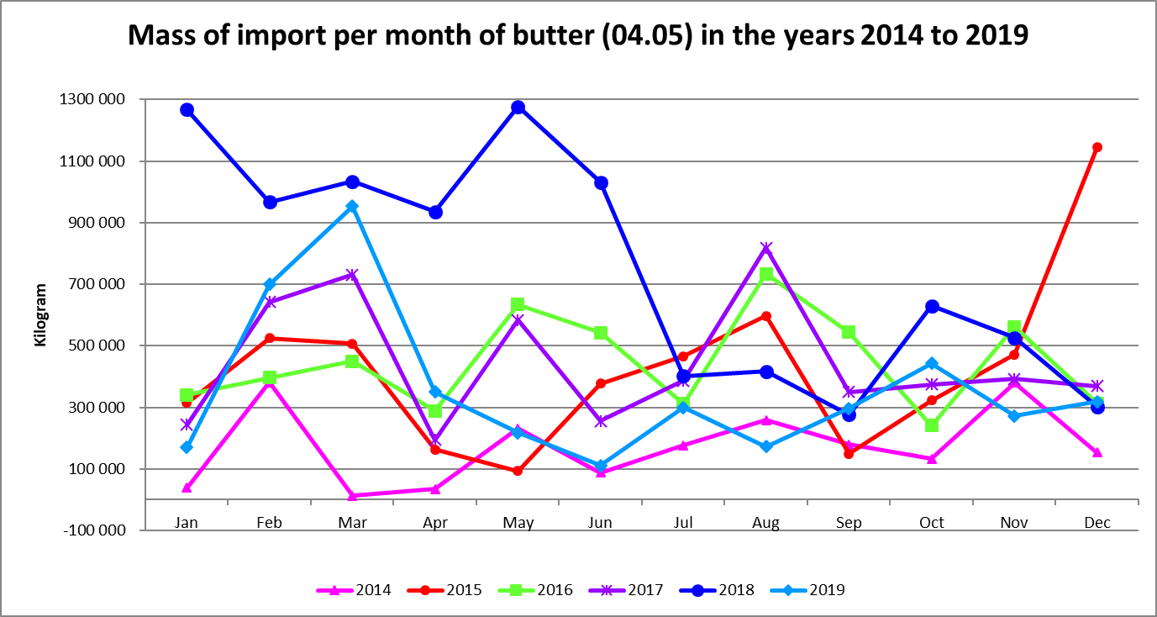

**Table 5**

**Highest and lowest imports per month of butter (04.05) in the years 2014 to 2019**

|  |  |  |
| --- | --- | --- |
|  | **Highest** | **Lowest** |
| **2014** | February | March |
| **2015** | December | May |
| **2016** | August | October |
| **2017** | August | April |
| **2018** | May | September |
| **2019** | March | June |

**Graph 6**

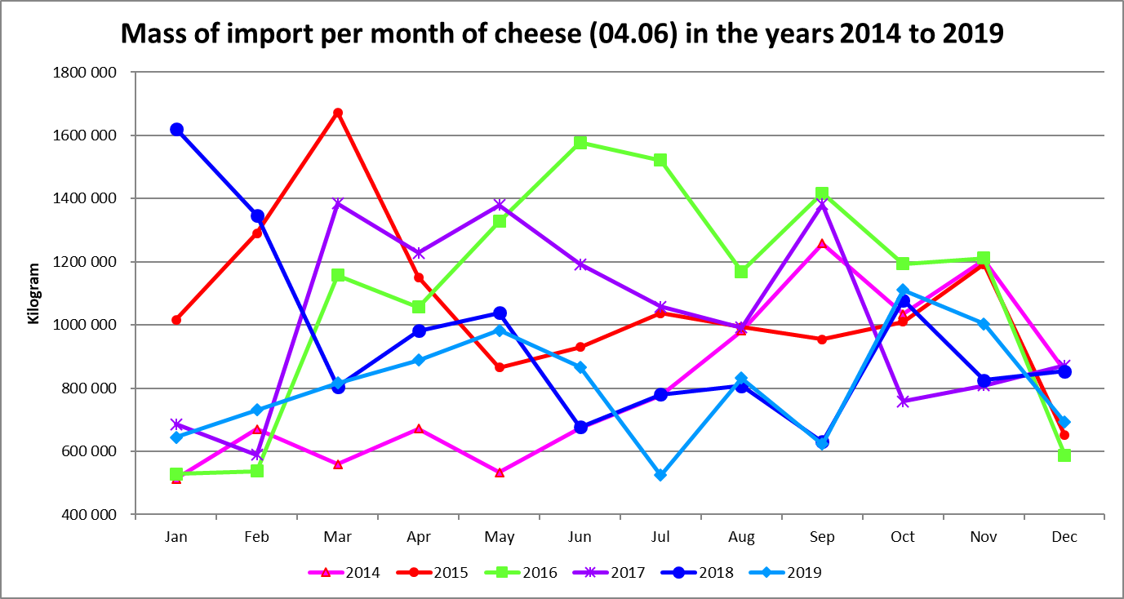

**Table 6**

**Highest and lowest imports per month of cheese (04.06) in the years 2014 to 2019**

|  |  |  |
| --- | --- | --- |
|  | **Highest** | **Lowest** |
| **2014** | September | January |
| **2015** | March | December |
| **2016** | June | January |
| **2017** | March | February |
| **2018** | January | September |
| **2019** | October | July |

**Graph 7**



**Table 7**

**Highest and lowest exports per month in terms of mass of milk and cream, not concentrated (04.01) in the years 2014 to 2019**

|  |  |  |
| --- | --- | --- |
|  | **Highest** | **Lowest** |
| **2014** | August | January |
| **2015** | August | January |
| **2016** | January | September |
| **2017** | November | June |
| **2018** | November | August |
| **2019** | October | September |

**Graph 8**



**Table 8**

**Highest and lowest exports per month in terms of mass of milk and cream, concentrated (sweetened and unsweetened) (04.02) in the years 2014 to 2019**

|  |  |  |
| --- | --- | --- |
|  | **Highest** | **Lowest** |
| **2014** | September | June |
| **2015** | August | December |
| **2016** | November | February |
| **2017** | November | January |
| **2018** | March | December |
| **2019** | October | July |

**Graph 9**

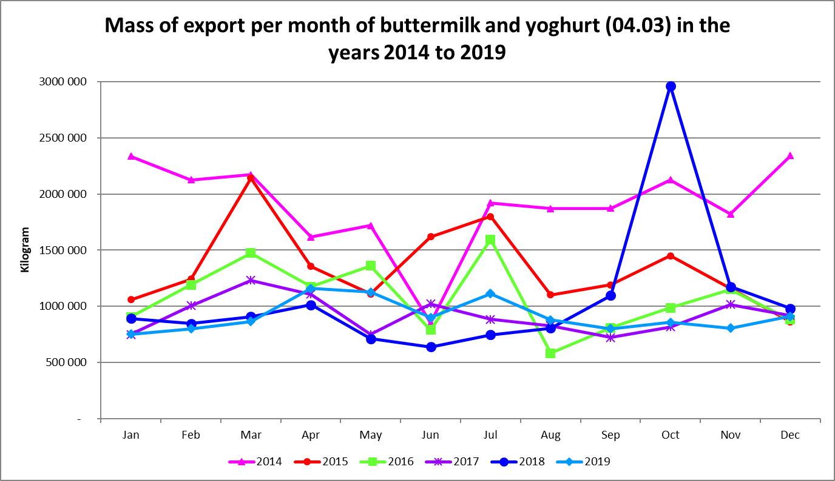

**Table 9**

**Highest and lowest exports per month in terms of mass of buttermilk (04.03) in the years 2014 to 2019**

|  |  |  |
| --- | --- | --- |
|  | **Highest** | **Lowest** |
| **2014** | December | June |
| **2015** | March | December |
| **2016** | July | August |
| **2017** | March | September |
| **2018** | October | June |
| **2019** | April | January |

**Graph 10**



**Table 10**

**Highest and lowest exports per month in terms of mass of whey (04.04) in the years 2014 to 2019**

|  |  |  |
| --- | --- | --- |
|  | **Highest** | **Lowest** |
| **2014** | December | October |
| **2015** | August | February |
| **2016** | March | August |
| **2017** | January | December |
| **2018** | May | February |
| **2019** | December | January |

**Graph 11**



**Table 11**

**Highest and lowest exports per month in terms of mass of butter (04.05) in the years 2014 to 2019**

|  |  |  |
| --- | --- | --- |
|  | **Highest** | **Lowest** |
| **2014** | May | December |
| **2015** | September | January |
| **2016** | November | July |
| **2017** | March | July |
| **2018** | August | June |
| **2019** | April | January |

**Graph 12**



**Table 12**

**Highest and lowest exports per month in terms of mass of cheese (04.06) in the years 2014 to 2019**

|  |  |  |
| --- | --- | --- |
|  | **Highest** | **Lowest** |
| **2014** | December | February |
| **2015** | October | January |
| **2016** | May | January |
| **2017** | November | February |
| **2018** | October | April |
| **2019** | March | January |