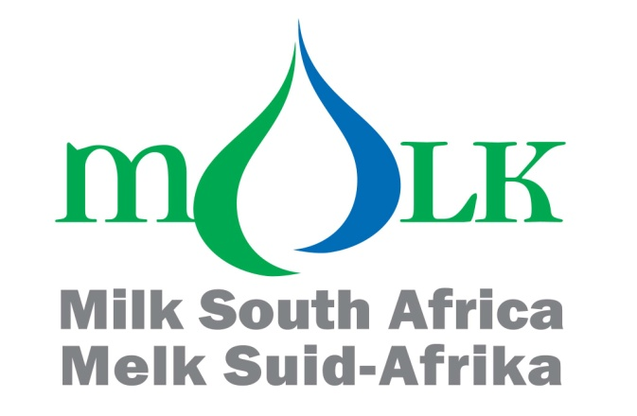

QUARTERLY REVIEW OF THE PERFORMANCE OF THE DAIRY INDUSTRY

The information in this document is from sources deemed to be correct. Milk SA, the MPO and SAMPRO are not responsible for the results of any decisions taken on the strength of this information.

Third Quarter 2020
1. INTERNATIONAL MARKET
FIGURE 1a: FAO FOOD PRICE INDICES, JANUARY 2010 – SEPTEMBER 2020
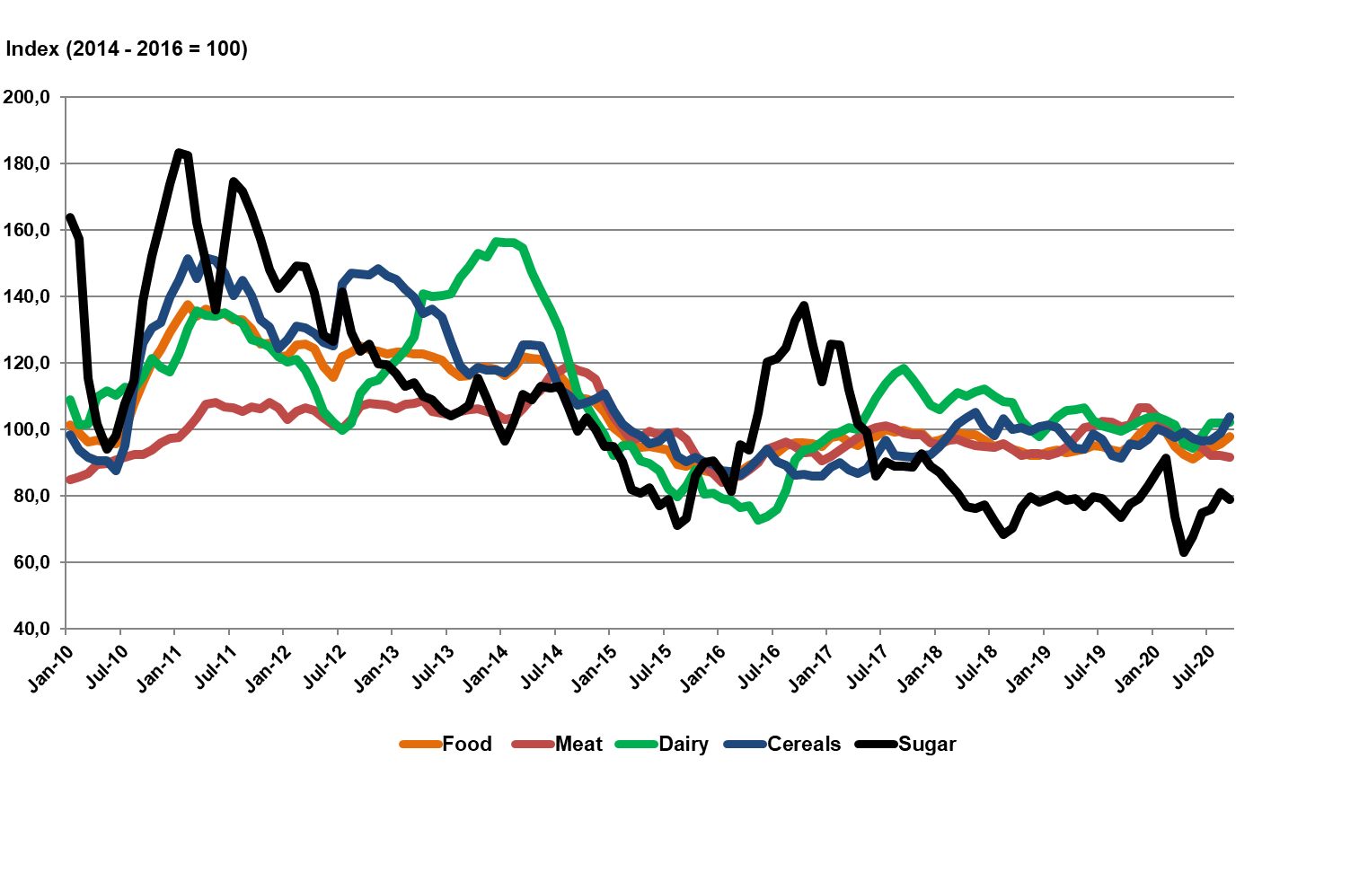
Source: FAO Food price index, Oct 20
The FAO Food Price Index* (FFPI) averaged 97.9 points in September 2020, up 2.0 points (2.1 percent) from August and now 4.6 points (5.0 percent) higher than its value a year ago. The September value, the highest since February 2020, represented the fourth consecutive monthly increase. Much firmer prices of vegetable oils and cereals were behind the latest rise in the FFPI. By contrast, prices of dairy products remained generally stable, while those of sugar and meat retreated from their August levels.

The FAO Dairy Price Index averaged 102.2 points in September, almost unchanged from August and up 2.5 points (2.5 percent) from the corresponding month last year.

FIGURE 1b: International Dairy Product Prices: Jan 2012 – Sep 2020
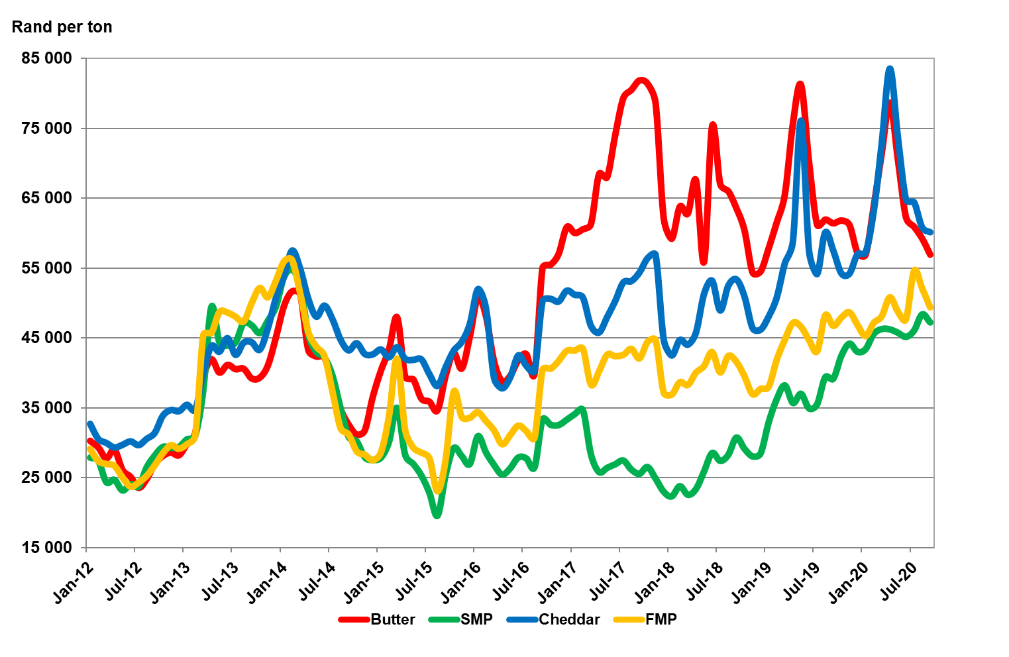
Source: USDA

In USD terms all dairy product prices in the above graph retreated in the September 2020 with the exception of skimmed milk powder (SMP); up by 7%. The price of butter down sharply with 18%, cheddar down 7% and full milk powder (FMP) went south with 6% (comparisons year on year). During September 2020 the Rand depreciated from R14.84 to the USD in September 2019 to R16.71 in September 2020 (13%). The result was that all dairy product prices in Rand terms increased with the exception being butter that decreased with 7% due to the sharp decline in the international price. The Rand price of SMP up by 21%, cheddar 5% and FMP up by 6%.

FIGURE 2a: Global dairy trade-weighted price index. Jan 2009 – Sep 2020

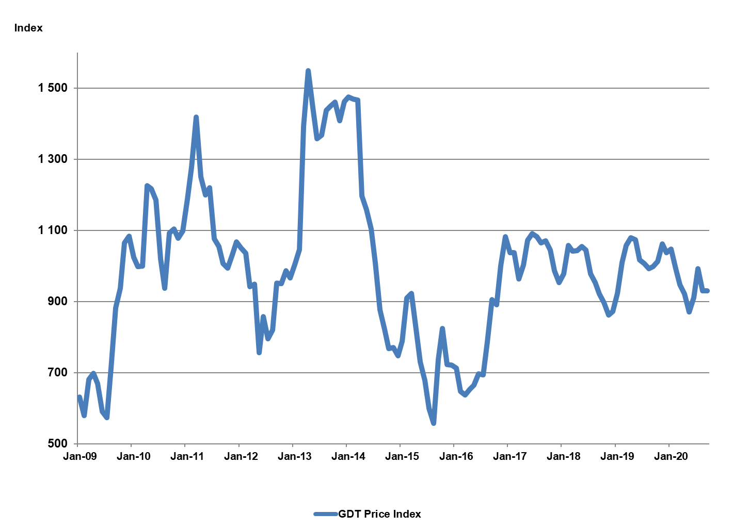
Source: GDT Platform

The Global Dairy Trade (GDT) platform is an online auction through which large volumes of dairy products can be sold or bought. There are two trading events per month where people across the globe can enter bids and/or offers.
Figure 2a above shows the movement of the Global Dairy Trade (GDT) price index inclusive of September 2020. The sharp decline in dairy product prices that commenced in February 2020 is clearly visible. The role of the 900 index support level is remarkable. Although the May 2020 level breached the support level, velocity was insufficient with June bouncing back above the support level. Given the circumstances of the worldwide pandemic and the resultant uncertainties, this illuminates the strength that the support level has built up over the past 42 months. Prices moved sideways from August to September 2020.

FIGURE 2b: FUTURE PRICES FOR DAIRY PRODUCTS ACHIEVED ON THE NEW ZEALAND FUTURES EXCHANGE (NDX): Nov 2020 – May 2021
Source: NZX Futures, Oct 2020
The New Zealand Future Exchange reflects most prices moving sideways, with the exception of butter and anhydrous milkfat, where higher prices are reflected in the first 5 months of 2021.

FIGURE 3: YEAR ON YEAR CHANGE IN UNPROCESSED MILK PRODUCTION IN MAJOR DAIRY EXPORTING COUNTRIES, 2016 – 2020 (first six months)
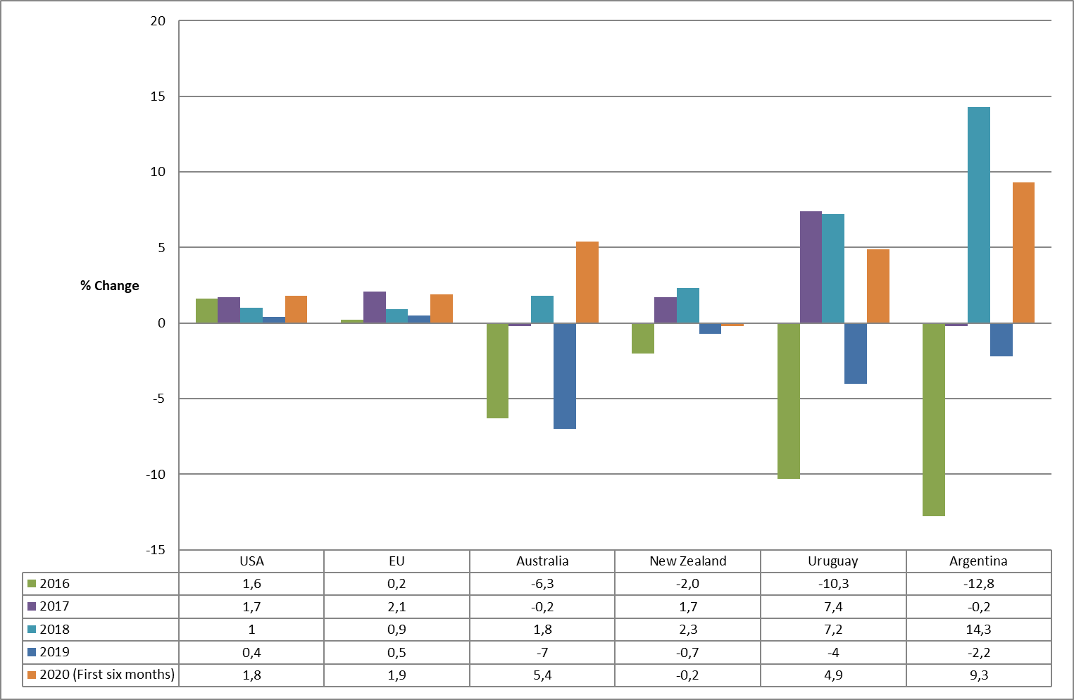

Source: CLAL, Sep 2020
Unprocessed milk production during 2019 is a picture of negative growth, zero growth and very little growth in the major dairy exporting countries. The climatic conditions in the different countries contributed to the negative growth picture while the declining trend in producer prices for some parts of 2018, coupled to the relatively low level of some of these prices during 2018 and 2019 also played a role.

However, these prices improved in the third and fourth quarter of 2019 and the result can be seen in first six months of 2020 with production improving substantially in all these countries if compared over the same period last year. Although New Zealand is showing negative growth, it is less negative than the previous year.

FIGURE 4: PRODUCER PRICES OF UNPROCESSED MILK IN THE EU, USA AND NEW ZEALAND IN EURO PER 100 KG, January 2013 – Aug 2020
Source: LTO Nederland, Oct 2020

The marked convergence of producer prices since middle 2017 with producer prices staying within the 30 to 35 Euros per 100kg price band seems to be something of the past. Producer price volatility is starting to come back (especially since middle 2019) reflecting to a larger extent country specific industry circumstance.
Since the beginning of 2018 USA producer prices was on an upward trend with prices breaking through 35 Euros per 100kg in March 2019 and going north of 45 Euros per 100kg in Oct 2019. Since then the trend reversed with unseen severity moving to levels last tested in February 2018 and then rebounded off the scale. Prices pulled back in August 2020. The USA Class III milk price fell by no less than € 11.44 per 100 kg standard milk in August. The wide fluctuations of cheese prices in the US are introducing wide swings in the producer price.
Producer prices in the EU have been moving sideways since the beginning of 2019, a short decline in the second quarter of 2020 and now a slight upward trend in the third quarter. In New Zealand prices reflect and upward trend in the second quarter of 2020 but are now on a strong decline.

2. SOUTH AFRICAN DAIRY MARKET
Import and export figures from SARS are supplied by SAMPRO.

FIGURE 5: TOTAL SOUTH AFRICAN IMPORTS AND EXPORTS OF DAIRY PRODUCTS, 2011 – 2019
The information regarding imports and exports by South Africa of dairy products in 2019, showed that:

- The mass of imports of dairy products in 2019 was 10.1 percent higher than in 2018. The increase from 2018 to 2019 is due to the increase in imports of three of the six categories of dairy products.
- The mass of exports of dairy products in 2019 was 0.8 percent lower than in 2018. The decrease from 2018 to 2019 is due to the decrease in exports of four of the six categories of dairy products.
- The mass of imports and exports in 2019, showed that South Africa was a net importer of, concentrated milk (04.02), whey and whey powder (04.04), butter and milk fats (04.05) and cheese and curd (04.06) but a net exporter of milk and cream (04.01) and buttermilk and yoghurt (04.03).
- The mass of sales by South Africa to the other members of the Southern African Customs Union (Botswana, Namibia, Lesotho and Swaziland), in period 2019, of each of the six categories of dairy products, was higher than the mass of South African exports of the dairy products in the same period.

FIGURE 6: SOUTH AFRICAN IMPORTS AND EXPORTS OF MILK AND CREAM (04.01), 2011 – 2019

FIGURE 7: S.A. IMPORTS AND EXPORTS OF CONCENTRATED MILK, (04.02) 2011 – 2019 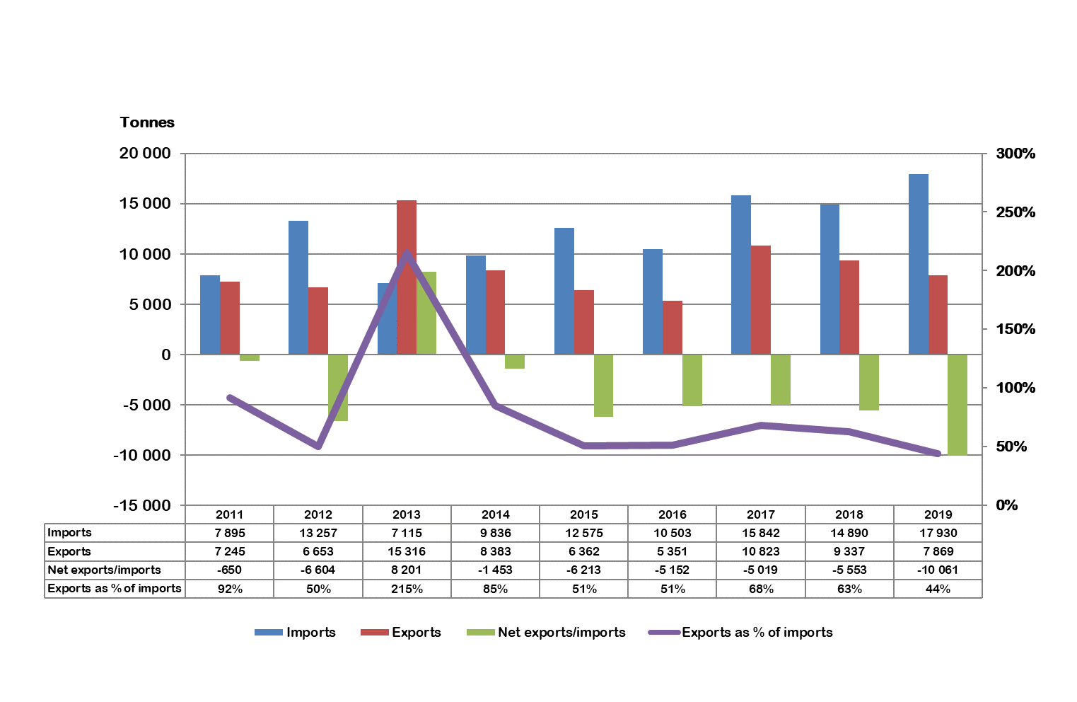
FIGURE 8: SOUTH AFRICAN IMPORTS AND EXPORTS OF BUTTERMILK AND YOGHURT, (04.03) 2011 – 2019
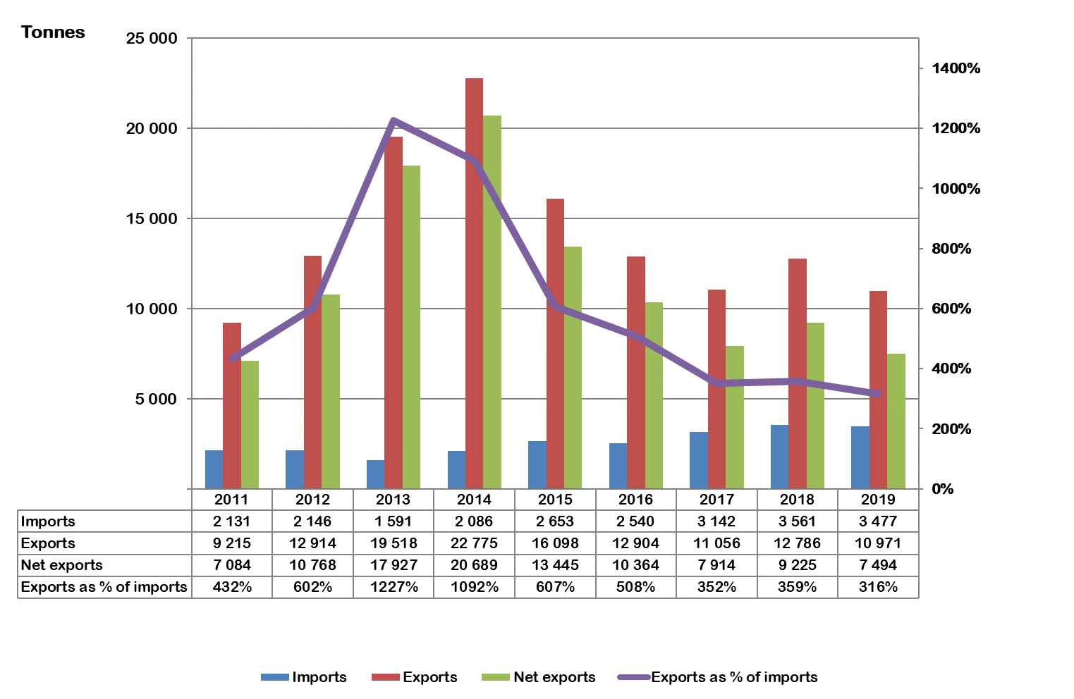
FIGURE 9: SOUTH AFRICAN IMPORTS AND EXPORTS OF WHEY AND WHEY POWDER, (04.04) 2011 – 2019
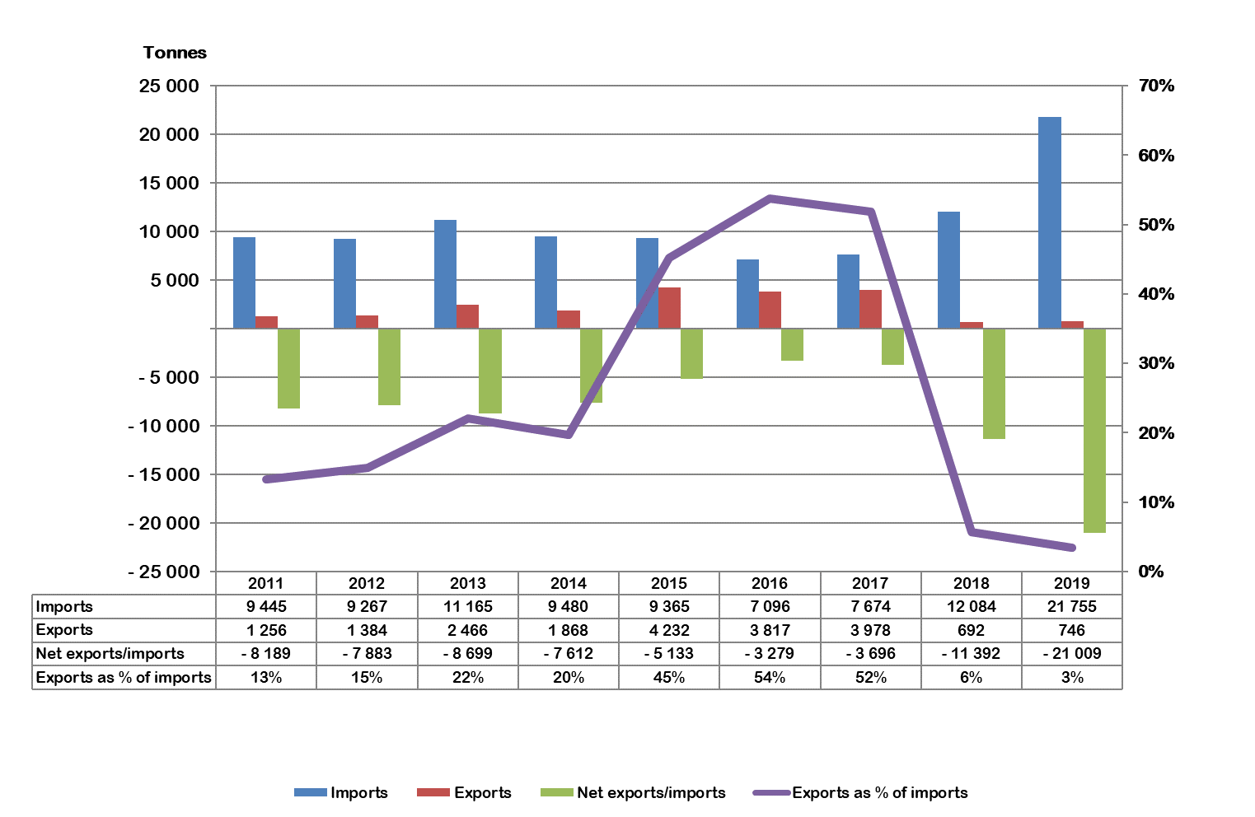
FIGURE 10: SOUTH AFRICAN IMPORTS AND EXPORTS OF BUTTER AND MILKFATS, (04.05) 2011 – 2019
FIGURE 11: SOUTH AFRICAN IMPORTS AND EXPORTS OF CHEESE AND CURD, (04.06) 2011 – 2019
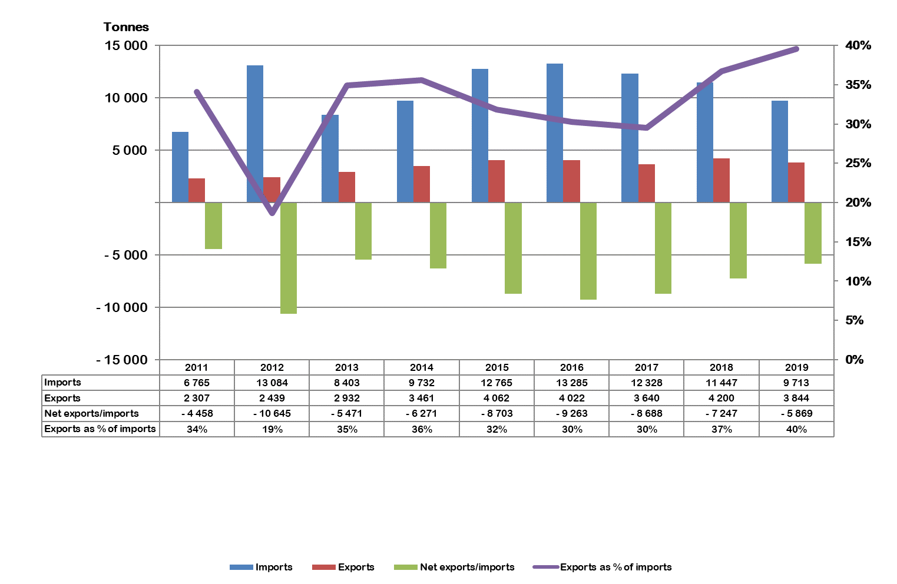

TABLE 1: AVERAGE SOUTH AFRICAN IMPORT AND EXPORT FOB-PRICES FOR DAIRY PRODUCTS, 2015– 2019
Tariff  heading | Description | Import price  (R/kg) |  |  |  |  | Export price  (R/kg)
 |  | 2015 | 2016 | 2017 | 2018 | 2019 | 2015 | 2016 | 2017 | 2018 | 2019
04.01 | Milk & cream | 7.65 | 7.44 | 7.65 | 8.00 | 8.95 | 10.30 | 10.18 | 10.93 | 11.20 | 11.30
04.02 | Concentrated milk | 30.92 | 32.94 | 32.31 | 30.84 | 36.49 | 30.97 | 37.00 | 41.51 | 36.56 | 36.97
04.03 | Buttermilk & yoghurt | 28.06 | 25.57 | 28.39 | 23.51 | 32.27 | 18.76 | 21.27 | 37.12 | 18.45 | 21.02
04.04 | Whey | 31.98 | 28.90 | 31.24 | 29.33 | 25.77 | 10.51 | 25.46 | 13.27 | 18.71 | 18.03
04.05 | Butter | 39.56 | 46.87 | 68.89 | 72.84 | 70.17 | 40.66 | 49.40 | 59.94 | 67.27 | 56.89
04.06 | Cheese | 54.94 | 57.21 | 62.19 | 62.92 | 69.85 | 45.50 | 51.99 | 60.86 | 53.15 | 56.25
Source: SARS as supplied to SAMPRO
The average f.o.b. export prices in 2019, of four of the six different categories of dairy products, are higher than in 2018.
TABLE 2: CHANGES IN THE RETAIL SALES QUANTITIES FROM THE YEAR JULY 2018 TO JUNE 2019, TO THE YEAR JULY 2019 TO JUNE 2020, AND CHANGES IN THE RETAIL PRICES FROM JUNE 2019 TO JUNE 2020 OF SPECIFIC DAIRY PRODUCTS
DAIRY PRODUCT | Change in Retail  Sales  Quantity  Percent | Change in  Retail  Prices  Percent
FRESH MILK | -4.0 | 4.2
LONG LIFE MILK (UHT MILK) | 0.01 | 7.8
FLAVOURED MILK | -6.7 | 5.3
YOGHURT | 10.0 | 0.6
MAAS | 12.7 | 3.1
PRE-PACKAGED CHEESE | 11.0 | 5.2
CREAM CHEESE | 1.7 | 8.4
BUTTER | 3.5 | 7.3
CREAM | 1.2 | 6.7

Source: Nielsen figures supplied by SAMPRO
In the period that ended in June 2020, the retail sales quantities of seven of the nine dairy products were higher than in the previous period. The retail prices of all nine dairy products increased from June 2019 to June 2020.

Fresh and long-life milk (UHT) (Unflavoured and unsweetened milk) utilize approximately 53.00 percent of the total unprocessed milk production in South Africa.
Changes in sales quantities and prices during the period in table 2 did not change at the same rate. This situation is illustrated in Tables 3 and 4.

TABLE 3: CHANGES IN THE QUANTITIES OF RETAIL SALES OF CERTAIN DAIRY PRODUCTS
PRODUCT | Sales in the  month of  June 2020  versus the  sales in the  month of  June 2019 | Sales in the  3 months from April 2020 to  June 2020  versus the  sales in the  3 months from  April 2019 to  June 2019 | Sales in the  6 months from January 2020 to June 2020  versus the  sales in the  6 months from  January 2019 to June 2019 | Sales in the  9 months from  October 2019 to June 2020  versus the  sales in the  9 months from  October 2018 to June 2019 | Sales in the  12 months from  July 2019 to  June 2020  versus the  sales in the  12 months from  July 2018 to  June 2019
 | percent | percent | percent | percent | percent
Fresh Milk | -9.4 | -9.3 | -7.4 | -5.5 | -4.0
UHT milk | 9.8 | 12.6 | 8.3 | 3.4 | 0.01
Flavoured milk | -11.8 | -11.9 | -10.6 | -8.6 | -6.7
Yoghurt | 17.3 | 18.1 | 11.5 | 10.2 | 10.0
Maas | 5.5 | 11.2 | 10.7 | 10.9 | 12.7
Pre-packaged cheese | 18.3 | 22.4 | 16.8 | 13.0 | 11.0
Cream cheese | 10.0 | 12.4 | 5.1 | 2.5 | 1.7
Butter | 16.3 | 15.4 | 8.1 | 4.9 | 3.5
Cream | 14.4 | 22.7 | 8.9 | 3.6 | 1.2
Source: Nielsen as supplied by SAMPRO
In June 2020, the retail sales quantities of two of the nine dairy products were lower while the retail sales quantities of seven of the dairy products were higher than in June 2019.The highest increases of 18.3 and 17.3 percent were respectively recorded in respect of Pre-packaged cheese and yoghurt.

The dramatic higher retail sales quantities of pre-packaged cheese in June 2020, is indicative of the extent of stockpiling by consumers in response to Covid19 and the related “lockdown” measures of the Government;

The retail sales quantity of fresh milk, in the year which ended in June 2020, was 4.0 percent lower and that of UHT milk 0.01 percent higher than in the year that ended in June 2020.

TABLE 4: CHANGES IN THE RETAIL PRICES OF CERTAIN DAIRY PRODUCTS
PRODUCT | June 2020 versus  May 2020  (1 month ago) | June 2020 versus  March 2020  (3 months ago) | June 2020 versus  December 2019  (6 months ago) | June 2020 versus  September 2019  (9 months ago) | June 2020  versus  June 2019  (12 months ago) | June 2020 versus  December 2018  (18 months ago) | June 2020 versus  June 2018  (24 months ago)
 | Percent | Percent | Percent | Percent | Percent | Percent | Percent
FRESH MILK | 0.7 | 1.0 | 2.3 | 2.9 | 4.2 | 7.9 | 6.3
UHT MILK | 2.1 | 6.6 | 8.7 | 4.1 | 7.8 | 17.8 | 18.7
FLAVOURED MILK | 2.1 | 3.3 | 14.3 | 2.6 | 5.3 | 13.8 | 13.1
YOGHURT | -1.5 | -0.7 | 7.0 | 1.7 | 0.6 | 4.9 | 3.6
MAAS | -1.9 | 0.0 | 3.9 | 2.5 | 3.1 | 6.2 | 2.1
PRE-PACKAGED CHEESE | 0.7 | 2.4 | 4.5 | 3.3 | 5.2 | 5.6 | 6.7
CREAM CHEESE | 3.3 | 6.5 | 7.5 | 8.4 | 8.4 | 14.2 | 11.3
BUTTER | 0.4 | -3.8 | 8.9 | 5.6 | 7.3 | 5.6 | 1.9
CREAM | 1.2 | 0.9 | 1.0 | 2.8 | 6.7 | 9.1 | 14.8
Source: Nielsen as supplied by SAMPRO
In the year which ended in June 2020 (12-month period), the retail sales prices of all nine dairy products increased with between 0.6 and 8.4 percent.

One of the nine product prices over the 12-month period that ended in June 2020 increased with less than the inflation rate.

In the year which ended in June 2020 (24-month period), the retail sales prices of all nine dairy products increased with between 1.9 and 18.7 percent.
FIGURE 12: PRODUCER PRICE INDICES OF SOUTH AFRICAN AGRICULTURAL AND FOOD PRODUCTS, January 2012 – Aug 2020.
Source: Stats SA
The PPI for Other Manufactured Food Products moved sideways from April 2019 to December 2019 but changed to an upward trend at the beginning of 2020.
In January 2020 the PPI for Dairy Products increased to 146.5 index points (from 143.0 in December 2019) but reversed back with 1,2% in February 2020 to 144.7 index points. The index increased marginally in March and more noteworthy in April and June reaching 151.2 points. The index pulled back in July and for August the index registered 150.3 point, some 5.1% up from December 2019.
In January 2020 PPI for Unprocessed milk decreased marginally to 130.3 index points (from 130.5 in Dec 2019) and increased to 130.7 index points in February 2020. The index increased sharply in March 2020 with 7% to 139.9 index points, reaching 141.4 in April to maintain this level through August 2020, some 8.4% up from December 2019.

FIGURE 13: CONSUMER PRICE INDICES OF SOUTH AFRICAN FOOD AND DAIRY PRODUCTS, JANUARY 2012 – Aug 2020
Source: Stats SA
The CPI for milk, cheese and eggs in November 2018 edged below the CPI for food suggesting a pricing strategy that enabled many dairy products to gain and or maintain market share despite consumer disposable income being eroded by increased administered product prices and a weak economy. The CPI for milk, cheese and eggs maintained this position through 2019 and for the first four months of 2020.
In May 2020 the CPI for milk, cheese and eggs, edged above the CPI food index, tracking the CPI food index trend.

FIGURE 14: ANNUAL SOUTH AFRICAN UNPROCESSED MILK PURCHASES,
2010 – 2019
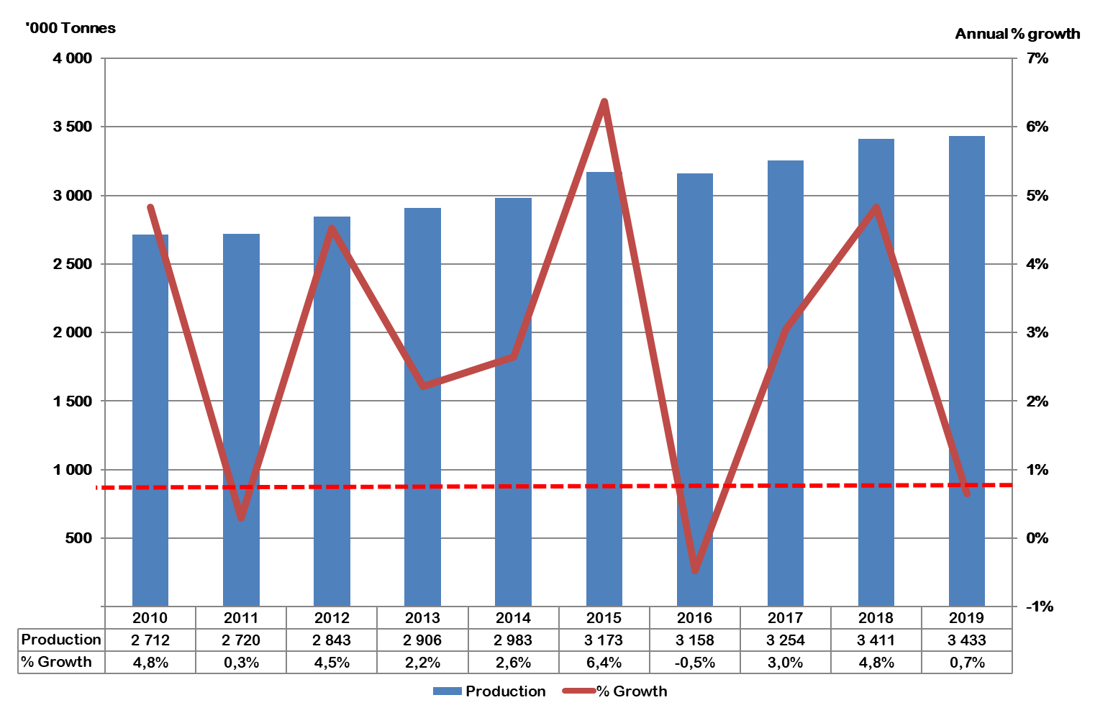
Source: Milk SA.
FIGURE 15: SOUTH AFRICAN UNPROCESSED MILK PURCHASES DAILY AVERAGE PER MONTH, JANUARY 2016 – AUGUST 2020
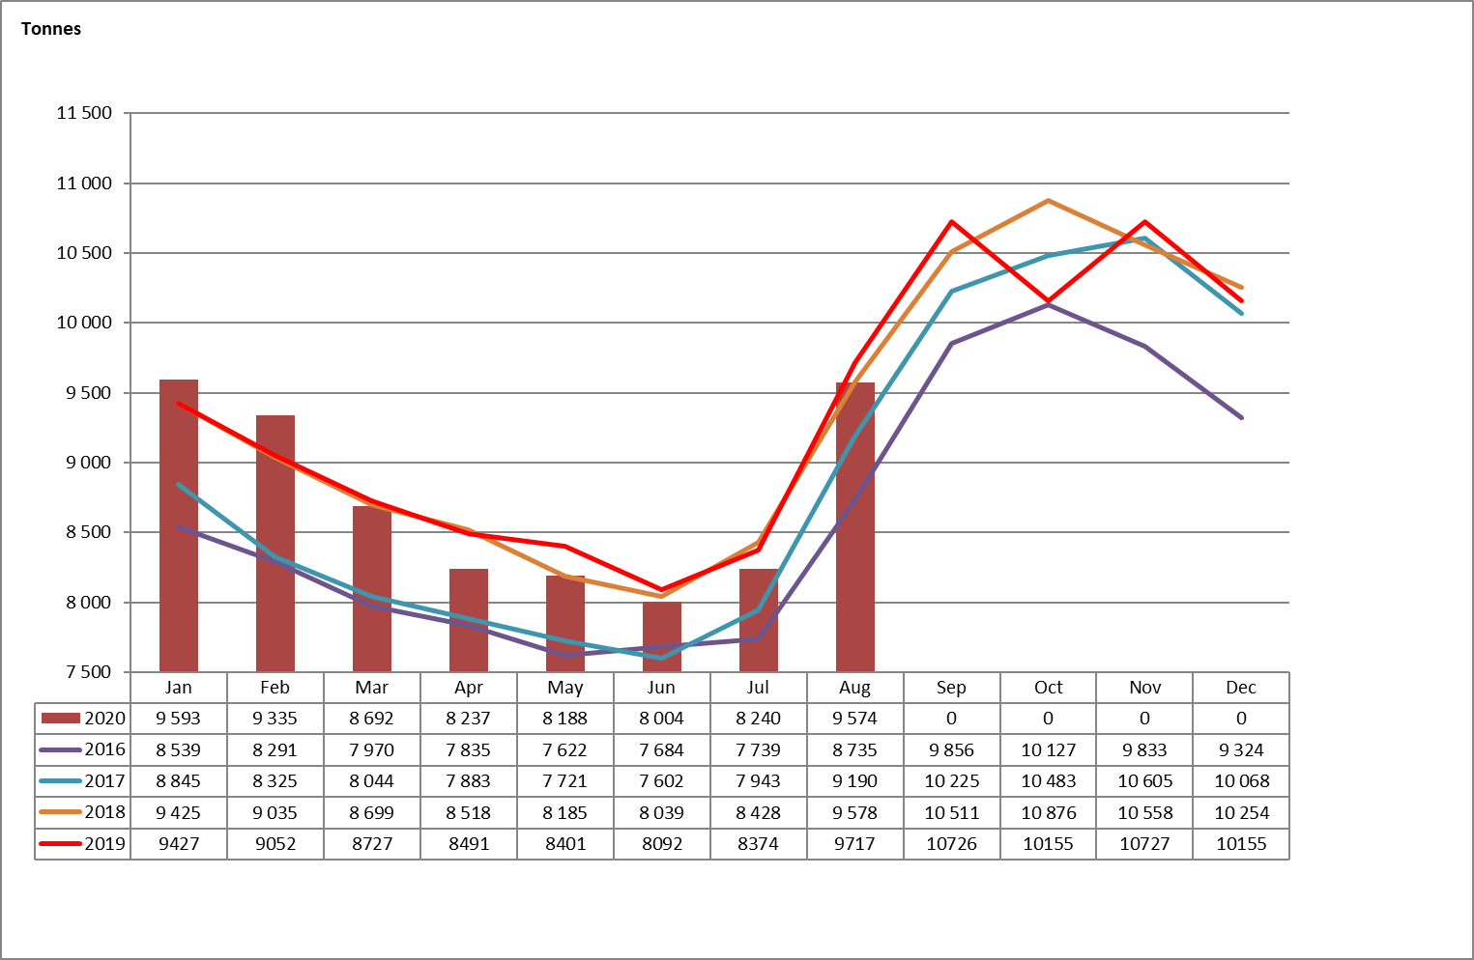
Source: Milk SA; Jul and Aug 2020 preliminary.

TABLE 5: CUMULATIVE UNPROCESSED MILK PURCHASES (Tonnes), 2016 – Aug 2020
Month | 2016 | 2017 | 2018 | 2019 | 2020
January | 264 711 | 274 208 | 292 171 | 292 222 | 297 374
February | 505 147 | 507 314 | 545 148 | 545 682 | 558 763
March | 752 227 | 756 690 | 814 832 | 816 208 | 828 202
April | 987 280 | 993 180 | 1 070 368 | 1 070 927 | 1 075 322
May | 1 223 556 | 1 232 517 | 1 324 102 | 1 331 360 | 1 329 153
June | 1 454 086 | 1 460 583 | 1 565 269 | 1 574 114 | 1 569 271
July | 1 694 009 | 1 706 830 | 1 826 534 | 1 833 695 | 1 824 699
August | 1 964 790 | 1 991 715 | 2 123 446 | 2 134 907 | 2 121 505
September | 2 260 473 | 2 298 450 | 2 438 789 | 2 456 699
October | 2 574 398 | 2 623 438 | 2 775 933 | 2 796 179
November | 2 869 392 | 2 941 589 | 3 092 669 | 3 117 985
December | 3 158 446 | 3 253 682 | 3 410 536 | 3 432 802
Source: Milk SA statistics; July and August 2020, preliminary.

For the first eight months of 2020, 0.63% less unprocessed milk was purchased compared to the same period in 2019, while milk purchases is on the same level if compared to 2018 over the same period.
The South African dairy industry, like many other industries in South Africa, has been under pressure since 2018 due to the low economic growth in South Africa and other factors such as the unreliable supply of electricity. Despite, the last four consecutive quarters of negative economic growth in 2019/20 and the current lock down (due to Covid-19) in SA, demand for dairy products held firm. This indicates a positive perception amongst consumers about the importance of dairy in their daily diet.

The outlook for the SA economy is alarmingly negative with economist and international financial institutions predicting a contraction of between 5% and 10% in 2020. In 2009 the SA gross domestic product contracted with 1,5% resulting in an estimated 800 000 job losses. The result of the projected contraction of the South African economy due the lock down will influence consumer spending negatively, changing demand levels in unison. These changing demand levels could differ substantially between products and all role players should monitor and communicate these changes continuously.

The document was compiled by Bertus van Heerden with input from: | Project Manager, Milk SA Project – Economies and Markets
Nico Fouché | CEO: Milk SA
Alwyn Kraamwinkel | CEO: SAMPRO
De Wet Jonker | Business Economist: SAMPRO

A publication of Milk SA prepared by the MPO and SAMPRO

