Attention: Milk processors, milk producers and other interested parties,

TRENDS OF MONTHLY UNPROCESSED (RAW) MILK PURCHASES IN THE RSA: 2013 TO FEB 2016

Milk purchases for February 2016 was 0,38% lower than the amount bought in February 2015. An amount of 237 449 tonnes is the preliminary milk purchase figure for February 2016.

The total milk purchases reported for 2015 is 3,173 million tonnes, versus 2,983 million tonnes in 2014 (for the same period), which is an increase of 6,37% for 2015.

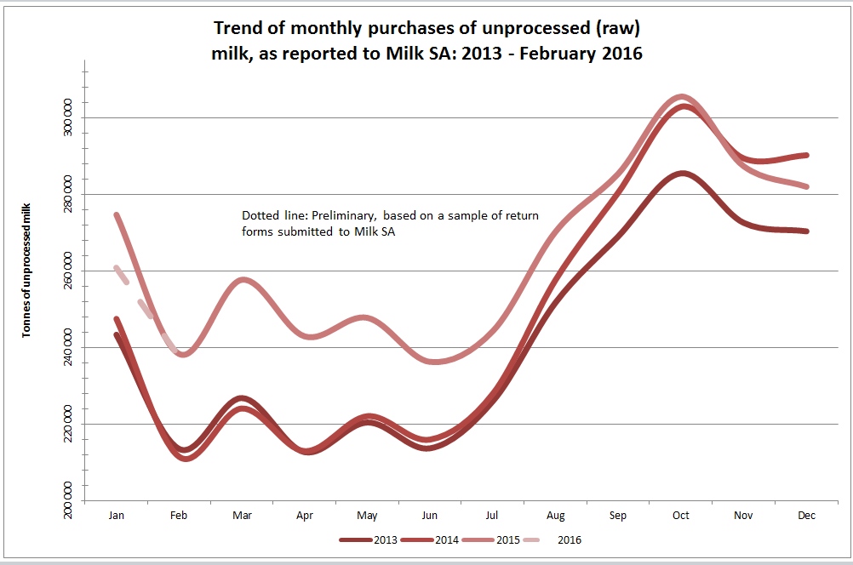

- Source: Milk SA Statistics (from monthly return forms).
- Note: 2013 - 2015 Reviewed, based on total figures declared to Milk SA.
- The composition of the sample (to determine the preliminary figures for the last two months) was amended because of changes in market participants' market shares of milk purchases.

Yours sincerely

Nico Fouché
CEO: Milk SA

2016.03.27

TT006

